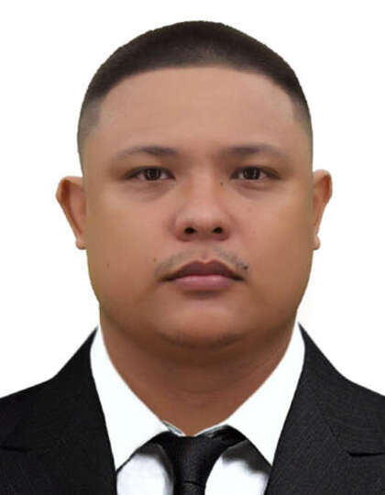
Arenas, jerald angelo eSTRADA
2419 Arellano Street Sunrise Subdivision Barangay Pantal Dagupan City, Pangasinan
arenasjerald@gmail.com
Mobile: +639361040939
Whatsapp: +639361040939
Facebook: Jerald Angelo Estrada Arenas
Instagram: @jeraldarenass

Objective:
Seeking a challenging position where I can my skills in customer service, teamwork, and problem-solving to contribute to organizational success and expand my professional experience. I’m also motivated and dependable professional eager to bring a positive attitude, adaptability, and strong people skills to a role where I can contribute to the team’s success while continuing to learn and grow.

Job experience:
- Marketing Specialist at Dynamic Concepts BPO (2015-2016)
- Responsible for creating advertising campaigns, strategies and demographic data of my target audience.

- Sales Specialist/Cashier at Flexi Finance Asia Inc. (Feb. 08, 2017-June 2018)
- Processing Loan applications, applying payment policies, implementing lending strategies, assessing customer needs, collecting client data and obtaining credit information.

- Branch Manager at REGASCO LPG Company (Jan. 2019-Jan. 2020)
- In charge of overseeing and coordinating all operations for the branch.
- Onboarding and training new staff members
- Developing goals to maintain sales performance

- Delivery Rider at Easyboy Delivery Services (Jan. 27, 2020-June 10, 2024)
- Loading, transporting and delivering foods/items to clients in a safe and timely manner.
- Reviewing orders before and after delivery to ensure that orders are complete, the charges are correct and the customer is satisfied.

- Sales Staff at ILUSTRADO Group of Companies (June 11, 2024-January 22, 2025)
- Responsible for selling products and meeting customer needs while obtaining orders from existing or potential sales outlet.
- To ensure that the customer is satisfied and adequately taken care of while making a purchase.
• Field Sales Rep. at Motorcycle City Dagupan (Feb. 03 2025-April 17, 2025)
- Responsible for selling products and meeting customer needs while obtaining orders from existing or potential sales outlet.
- To ensure that the customer is satisfied and adequately taken care of while making a purchase

Education
- ELEMENTARY:
- Al-Hekma International School in Jeddah, K.S.A. (1996-2005)

- HIGH SCHOOL:
- Our Lady of Mount Carmel Montessori in Baguio City (2005-2006)
- Graduated at Don Bosco High School in Baguio City (2006-2009)
• VOCATIONAL:
- NC1 Ship’s Catering Certificate (Completed)
- Conducted at ASIAN INSTITUTE of MARITIME STUDIES in Pasay (6 days)
- Assessed by TESDA Manila (May 15, 2025)

PERSONAL BACKGROUND
- DATE OF BIRTH: October 25, 1993
- PLACE OF BIRTH: Dagupan City, Pangasinan
- YEARS OF AGE: 31 y/o
- GENDER: Male
- HEIGHT(cm): 163 cm
- WEIGHT(kgs): 85 kgs
- NATIONALITY: Filipino
- CIVIL STATUS: Single
- RELIGION: Roman Catholic

BACKGROUND SKILLS:
- Computer Literate
- Good communication Skills
- Excellent customer service
- Sales background
- Managerial background
- Delivery Experience
- Maritime Training Certificates

