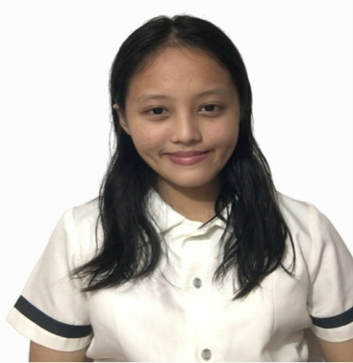
Sanahia Marie R. Redelosa
R. Magsaysay Ave.
Baybay City, Leyte, Philippines, 6521
+639615162475
nahiaredelosa@gmail.com

OBJECTIVE
To obtain the position of being a virtual assistant. Showcasing my skills in writing, editing and creating ideas into reality.

JOB SKILLS

Drawing skills (sketching, pen and ink drawing, and etc.)
- Adaptability and flexibility to new environment and challenges.
- Resilient and persevering in tasks.
- Knowledgeable in using Microsoft Office and Google Applications.
- Problem-solving and critical thinking skills.
- Does well in writing essays and academic papers.
- Skilled in time and tasks management.
- Communication skills (written and basic presentations).
- Willingness to learn new concepts.
- Knowledgeable in using Video Conferencing platforms (Zoom, Google Meet, Skype, and etc.)

EDUCATIONAL ATTAINMENT

TERTIARY Eastern Visayas Sate University-Ormoc City Campus
Bachelor of Science in Civil Engineering 2024-2028

SECONDARY Baybay City Senior High School (Grade 11 & 12)
Science, Technology, Engineering, and Mathematics
strand 2022-2024
Consistent Honor Student
Baybay National High School (Grade 7-10)
Science, Technology, and Engineering curriculum
2018-2022
Consistent Honor Student

PRIMARY Pres. Carlos P. Garcia Elementary School(Grade 1-6)
Consistent Honor Student
Class Valedictorian

SEMINARS/TRAINING ATTENDED

- Baybay City, Senior High School’s Publication Training, Baybay City, Leyte April-May 2024- Participant
- Baybay City Senior High School’s Publication Training, Baybay City, Leyte March-April 2023- Participant
- Baybay National High School’s Publication Training, Baybay City, Leyte August 2019- Participant
- Drug Abuse Resistance Education (DARE) Program January 16-March 2, 2017- Participant

