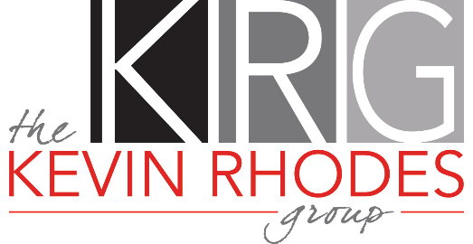
Offer Suggestions

- Any offers received on the launch weekend will be reviewed with the seller the following business day.
- Please submit your offer in 1 PDF (preferred) to krhodes@kw.com.
- In your initial email to me, please try to outline via bullet points, the highlights of your offer.
- Submit lender pre-approval letter or proof of funds letter if cash.
- Seller’s Name: James S. and Deborah A. Wartman
- Preferred Closing Date: ASAP
- Preferred Cost-Free Seller Leaseback Terms: 2-3 days allowing the transaction to fully fund, before my seller fully moves out.
- Exclusions: None
- Title Company: Integrity Land Title, 361. W. Byron Nelson Blvd, #100, Roanoke, 76262, 817-687-8851, Closer: Sandra Ramsey, closing@integritylt.com. REMOTE/MOBILE CLOSING OFFERED AT NO COST TO YOUR CLIENT!
- Encouraged for any/all survey related fee’s to be that of the Buyer.
- Objections (Para. 6D) = 1 day
- Residential Service Contract (Para. 7H): Encouraged to be $0 if multiple offer situation.
- Please submit all supplemental documents w/your offer that are in the MLS signed by Buyer.
- Please fully complete both columns on page 10 of the contract (Broker Information Page)
- Please do not fill in Para. 21 for the Seller. I will do this for my client. Feel free to fill in the Buyer’s side.
- 3rd Party Financing Addenda: If multiple offer situation, it is preferred that the 2nd box in Para. 2 is checked. If days are needed, please consider choosing the shortest number of days possible. 21 days (or more) is not preferred.
- Feel free to text me once you’ve emailed me your offer, but please do not expect a reply to both your text and your email confirming receipt of your offer. I will only respond to one of them.

Thank you!
Kevin Rhodes, Broker-Associate | krhodes@kw.com | 832-233-0265
Keller Williams Realty
2106 E. State Hwy. 114, Ste. 101, Southlake, TX 76092
Office: 817-328-1104 I Cell: 832-233-0265 I Fax: 817-503-8703
Email: krhodes@kw.com I Website: www.RealtorRhodes.com

