Theme 3: How we pray together
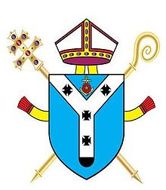
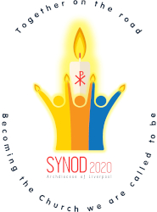
Synod 2020
Liverpool Archdiocese
Primary School Resources

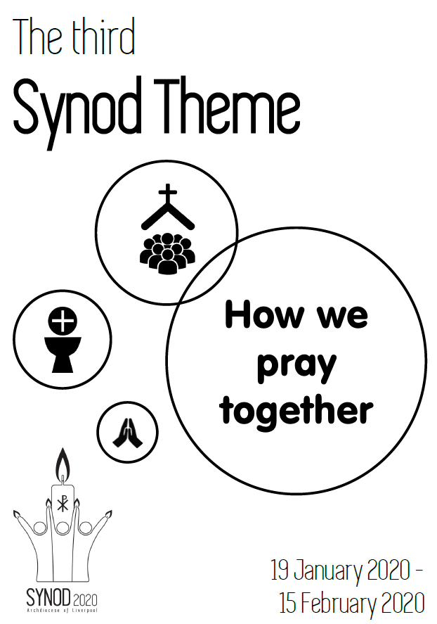
This date has been extended to Friday 28 February 2020 for schools

Collective Worship 3: How we pray together - SCRIPT

Introduction
Please use this short collective worship as a guide for gathering the proposals for action from Year 5 and 6 children in your school.
(Please discuss the meaning of the words ‘theme’ and ‘proposal’ beforehand.)

Pre-Collective Worship (in advance)
Choose the readers.
Print the resources.
Prepare the music (to gather and exit).
Start the PowerPoint to accompany the Collective Worship. (the red writing denotes a mouse click or change of slide.)

On the Day
Display the Synod Candle (if you have one) and a Synod 2020 poster.
Amend the Focus Table with signs/symbols that signify ‘prayer’.
Gather
Light the candle and PLAY the opening song – In the Stillness of Our Hearts (Joanne Wallace) https://synod2020.co.uk/resources/schools

ADULT Introduction
Sign of the Cross…
Welcome everybody. We gather here today to look at our third Synod Theme:
‘How we pray together’.

These are some of the things people said about this:

- Liturgy and worship are central to our school’s mission
- Families need help to pass on their faith
- People like to pray in many different ways
- People love seeing children at Mass
- Sunday Mass is very important to us, but some people find it hard to get there
- Prayer helps to make us strong
- People love to go to Church to pray

We need to listen carefully today so that we can hear God’s message to us and let the Holy Spirit guide us to make a list of our ‘proposals for action’.

CHILD Reader 1:
Archbishop Malcolm McMahon, by calling the Synod, has reached out to all of us. He asks us to guide the future of the Catholic Church in the Archdiocese of Liverpool by expressing our thoughts, feelings and opinions. He wants to know what we think.

CHILD Reader 2:
In the third Synod theme – ‘How we pray together’ we are invited think about the various ways and places we pray. By thinking about this and our chosen scripture passages today, we will be asked to make proposals for action about the different ways we can do this.

CHILD Reader 3:
In John’s Gospel we hear how Jesus prayed for his friends before he left them and asked God to keep them close to him.
In Luke’s Gospel, Jesus teaches his friends how to pray. He uses the prayer we know as the ‘Our Father’.

Listen
CHILD Reader 4:
The scripture today asks us to pray meaningfully to God for each other for the things we need and to forgive others like God forgives us. As you listen, think how we can live this out in our lives today.

CHILD Reader 5:
A reading from John’s Gospel: (God’s Story 3 p109) ‘Jesus prays to his Father’
“Holy Father, I am coming to you.
Keep my friends safe.
They belong to you.
Keep them close to you and to each other.
Let them be as close as I am to you.
I kept them close to you.” “Father, I pray for these my friends and for all those in the future whom they will bring to know me.
Just as you and I are one,
I pray that my friends will always be one with us and with one another.”

CHILD Reader 6:
A reading from Luke’s Gospel: (God’s Story 3 p104)
Jesus was praying one day. When he had finished, one of the disciples said,
“Lord, will you teach us to pray?”
Jesus said to them,
“When you pray, say this:
Father, let everyone honour your holy name.
May everyone live in your love and friendship.
May we all have enough to eat every day.
Forgive us when we do something wrong because we forgive anyone who has hurt us.
And be with us if we have to make difficult choices.”

Respond
CHILD Reader 7:
In this reading Jesus teaches us to pray for ourselves and for others.
Let us pray the words of the Our Father together, now…
Our Father, Who art in heaven,
Hallowed be Thy Name.
Thy Kingdom come.
Thy Will be done,
on earth as it is in Heaven.
Give us this day our daily bread.
And forgive us our trespasses,
as we forgive those who trespass against us.
And lead us not into temptation,
but deliver us from evil. Amen

CHILD Reader 8:
Pope Francis tells us that,
“Our prayer cannot be reduced to an hour on Sundays.
It is important to have a daily relationship with the Lord.”

ADULT:
Let us take a moment to reflect on how can we talk to God each day?
Think about your answers to the following questions;

- When and where do we pray? (PAUSE)

- What different ways do you know how to pray? (PAUSE)

- Who do we pray for and why do we pray for them? (PAUSE)

- What could help you to pray more at school, at home and in Church? (PAUSE)

Going Forth
CHILD Reader 9:
Please join your hands as we say together:
Loving God,
We know you are always with us.
May our hearts be open to you.
May our lives be a prayer to you.
May our worship remind us how much we need you.
Fill our hearts with love so we can make a difference to the world and make it a better place.
AMEN!

ADULT:
You will now be given time to have a whole class discussion and then write some ideas about your ‘proposals for action’ for the Theme 3: How we pray together.

What more can the Catholic Church do to help young people to go to Mass and to pray?

Once completed, pass your ‘proposals for action’ to your RE co-ordinator or head teacher.
Thank you once again for taking the time to help with the Synod 2020 journey.

PLAY an ending song –
Sing or listen to the hymn, ‘Here I am to Worship’
After the Collective Worship
*Allow pupils time to talk together and complete the sheet with proposals for action.
*You may want to remind them of the questions for reflection in the Collective Worship (Slide 12)
*Collate these sheets and pass them to your RE co-ordinator or headteacher.
*Please pass them to your School Council or Faith in Action group etc. so they can decide which 5 proposals for action best represent your school.
*Submit these 5 proposals for action by email to the Synod 2020 Office by Friday 28 February 2020: synod2020@rcaol.co.uk

Please send the SYNOD leaflet home for parents and encourage them to complete their proposals for action, too.
Resources for the final theme will be available in due time.
THEME 4 – Building Community, nurturing belonging
School Name and Postcode:___________________________________________

Theme 3: How we pray together

What more can the Catholic Church do to help young people to
go to Mass and to pray?

Your Proposals:

