Parish Proposal Form
Parish
Town / City
Pastoral Area
Synod Member
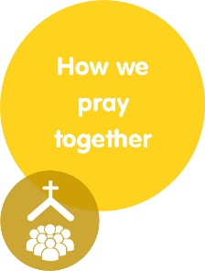

Having reflected on the situation, how our Faith informs us, and what needs to be done in order to become the Church God is calling us to be; the proposals for action submitted by our parish to Synod 2020 on the Theme How we pray together are as follows:
Proposal 1
Proposal 2
Proposal 3
Proposal 4
Proposal 5

