School Proposal Form
School
Town / City
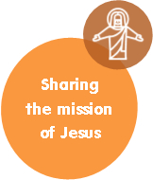

Having reflected on the situation, how our Faith informs us, and what needs to be done in order to become the Church God is calling us to be; the proposals for action submitted by our school to Synod 2020 on the Theme Sharing the mission of Jesus are as follows:
Proposal 1
Proposal 2
Proposal 3
Proposal 4
Proposal 5

