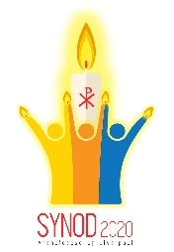
Before Mass begins a parishioner might introduce “Synod Sunday” and explain what will be different about the Mass today.
Mass for Synod Sunday - Introduction

Welcome everyone.
Today we are celebrating “Synod Sunday”.
At the invitation of Archbishop Malcolm, the Archdiocese of Liverpool, people and priests together, are embarking upon a journey that will lead us to an Archdiocesan Synod in October 2020 . During the next two years we will gather to reflect on what God is asking of our Church in the years to come. We will hear more about this Synod during the Mass and there are leaflets for you to take home to read.
Today we have been asked to pray for God’s blessing on these next two years as we try to listen to each other, to the world we are living in, and to the voice of the Holy Spirit. The word “Synod” originally meant “Together on the Road”. The idea of being on a journey together in God’s Church is a part of our prayer today.

If your primary school have produced a display of footprints also add…
You might have noticed the footprints around the church which have been prepared by the children of our school. We can pray about our children and our grandchildren today. What kind of church do we want them to find here in the years to come?

If there is a display of things for the journey also add…
There’s a little display here too with things that you need for a journey – you can see a rucksack, food and drink, good shoes, a map and a compass. Let’s pray that we will stay faithful to the journey that God is asking us to walk together as members of His Church.

I (Based on the Readings)
Mass for Synod Sunday – Penitential Act
Lord Jesus, you came not to be served, but to serve:
Lord, have mercy.
You gave your life as a ransom for many:
Christ, have mercy.
You show us your mercy and give us your help:
Lord, have mercy.

II (Based on Psalm 32)
Lord Jesus, your word is faithful, and your works are to be trusted:
Lord, have mercy.
You fill the earth with your love:
Christ, have mercy.
You look on those who revere you and hope in your love:
Lord, have mercy.

III (Based on Synod themes)
Lord Jesus, you show us how to be your Church in the world today:
Lord, have mercy.
You speak to us through the lives of those around us:
Christ, have mercy.
You walk with us as we journey together to the Father:
Lord, have mercy.

PRIEST: Christ is among us now as the one who serves us. It’s with trust in His great mercy that we ask for His help.
Mass for Synod Sunday – Prayers of the Faithful

READER:
As we begin our journey towards Synod 2020 we pray for our Archbishop Malcolm.
May he know the guidance of the Holy Spirit as he leads our Church.
Lord in your mercy R/ Hear our prayer.
On this World Mission Day we pray for those who have been forced to make a journey they did not wish for. We pray for refugees, the homeless and those who are seeking work.
Lord in your mercy R/ Hear our prayer.
We ask God to help us to listen:
to keep us humble enough to know that we still have much to learn from Him.
In our conversations with each other may we hear the voice of the Holy Spirit guiding us on our journey.
Lord in your mercy R/ Hear our prayer.
We pray for all who are on a difficult stage of their journey through life
and for those who walk with them, trying to lighten their burden.
Lord in your mercy R/ Hear our prayer.
We ask the help of Mary, the Mother of the Church, as we say:
HAIL MARY …

PRIEST: Loving God, hear the prayers we have spoken aloud, and the cry of our hearts that is known to you alone. We make all our prayers in the name of Jesus Christ Our Lord. R/ Amen.

These suggested hymns reflect the readings and/or the Synod themes
Mass for Synod Sunday – Music

- City of God (Awake from your slumber) – Dan Schutte SJ
- Brother, sister, let me serve you – Richard Gillard
- The Kingdom – Mike Anderson
- Guide me, O thou great Redeemer – W Williams
- Walk with me, O my Lord – Estelle White
- From heaven you came (The Servant King) – G Kendrick
- Lord all the world belongs to you – Patrick Appleford
- Take my hands – Sebastian Temple
- Will you come and follow me – John Bell
- All my hope on God is founded – J Neander / Robert Bridges
- Jesus, You are Lord – Mary Barrett
- Make me a channel of your peace – Sebastian Temple
- We are marching in the Light of God - Traditional
- Any hymn setting of Psalm 23

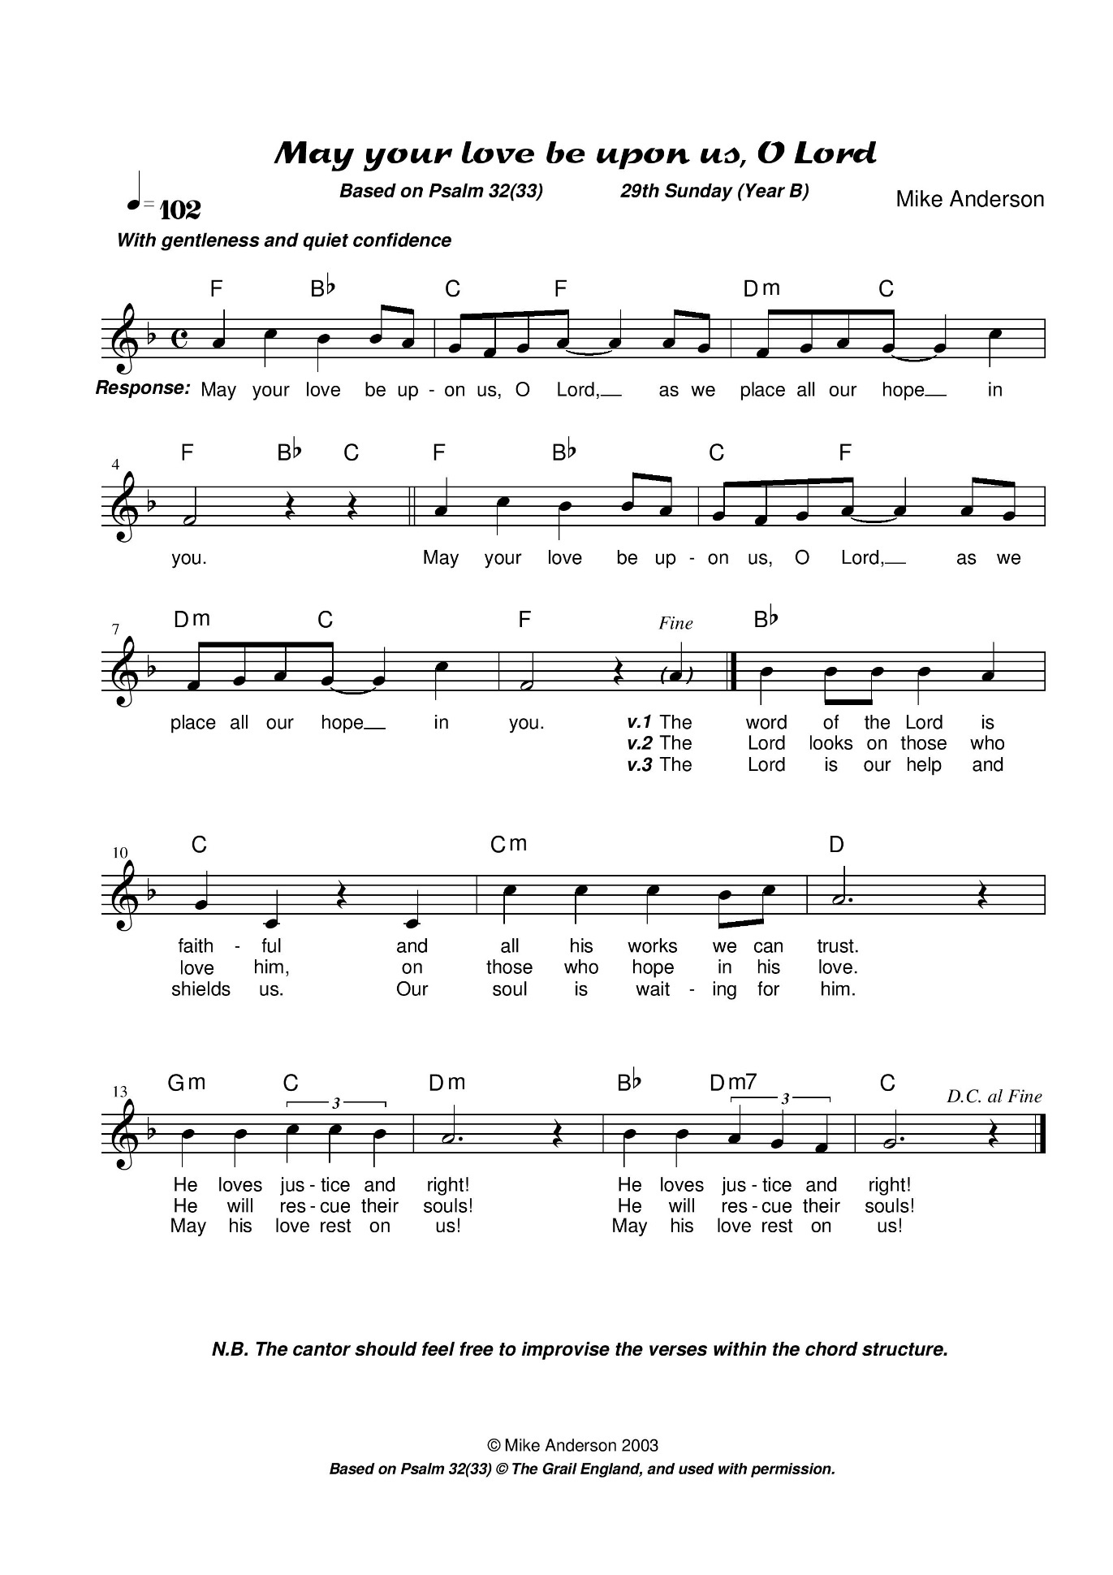
Mass for Synod Sunday – Psalm Setting

www.mikeanderson.net/Upcoming%20Psalms.htm

