Together for a Period-Friendly World:
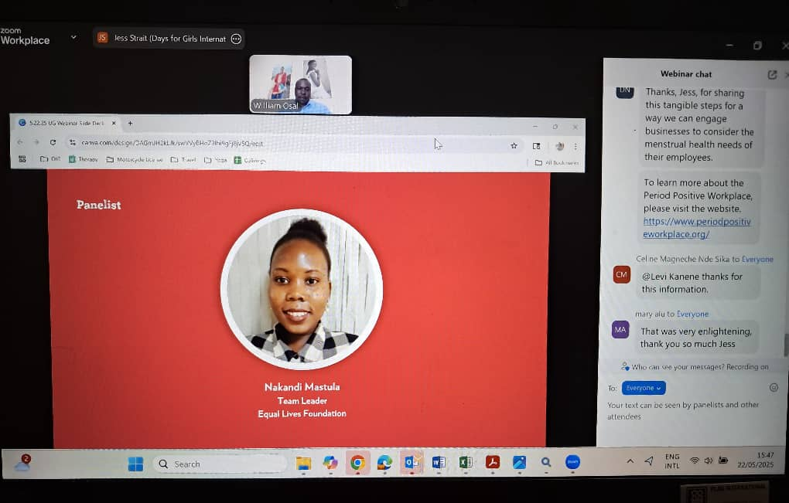
Equal Lives Foundation Joins Days for Girls Uganda in Marking Menstrual Hygiene Day 2025
On May 22, 2025, Equal Lives Foundation pr oudly partnered with Days for Girls Uganda to host a powerful and timely webinar in celebration of International Menstrual Hygiene Day. Held under the global theme “Together for a Period-Friendly World,” the event brought together a diverse group of stakeholders to address the urgent challenges facing menstrual health programming—particularly in the wake of shifting global funding structures.
The 60-minute webinar, which began at 3:00 PM EAT, focused on the theme “Inclusive Programming for Menstrual Health Amidst Fragile Funding Terrain.” This topic resonated deeply with participants, as recent changes—such as the dismantling of USAID-funded projects—have significantly impacted sexual and reproductive health initiatives. These funding disruptions have created critical gaps in access to menstrual health products, services, and education, especially in low- and middle-income countries where resources are already limited.
Masitula Nakandi, the Team Leader ELF delivered a compelling presentation on community-based strategies for supporting girls and young women in rural communities. Her insights highlighted the resilience and innovation found at the grassroots level, where local leaders and organizations are working tirelessly to ensure that menstrual health remains a priority despite financial constraints. Nakandi emphasized the importance of culturally sensitive education, locally sourced menstrual products, and peer-led support networks that empower girls to manage their periods with dignity and confidence.
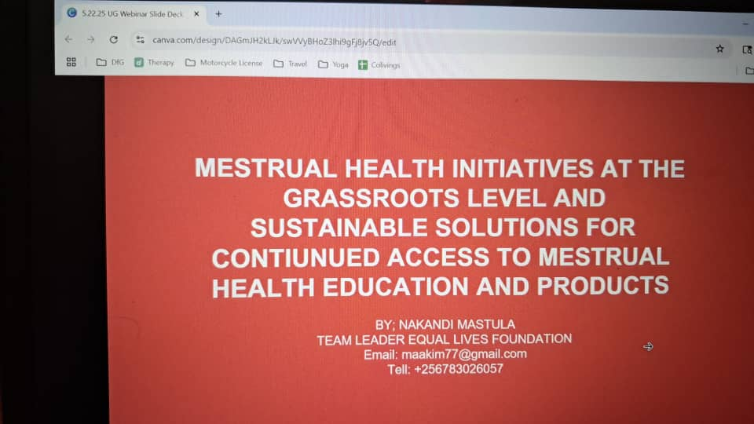
The webinar opened with global perspectives on how international policy and funding shifts are affecting menstrual health programs worldwide. A keynote speaker set the stage for a rich panel discussion, where experts from global, national, and community levels shared strategies for sustaining menstrual health efforts. Topics included policy reforms—such as eliminating withholding taxes on raw materials for menstrual products—alternative funding mechanisms, and the role of cross-sector collaboration in scaling inclusive programming.
Participants engaged actively during the Q&A session, raising questions about youth engagement, policy advocacy, and the role of community organizations in bridging service gaps. The event concluded with a strong call to action: for stakeholders to unite in building resilient, inclusive, and sustainable menstrual health programs that can withstand financial uncertainties and continue driving progress in gender equality, health equity, and education.
As the world moves toward a more period-friendly future, the partnership between Equal Lives Foundation and Days for Girls Uganda stands as a beacon of hope and action. Their joint commitment to empowering girls and women through education, advocacy, and access to menstrual health resources is a reminder that even in the face of funding challenges, collective action can—and must—prevail.
This celebration of Menstrual Hygiene Day 2025 was not just a moment of reflection, but a rallying cry for continued innovation, collaboration, and resilience in the menstrual health movement.

