Girls Mentorship Session

Date: March 2, 2025

Location: Kireka

Introduction
The Equal Lives Foundation (ELF) organized a mentorship session titled "Heartbeats for Girls and Young Women" on March 2, 2025, in Kireka. The session aimed to navigate the issues around relationships for young women and girls. ELF's mission is the holistic empowerment of children and youth to lead sustainable and innovative development for national transformation. Through collaboration and resilience, ELF strives to build a future where every young individual can contribute to a thriving, equitable, and environmentally conscious world.
Attendance
The session was attended by 26 girls and young women aged between 16 and 30 years. The participants included a mix of students and working individuals, all eager to learn and grow through the mentorship provided. The session was led by senior mentors Allen Sempijja, and Grace Ntambi. These experienced mentors guided the participants through various important topics, sharing their wisdom and insights to help the young women navigate their personal and professional lives.
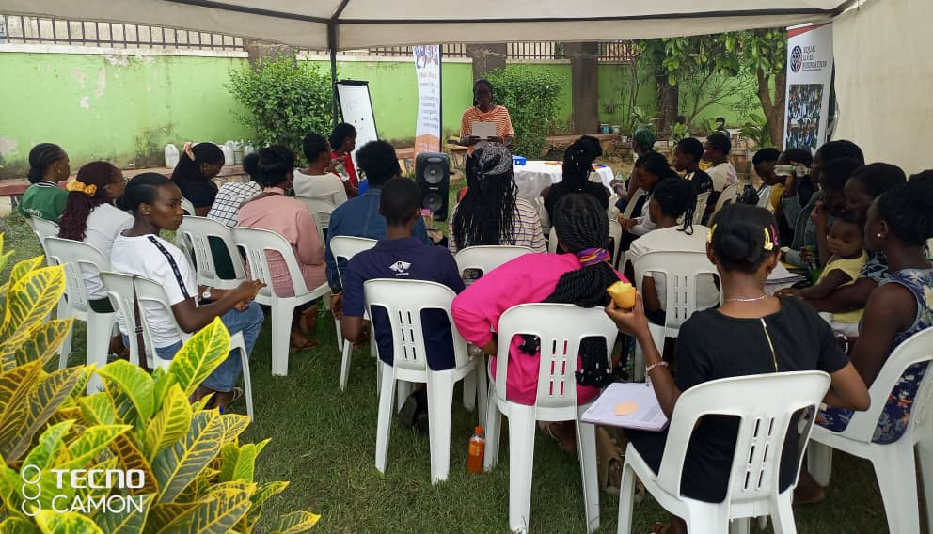
Topics Covered
The session covered a range of topics crucial for the development of the participants. These included self-identity, healthy relationships, self-awareness, self-improvement, and self-care. The mentors emphasized the importance of understanding oneself and building healthy relationships. One participant remarked, "I loved the session on self-identity, ensuring self-evaluation and tips on healthy relationships." Another participant appreciated the focus on self-awareness, stating, "Self-awareness topic was a nice topic."
Feedback from Participants
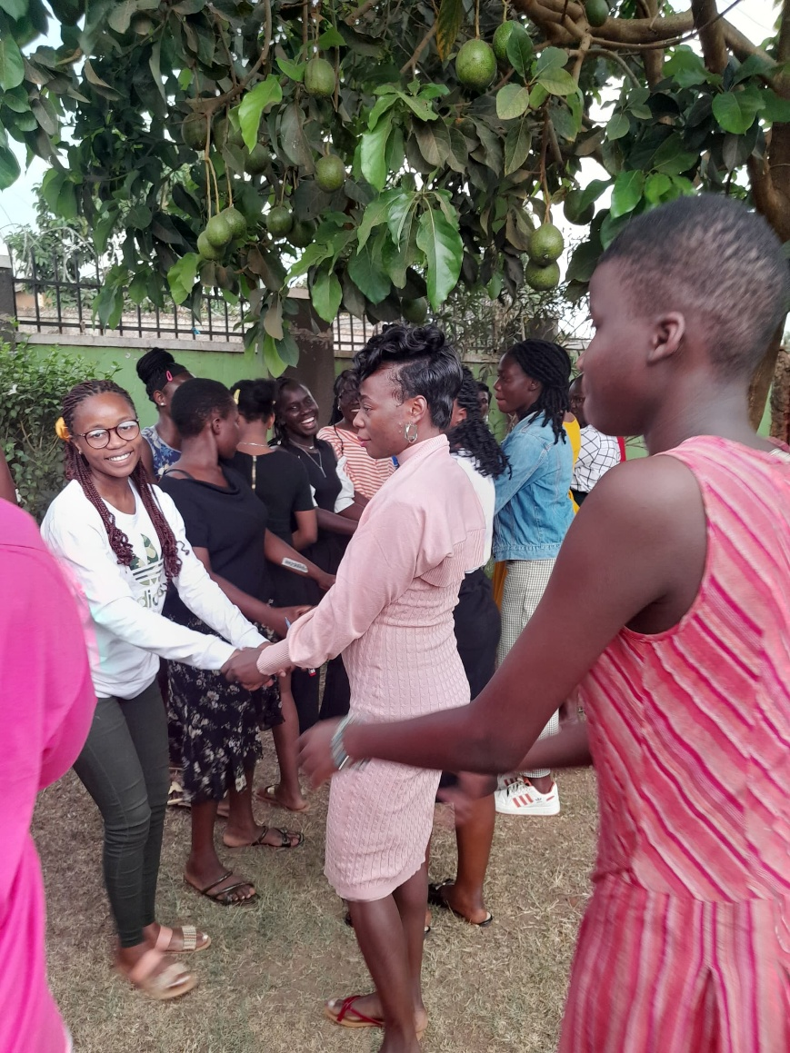
The feedback from the participants was overwhelmingly positive. Many expressed their gratitude for the advice and guidance provided. One participant shared, "I liked the advice on everything on relationships," while another mentioned, "Thanks for broadening our minds." The interactive and welcoming nature of the mentors was also highlighted, with one participant noting, "I loved everything about the session and I don’t regret choosing to be here. I loved the way our mentors are so interactive and welcoming." The session was described as "very fruitful" and "beneficial," particularly the topics on self-care and relationships.
Future Topics Suggested by Participants
Participants expressed a keen interest in future sessions covering a variety of topics. These included love and the road to marriage, more discussions on relationships to address issues like suicide due to relationship problems, and meeting in different age groups to discuss and understand their future. One participant suggested, "Need to meet again in different age groups to discuss and understand about our future." Other suggested topics included approaching older people for support and mentorship, maintaining a Christian life, financial independence, and addressing misbehavior with boys.

Questions Raised
During the session, participants raised several questions, reflecting their concerns and seeking guidance on various issues. These questions included:
"Is it bad to love too much? Could loving too much be bad?"
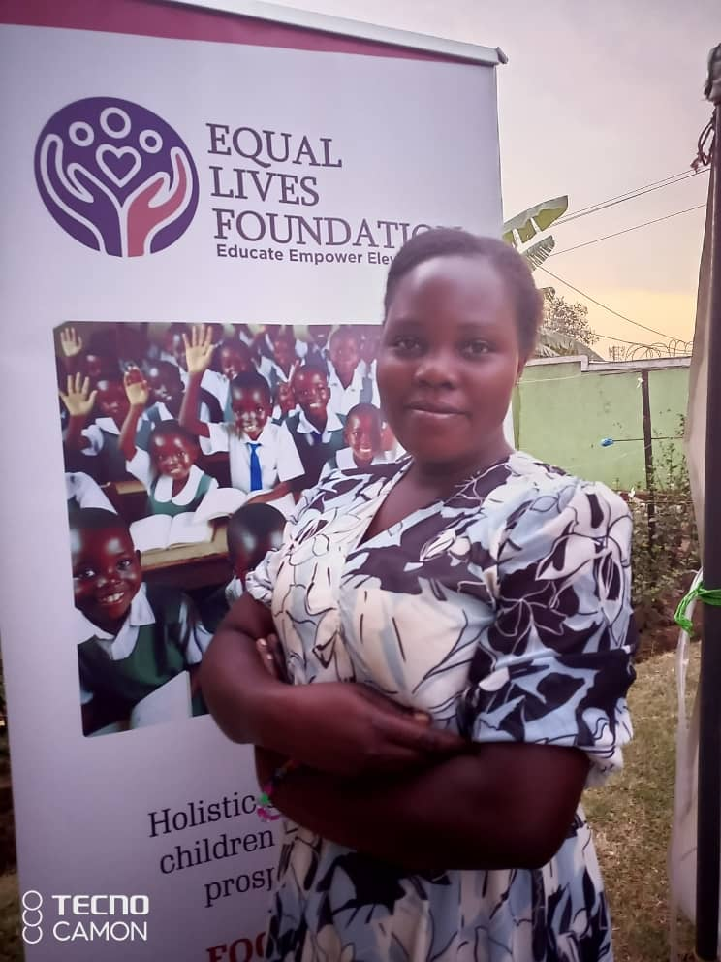
"A woman about 24-25 years old, which age bracket do we expect her man to be?"
"Is love enough signal that someone is fit for marriage?"
"I have a friend who is a Muslim. She has aborted thrice at the age of 16. How can I distance myself from her?"
"Let's say you entered a relationship and you came back and decided to leave the guy because it is not the right time. Should you still be friends with the guy or let him be?"
"If you are in a relationship and the guy says he works day in day out but you never see his money every time he says he has no money. What should you do?"
"How can you deal with a toxic person?"
"If you have been with someone for more than 3 years without meeting, then he tells you he messed up and impregnated a girl and now would like to come back to you saying it was a mistake. What do you do?"
Conclusion
The Girls Mentorship Session held on March 2, 2025, in Kireka was a resounding success. The participants were highly engaged and appreciative of the guidance provided by the mentors. The session not only addressed important topics but also encouraged the participants to reflect on their personal growth and relationships. The positive feedback and the interest in future sessions highlight the impact of such mentorship programs in empowering young women. Moving forward, incorporating the suggested topics and continuing to provide a supportive and interactive environment will further enhance the effectiveness of these sessions.

