Using Machine Learning to Identify C. elegans in Images by Life Stages
Students: Anshul Rastogi and Garima Rastogi
Mentors: Dr. Alyson Michael, PhD; Dr. Kelly Salmon, PhD; and Dr. Peter Faletra, PhD

Abstract
Caenorhabditis elegans is a prime model organism for studies. However, counting C. elegans in their various life stages for research is a tedious task. We intend to create a program that can automate this process of tallying C. elegans by life stage with machine learning. This program is decomposed into two neural networks: Model 1, which is an object detector that will recognize hatched C. elegans and C. elegans eggs in an image and send the identified images of the former to the following model, and Model 2, which will receive the distilled images from Model 1 and group them by life stage into one of three groups: L1 and L2, L3 and L4, and adult. To train Model 1, images were taken with the camera of an iPhone 6s over an ocular lens of a stereo microscope set at various arbitrary magnifications. Images were annotated for object detection with Roboflow and their custom YOLOv5 object detection model was trained for 400 epochs with a batch size of 16. At the end of the training, precision on the validation dataset reached approximately 0.9, while recall reached approximately 0.75. Model 2 is a sequential image classifier made with Tensorflow Keras, and has already been trained successfully on a test dataset of stuffed C. elegans plush from Giant Microbes. Model 2 is yet to be trained on the actual dataset.

Introduction
Caenorhabditis elegans is a leading model organism in biological research. This microscopic nematode’s short lifespan, inexpensive sustainment cost, and numerous evolutionarily conserved pathways have led to its presence in laboratories worldwide. Today, the C. elegans genome and nervous system are entirely mapped, and thousands of strains of this species are maintained [6].

Research with C. elegans often involves manually counting and categorizing these nematodes on agar medium in their various life stages. The collection of this data is tedious, demanding several hours from scientists as they count C. elegans through a microscope. Collectively, the task of counting C. elegans alone accounts for thousands of hours from researchers thus far.

In this paper, our progress in creating a machine learning-based program to automate the process of tallying C. elegans by life stage is presented. C. elegans start as an egg, and then have four primary larvae life stages — L1, L2, L3, and L4, in order — before the reproductive adult stage is reached. These life stages are illustrated in Figure 1 below:
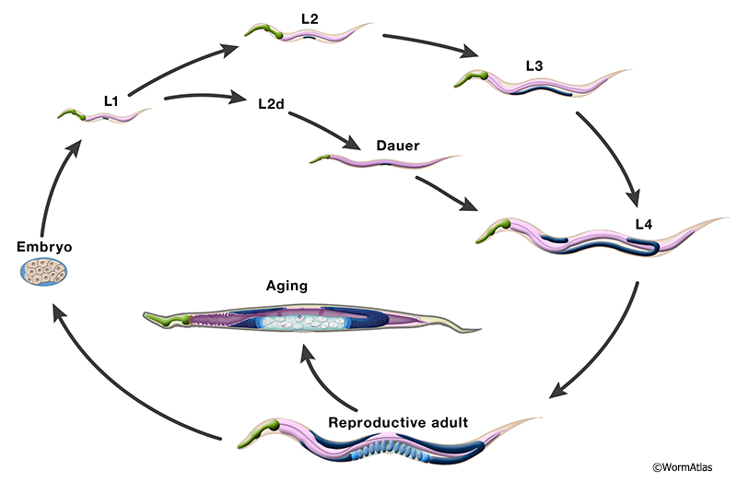
Figure 1. A depiction of C. elegans life cycle [3]. The life stages of interest are the egg (“Embryo”), L1, L2, L3, L4, and adult (both reproductive and aging).

The end goal is to be able to feed the program images and receive a count of C. elegans in each of the following four categories: eggs, L1 and L2, L3 and L4, and adult. Although other life stages, such as the dauer stage, exist, they are rare and are therefore not among the the four aforementioned groups.

Software to automate the counting of C. elegans has been created before. Automated Wormscan [1], for instance, uses movement in video to detect hatched C. elegans without the use of machine learning. The Lifespan Machine [2] counts C. elegans to determine their age and therefore aid with aging research involving the nematode. Neither software, however, can categorize C. elegans by life stage. We hope that our progress — as detailed in this paper — will allow us to eventually create a program that can count the C. elegans by life stage as well.

Machine learning was selected for this task as programming a solution by hand would require the programmer(s) to know or determine the algorithm for processing an image appropriately to identify C. elegans in images and identify their life stage. The rules for such an algorithm would be extremely difficult to determine due to the sheer variability possible in such images — C. elegans in the image may be at various angles, or there may be debris in the medium, for instance. Computer vision neural networks, however, can discover these rules through training, where they alter the weights of the filters in their layers after each iteration of the training dataset, or epoch.

Specifically, neural networks are comprised of operations called neurons, which each perform operations on data. These neurons are weighted, which determines how they affect the data passed through them. These weights adjust as the neural network trains to make the neural network better match the correct output for a given input.

The process for training a neural network model is described in the Methods section below.

Methods
Our goal was chosen to be achieved by splitting our project into two machine learning models.
- Model 1: This is a YOLOv5 object detector that identifies the hatched C. elegans and eggs in the image. The eventual goal is for the program to be able to identify and record the number of eggs, while the identified C. elegans will be passed to Model 2 as individual images.
- Model 2: This is an image classifier that is going to be trained to take the C. elegans images produced by Model 1 and classify each image into one of three groups, all labelled by life stage - L1 and L2, L3 and L4, and adult.

To train models like these, a training dataset is required. Such a dataset needs to be manually annotated, meaning that the model, when training, receives both the training images and their correct corresponding outputs (the image’s annotations). Training consists of epochs; one epoch is a model’s iteration over the annotated training dataset. During an epoch, the model adjusts the weights of its neurons so that its outputs on the training images better match the correct corresponding outputs.

I. Model 1
Collecting Images
To construct Model 1, images were first collected for training and testing the model. The camera of an iPhone 6s smartphone over one ocular lens of a stereo microscope at various magnifications was used to take pictures of petri dishes with wild-type C. elegans. Videos were also recorded and online software, such as ezgif.com, was used to extract the frames to jpegs, therefore allowing us to more easily gather large quantities of images.

Annotating Images
To annotate the images, they were first stored as an Object Detection dataset type on Roboflow. Their annotation tools were used with two classes of objects created — Class 0, which translates to the “Eggs” class, and Class 1, which translates to the “Worms” (hatched C. elegans, constituting all relevant life stages from L1 to adult) class. A total of 769 images were annotated. Across the images, there were a total of 1,324 “Eggs” and 5,406 “Worms” annotated. The images were not augmented prior to training as the object detection model we used for Model 1, YOLOv5, already augments the images itself. A 71-20-9 Training-Validation-Testing split was used for the images, meaning that 71% of the images (545) were arbitrarily assigned by Roboflow to a training dataset, 20% (152) to a validation dataset, and 9% (73) to a testing dataset.
Some images from after our annotation process are displayed in Figure 2
(Images 1 - 6). Class 0 has lime-green bounding box annotations, whereas Class 1 has annotations.

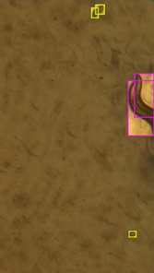
Worm track example
Eggs
Worms
Debris
Image 1. An annotated image with worm tracks. Note that the eggs and worms, as well as examples of a worm tracks and debris, are indicated in the left image by added colored arrows and corresponding text boxes for the reader’s convenience. However, the model trained with the image on the right.

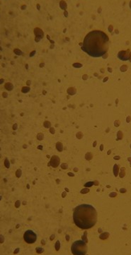
Image 2. A null image with bubbles (the oil-like droplets in the image).

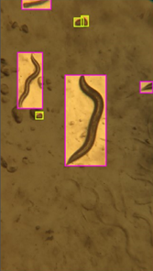
Bubbles
Debris
Image 3. An annotated image with bubbles. In the doctored image on the left, some of the bubbles are indicated by the white arrows, and some of the debris particles are indicated by the black arrows. Note that the model trained on the image to the right, not the one on the left.

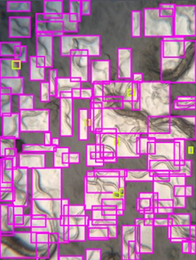
Image 4. An annotated image with multiple worms and eggs.

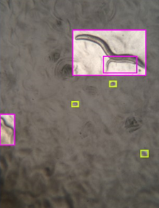
Debris
Image 5. An annotated image with worm tracks, bubbles, and noticeable debris, some of which is pointed out in the doctored image on the left. Note that the model trained on the image to the right, not the left.

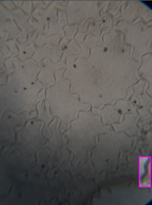
Debris
Worm tracks
Image 6. An annotated image with worm tracks, debris, and a worm. In the edited image on the left, some debris particles are indicated by the white arrows and corresponding text box, while some work tracks are indicated by the yellow arrows and corresponding text box. Note that the model trained on the image to the right, not the left.

Petri dishes may have bubbles or debris in the medium, such as the ones visible in images 2, 3, and 6, which can resemble eggs. Therefore, images displaying these aberrations were added to the dataset to ensure that the model could be trained to make the distinction between eggs and bubbles. Similarly, pictures like images 1 and 2 served to help train the model to differentiate between worm tracks and hatched C. elegans. Additionally, null images such as image 2, being those with neither eggs nor worms, were a significant subset of the images Model 1 trained on as it taught the computer that not all images need to have eggs and/or worms.

Training the Model
To train the neural network, the object detection model YOLOv5 [4] was used. Specifically, the export code for our Roboflow-annotated dataset was used in a custom YOLOv5 model set up by Roboflow [5].

The model was trained on our dataset for 400 epochs with 16 images per batch. The set-up model was accompanied by a TensorBoard that displayed metrics of our model over the epochs as graphs which are displayed in the Results section.

II. Model 2
To construct Model 2, a sequential image classifier was coded using Tensorflow Keras. The layers are as follows, in order:

128 3x3 2D Convolutional Filters with Rectified Linear Unit Activation
2x2 Max-Pooling Layer
256 3x3 2D Convolutional Filters with Rectified Linear Unit Activation
2x2 Max-Pooling Layer
A Flatten Layer
A 512-neuron Dense Layer with Rectified Linear Unit Activation
A 1-neuron Dense Layer with Sigmoid Activation

The model was successfully trained on a dummy dataset comprised of a stuffed C. elegans plush from Giant Worms against various backgrounds. The training was done for only 5 epochs and reached an accuracy of 50.0% on the training data and 50.0% on the validation set; the training was done only to ensure that the model could be trained.

Our planned future work with this model is discussed in the Discussion section below.

Results
I. TensorBoard Metrics
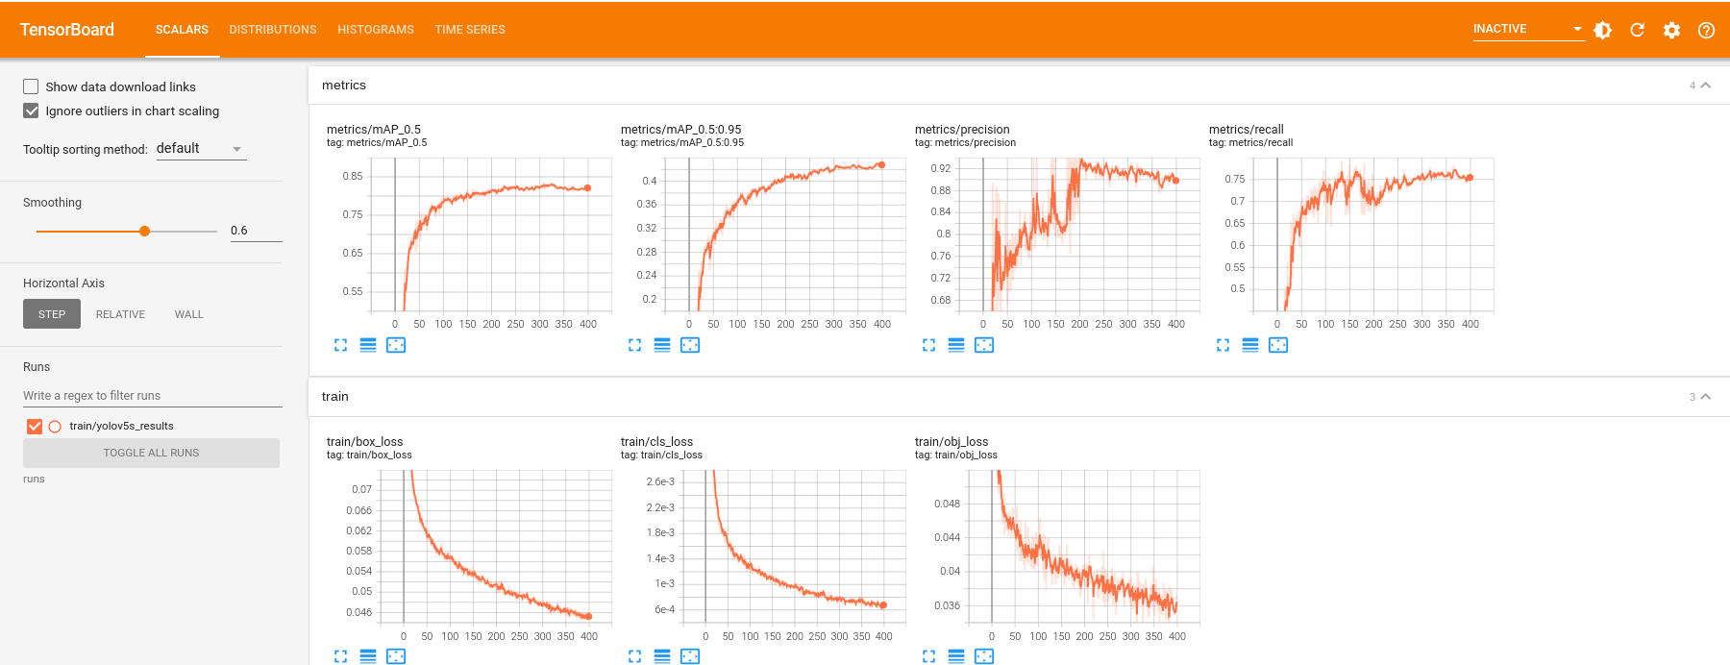
Figure 3. The model’s TensorBoard graph (epoch vs. precision) for the precision metric, where
precision = (true positive)/(true positive + false positive) [detailed in the Discussion section].
Figure 4. The model’s TensorBoard graph (epoch vs. recall) for the recall metric, where
recall = (true positive)/(true positive + false negative) [detailed in the Discussion section].
Figure 5. The model’s loss on the bounding boxes (leftmost), bounding boxes’ classifications (middle), and objective loss (rightmost).

II. Trained Model 1’s Predictions on the Test Set
Below are several selected images displaying Model 1’s bounding box predictions on images from the testing set following training. These are not necessarily representative of the model’s performance or efficacy as a whole.

The numbers above each box are the class (0 or 1, corresponding to eggs or worms, respectively), and the confidence, respectively. For example, in image 7, the “1 0.94” above the left worm’s bounding box means that the program identified the boxed image to belong to Class 1 (“Worm”) and that the model is 94% confident in its identification. Similarly, if the numbers “0 0.80” display above a bounding box, the model is 80% confident that the bounded image is an egg. Additionally, the bounding box colors correspond to the class - blue bounding boxes correspond to Class 1, and pink bounding boxes correspond to Class 0.
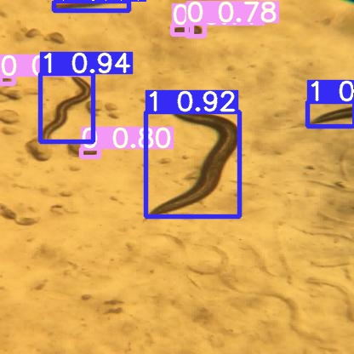
Image 7. Prediction on an image with bubbles and eggs.

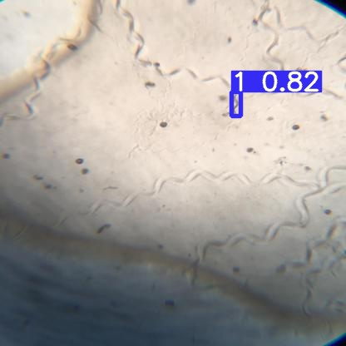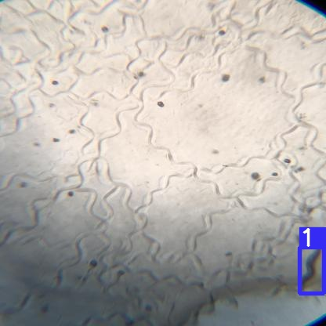
Image 8. Model 1’s predictions on images with only one worm but multiple worm tracks and bubbles. The model accurately identifies the only worm in each image.

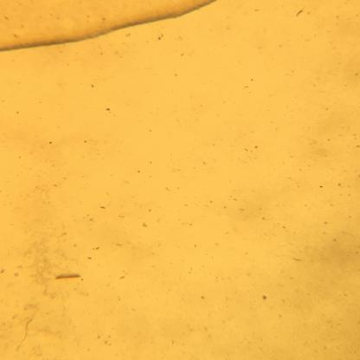
E. coli lawn
Image 9. Prediction on a null image, but with an edge of an E. coli lawn. Note the E. coli lawn was labelled post-prediction on the left image; the image for the prediction originally looked like the one to the right.

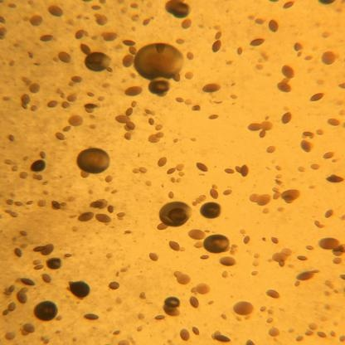
Image 10. Prediction on a null image with egg-like bubbles.

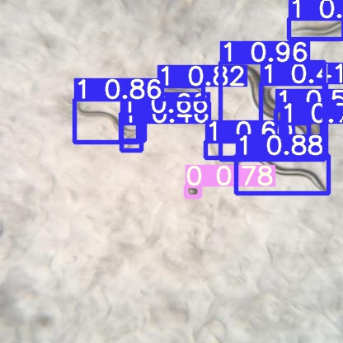
Image 11. Prediction on an image with no bubbles and no worm tracks.

Discussion
TensorBoard Metrics
The precision metric (displayed in Figure 3) is equal to the value (true positive)/(true positive + false positive). In context, “true positive” is the state where the model accurately identifies a worm as a worm or an egg as an egg. As this means that our model is doing the right thing, we want to maximize true positives. ‘False positive’ is the state where the model incorrectly identifies an object/blemish as a worm or an egg, such as when a bubble in the agar is labelled as an egg. Since this means that our model erred, we want to minimize false positives. Thus, we want the precision metric to reach a value as close to 1 as possible. Our model, as shown in Figure 3, reached a precision of approximately 0.90 by the end of 400 epochs. This suggests that there are few false positives - approximately 1 in 10 - which is a pretty good statistic given the number of images we had to work with. To put it in perspective, most well-written models with very high precision are usually trained on thousands of images. This suggests that either YOLOv5 yielded a lot of augmented images or our model was overfit - a source of error we will discuss later.

The recall metric shows the graph of the value (true positive)/(true positive + false negative) as it changes. As explained in the previous paragraph, we want to maximize true positives. ‘False negative’ is the state where the model incorrectly ignores a worm or an egg in an image by perhaps mistaking it for a bubble or a worm track or just missing it completely. Since a false negative occurs in a scenario where the model errs, we want to minimize false negatives. Therefore, we want the recall metric to reach a value as close to 1 as possible. Our model, as shown in Figure 4, reached a recall of approximately 0.75 by the end of 400 epochs. This is a relatively low number and definitely needs a significant improvement. It suggests that there are many false negatives, approximately 1 in 4 identifications being a false negative. The recall and precision metrics suggest that our model is more likely to miss a worm or an egg than incorrectly identify an object as a worm or an egg.

Finally, as loss is the measure of the cumulative error of a model, the goal when training a model is to minimize loss. In Figure 5, we see that both the bounding boxes’ and objective’s losses reach a value close to 0.04, which is reasonably low and will go down as we work to improve precision and recall. The bounding boxes’ classifications’ loss is well below zero. This value is reasonable, as the two possible classifications are worms and eggs, which are quite distinct from each other.

Images
In image 7, the model is presented with an image with worms, eggs, and bubbles. Based on the confidence level of the machine, indicated by the decimal number beside the class number, we infer that the model is quite confident when identifying worms. However, with eggs, the confidence level is a lot closer to the 70% - 80% range, and the prediction neglects the egg indicated in image 12 (below), which is an example of the false negative discussed above:
Missed egg
Image 12. The model’s prediction on an image with a missed egg labeled. Note the labelling in black was done post-prediction.

This suggests that the program needs to train on more images with both bubbles and eggs to learn how to better differentiate between the two structures.

In image 8, the model is presented with two images with worms, worm tracks, and bubbles. It accurately identifies the singular worm in each image. The confidence for the C. elegans to the right isn’t visible, but the one on the left is 82%, suggesting that our model needs more training on images with worm tracks and worms.

In image 9, the model is presented with a null image that has the edge of an E. coli lawn. The model is trained on images like this one for two reasons. Firstly, it teaches the model that there can be images with neither worms nor eggs. Secondly, it teaches the model to not recognize the edge of an E. coli lawn as a worm. Since this was a null image, we do not have any confidence levels to analyze here.

In image 10, the model is presented with a null image that has numerous egg-like bubbles. As the image has no bounding boxes marked, we can infer that the model accurately determined that the bubbles are not eggs. Again, this image was a null, thus we do not have any confidence levels to analyze here.

In image 11, the model is given an image with no bubbles and no worm tracks. It accurately identified all present worms and eggs, with the confidence for worms ranging between 80% and 96%, and the confidence for the single egg being 78%. Just as in the other images with eggs that the model predicted on, the model’s confidence is around 80%, which suggests that the model isn’t well trained on identifying eggs, or that it isn’t always very confident when it marks an egg as an egg and leaves a bubble unmarked.

Potential Sources of Error
A potential source of error is overfitting, which occurs when a model is too well-trained on an image or a dataset. In our case, the images we gathered tended to be grouped such that there would be anywhere from 25 to 75 frames of the same area on the same plate, with every photograph taken in intervals of half a second to one second. Thus, there were 10 to 30 different groups of similar images that the model may have understood very well due to the training set. To fix this issue, some images from the current training set must be removed and a greater variation must be added to the set to improve the model’s ability to generalize.

Additionally, during the annotation stage, some human error may have been present. For example, some eggs might be mistaken for bubbles and vice versa, as the annotation was done. This error may have been what was reflected in image 7.

Further Work
Another thousand images have been gathered for Model 1. These images need to be annotated to be useful for training the model. Additionally, Model 2 remains to be trained. For this, images of individual worms in their various life stages must be gathered. The current plan for this step is to use a program on the annotated images from Model 1’s training set to extract the individual worms as their bounding boxes and sort through them manually.

Additionally, in image 7, the model didn’t mark an egg as an egg and perhaps mistook it for a bubble. Combined with the analysis of the recall metric, it can be inferred that this may have been caused by the issue of eggs being underrepresented in the training data. Thus, more images with eggs are necessary, as well as images with bubbles to help the model learn the difference between the two better.

Finally, the images gathered were of the wild type C. elegans. Another direction to take this project could be to train the model on mutants as well, allowing for the model to recognize a variety of C. elegans strains, instead of just one.

References
- Puckering, Timothy, et al. “Automated Wormscan.” URL <https://www.ncbi.nlm.nih.gov/pmc/articles/PMC5365223/>
- Stroustrup, Nicholas et al. “The Caenorhabditis elegans Lifespan Machine.” Nature methods vol. 10,7 (2013): 665—70. doi:10.1038/nmeth.2475
- Herndon, L.A.; Wolkow, C.A.; Driscoll, M., and Hall, D.H. 2018. Introduction to Aging in C. elegans. In WormAtlas. doi:10.3908/wormatlas.8.4
- Jocher, G. Last Updated in 2021. YOLOv5 in PyTorch. Github; <https://github.com/ultralytics/yolov5/>
- Nelson, J.; Solawetz, J. “How to Train YOLOv5 On a Custom Dataset.” Roboflow 10th of June, 2020. <https://blog.roboflow.com/how—to—train—yolov5—on—a—custom—dataset/>
- Kosinski, R. A.; Zaremba, M. (2007) “Dynamics of the Model of the Caenorhabditis Elegans Neural Network”. Acta Physica Polonics B. 38(6):2201. Bibcode:2007AcPPB..382201K

