Testing 10 Microsatellite Primers on Cyp. arietinum
Can primers originally developed for Cyp. tibeticum work in a similar species?

Liam Markey
St. Johnsbury Academy
Abstract:

Cypripedium arietinum, also known as the ram’s head lady’s slipper, is distributed in small populations among regions of the northern US and northeastern Canada. Endangered in New Hampshire as well as in Vermont, populations of these plants across the two states are small and sparse (North American Orchid Conservation Center, 2021). The genetic diversity of any of these local populations is currently unknown. Genetic diversity, the amount of genetic variance across individual plants, allows a population to better respond to an adverse event - thus, it is important to assess the genetic diversity of a population to ensure their survival. To do this, a specific region of the plant genome called a microsatellite can be targeted for copying using DNA primers, which act as parameters for the region. The objective of this experiment has been to test 10 microsatellite primers originally developed for Cyp. tibeticum (Li et al., 2017) in order to gauge their effectiveness with the ram’s head species. The most effective was primer M289, but further testing is needed to confirm the results for the other primers.

Introduction:

A limited number of suitable habitats and variables in the ram’s head lady’s slipper (Cypripedium arietinum) reproductive cycle places this species at particular risk for regional extinction. Ram’s head reproduces, like other slipper orchids, both through seeds and vegetative reproduction. Seeds offer the genetic diversity of meiotic genetic recombination that vegetative reproduction does not, but the development of an embryo from seed to germination, in vitro and in the wild, is hypothesized to be a long and difficult process. By comparison to other local lady’s slippers like Cyp. parviflorum, Cyp. arietinum also produces far smaller seeds with far fewer seeds per seed pod. Additionally, axenic seed culture of the ram’s head has yet to be successful, yet it has succeeded for both Cyp. reginae and Cyp. parviflorum. Axenic seed culture research is ongoing at the NHAS Lab.
Limited genetic diversity may be a problem for the ram’s head populations across Vermont and New Hampshire. Genetic diversity is best studied in these plants by analyzing microsatellite regions. These regions of DNA do not appear to affect plant function, and therefore acquire mutations more readily than more conserved regions of DNA (i.e., more important genes like those controlling root growth and carbon fixation systems). This makes microsatellites ideal targets for genetic analysis. To effectively target the microsatellite regions for copying and eventual analysis, microsatellite primers, the sequences which set parameters for the necessary region of DNA to be copied, need to be identified and confirmed. Control primers are also important because they can be used as a more consistent result to compare with the microsatellite results. A preliminary round of amplification showed that the most effective control tested was a chloroplast primer developed for universal use. (Taberlet et al., 1991)
To test these primers, genomic DNA from raw plant tissue samples was first isolated during DNA extraction, Polymerase Chain Reaction was performed to test the microsatellite primers on the target region(s), gel electrophoresis showed whether the primers worked, and finally, PCR purification was performed to purify the PCR product for DNA sequencing. After several rounds of PCR, it was clear that many of these primers generated more than one band. In this case, a normal purification process would mix all the generated bands – and multiple DNA fragments cannot all be effectively sequenced at the same time. Thus, to separate them, individual bands were extracted directly from the gel and purified in a process called gel excision. The purified products were sent to Eton Biosciences for Sanger sequencing, and the resulting sequences were analyzed using NCBI BLAST to confirm the amplified region looks similar to the Cyp. tibeticum microsatellite sequence.

Methods:

DNA extraction:

DNA extraction was performed using the New England Biolabs (NEB) Genomic DNA Extraction Kit, following kit protocol, except a micropestle was used to crush the raw sample and all incubations were performed using a water bath. After the DNA extraction process was complete, a spectrophotometer was used determine whether the DNA concentration of each sample was high enough to be used.

PCR:

PCR was performed using 50µL single reactions, with reagent amounts per tube of 25µL NEB Master Mix, 2µL forward primer, 2µL reverse primer, 5µL DNA, and 16µL molecular grade water. Ultimate Mixes were created to combine constant ingredients into one place, then pipetting 46µL of the mix into each tube so as to save pipetting steps. Primer mixes (forward/reverse primer) were created for each primer and 4µL was pipetted into each tube so as to save pipetting steps. The tubes were mixed and labeled, and the thermocycler program was set for: a 95.0 ℃ initial denaturation for 120 seconds; 35 cycles of: denaturation at 95.0 ℃ for 30 seconds, annealing at 49.0 ℃ for 30 seconds, and extension at 68.0 ℃ for 30 seconds; then a 68.0 ℃ final extension for 60 seconds.

Gel electrophoresis:

Gel electrophoresis was performed using a 2% gel and a blueGel electrophoresis system. A microwave was used to heat up the gel ingredients and 2µL GelGreen DNA stain was added once mixture was comfortable to touch. Gel was covered from light and allowed to set for ≈15 minutes. After cooling, the gel tray was moved to the buffer chamber of the blueGel, the gel covered with TBE buffer, and 6µL of 100bp ladder was loaded on either side of the gel along with 10µL of each PCR sample. The blueGel was run for ≈30min, under black box cover to minimize light exposure. Gel results were documented using a phone camera and the black box cover.

PCR Purification:

PCR purification was performed for PCR products that were shown to generate single bands. The NEB PCR and DNA Cleanup Kit was used, following kit protocol. DNA was eluted into 15µL of elution buffer.

Gel Excision:

Gel excision, or gel extraction, was performed for PCR products that were shown to generate multiple bands. Bands were cut out of a gel. The NEB Gel Extraction Kit was used, following kit protocol. All incubations were performed using a water bath.

DNA Sequencing:

Purified PCR reactions and appropriate forward primer were mailed to the Eton Biosciences lab in Boston, MA for DNA sequencing. Returned chromatograms were analyzed using FinchTV (Geospiza Research Team, 2012). DNA sequence alignments were performed using Clustal Omega (Madiera et al., 2019).

Materials:

- Centrifuge
- Vortex
- Water bath
- P10, P20, P200, P1000 micropipettes
- P10, P20, P200, P1000 micropipette filter tips
- blueGel® gel electrophoresis system
- miniPCR® thermal cycler
- NanoDrop ND-1000 spectrophotometer
- 0.2mL PCR tubes
- 0.5mL tubes
- 1.5mL tubes
- 2 Cyp. arietinum raw samples the same plant, from the leaf
- NEB Monarch gDNA Extraction Kit
- NEB Monarch PCR & DNA Cleanup Kit
- NEB OneTaq 2X Master Mix with Standard Buffer
- NEB OneTaq 2X Master Mix with GC Buffer
- Primers – M150, M164, M172, M182, M209, M289, M294, M372, M401, M576 (Li et al., 2017)
- Control primer – universal chloroplast (Taberlet et al., 1991)
- Sterile water
- Digital scale sensitive to 0.1 grams
- Weigh boats
- Agarose
- Spatula
- Graduated cylinder
- TBE buffer
- 250mL Erlenmeyer flask
- Tissues
- Graduated cylinder
- Microwave
- GelGreen® DNA stain

Results:

Primer | Works (gel)? | Consistent? | Generates multiple bands?
M150 | Yes | No | Yes
M164 | Yes | Unknown | Sometimes
M172 | Yes | Unknown | Sometimes
M182 | Yes | No | No
M209 | Yes | Unknown | Sometimes
M289 | Yes | Yes | No
M294 | Yes | No | Sometimes
M372 | Yes | No | Yes
M401 | No | Yes | N/A
M576 | No | Yes | N/A
Table 1. Summary of results.

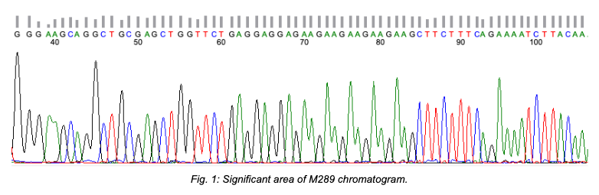

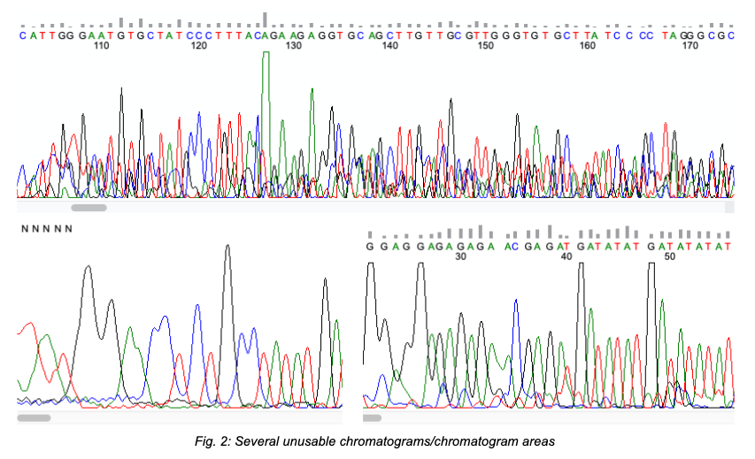

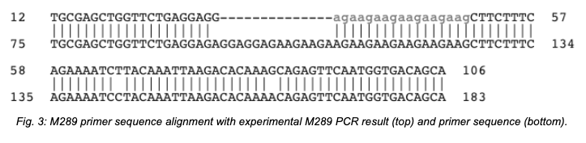

Discussion:

(Note: After 3 “rounds” of PCR with NEB standard buffer master mix, another 2 rounds were performed with NEB GC buffer master mix instead. Not enough testing has been performed with GC buffer to draw definitive conclusions about primer effectiveness. Some primers may have been more effective with GC, but more testing is necessary.)

A preliminary round of amplification showed that the most effective control tested was a chloroplast primer developed for universal use. (Taberlet et al., 1991) Primer M289 consistently worked across the standard and GC buffer reactions. It always generated a single band and seems to have been the most promising of all the primers tested. Primers M401 and M476 consistently failed to generate DNA bands, but the majority of other primers require further testing to confirm results. M164, M172, M209, and M294 sometimes each? generated multiple bands across the standard and GC buffer results. Notably, each primer generated bands with varying intensities across both reactions. M150 and M372 consistently generated multiple bands across the standard and GC buffer results, but M182 generated a single band and was only effective in the GC buffer reaction.

PCR products from M289, M164, M172, and M150 were purified and sent for sequencing. The resulting chromatogram from M289 (Fig. 1) was clear with little background noise. When compared with other sequences using the NCBI BLAST search tool, the product sequence matched the original Cyp. tibeticum sequence deposited by Li et al. (2017) almost perfectly (Fig. 3). However, resulting chromatograms from other primers were less promising (Fig. 2). M164 and M172 sequences did not match anything in BLAST, so the sequences were aligned to the Cyp. tibeticum sequences using CLUSTAL Omega (Madiera et al., 2019). Neither sequence matched the primer sequences very well, although M172 aligned well at a region ≈20 bp long at the end of the sequence, suggesting the microsatellite regions may have diverged greatly between the two species. Chromatograms from the four individual bands generated by M150 were very different from one another. Band 2 generated an unusable chromatogram, bands 3 and 4 generated messy chromatograms with a large amount of background noise, whereas the chromatogram from band 1 was much clearer. BLAST results from M150 chromatograms isolated usable areas, and manual alignments with the original sequences showed varying results - The usable area from Band 1 did not match the original sequence at all, but bands 3 and 4 both showed better matches towards the end of the sequence at a region ≈20 bp long.

Overall, further testing is needed to confirm the results for many of the primers, but M289 was most effective across all stages of analysis. This work will allow for future genetic diversity work and analysis with this primer.

References:

"Cypripedium arietinum: Ram's Head Lady's Slipper." Go Orchids, North American Orchid
Conservation Center, 2021, goorchids.northamericanorchidcenter.org/species/cyp ripedium/arietinum/. Accessed August 2021.

Geospiza Research Team. FinchTV. Version 1.5.0, 2012.

Li, Jing, et al. "Development of microsatellite markers for Cypripedium tibeticum (Orchidaceae)
and their applicability to two related species." Applications in Plant Sciences, vol. 5, no. 12, 21 Dec. 2017. https://doi.org/10.3732/apps.1700084. Accessed July 2021.

Madiera, F., et al. "The EMBL-EBI search and sequence analysis tools APIs in 2019." Nucleic
Acids Research, https://doi.org/10.1093/nar/gkz268. Accessed July 2021.

Taberlet, P., et al. "Universal primers for amplification of three non-coding regions of
chloroplast DNA." Plant Molecular Biology, https://doi.org/10.1007/BF00037152. Accessed July 2021.

Altschul, S.F., et al. "Basic local alignment search tool." Journal of Molecular Biology,
https://doi.org/10.1016/S0022-2836(05)80360-2. Accessed August 2021.

