Evaluating the relationships between wildfires and drought using machine learning
Angela Chen
North Carolina School of Science and Mathematics, 1219 Broad St, Durham, NC 27705
Phone: 919-656-6626, Email: chen23a@ncssm.edu

Abstract
In recent years, many destructive wildfires have plagued California. Extreme fire conditions, such as drought, have been taking place simultaneously with many of these wildfires. In this study, the relationship was quantified between the self-calibrated Palmer Drought Severity Index (sc-PDSI) and wildfire burn area (BA) in California during the time of 1984-2018, and results indicate that the drought is a significant driver of wildfire BA in California. The methods of wavelet transform coherence, cross wavelet transform, and continuous wavelet transform were used in conjunction with machine learning algorithms to analyze and establish the relationship between sc-PDSI and wildfire BA. This study concludes that there was a statistically significant relationship between wildfire BA and sc-PDSI in 6-8-, 5-6-, and 2–3-year bands during the study period, during which sc-PDSI was one of the main drivers for wildfire BA. In addition, machine learning was utilized in conjunction with the Quantile Regression Model (QRM) in order to quantify the relationship between sc-PDSI and wildfire BA in California. The findings provide a promising direction to improved prediction of wildfire BA which is significant in the aid of damage control of wildfires in California, potentially leading to fewer burned acres, less economic damage, and fewer casualties.
Keywords: Wildfire, Drought, Burn Area, Machine Learning, Wavelet Analysis, Quantile Regression Model, PDSI, Forecast Model, California
Summary text:
In this study, the relationship was quantified between the self-calibrated Palmer Drought Severity Index and wildfire burn area in California during the time period 1984-2018. The results indicate that the drought was one of the main drivers for wildfire burn area in California. The results can be used to aid damage control of future wildfires in California.
Introduction
In recent years, the number of wildfires has increased, and wildfires have spread more rapidly, becoming more difficult to control (Thompson et al. 2015; Brainard 2020). Especially in the state of California in the United States, wildfires have been devastating, coinciding with extreme fire weather conditions: anomalously warm conditions and the late arrival of autumn precipitation (Goss et al. 2020). These deadly fires have caused over 150 fatalities, the burning of over 30,000 structures, and the scorching of over 1.2 million hectares (Keyser et al. 2019). In 2019 alone, California fires cost over $163 million to put out, and the total economic damage was over $80 billion (Abatzoglou et al. 2020). Additionally, millions across the state were exposed to wildfire smoke, resulting in public health emergencies, degraded air quality, and the closing of many schools and facilities (Mull 2018). California critically needs quantitative assessments and predictions that will reshape its approach to its current crisis, as experts say current immediate answers are futile (Abatzoglou et al. 2020). Therefore, it is crucial for us to examine climate and other factors that potentially affect wildfires but are understood to a limited extent in the literature. A critical example of such is the possible relationships between drought, climate, and wildfires (Taufik et al. 2017).
Recent studies have worked to determine the significance of climate in relation to wildfires. Climate change has increased the risk and extent of wildfires in the Western United States, as well as the dryness of forest fuels, which is organic matter that burns and spreads wildfires (Riley et al. 2013; Addington et al. 2015, Markovic et al. 2016; Williams et al. 2018; Di Virgilio et al. 2019; Keyser et al. 2019; Goss et al. 2020). The warmer and drier conditions caused by climate changes lead to increased drought, longer fire seasons, and larger wildfires that are much more difficult to put out (Heyerdahl et al. 2008; Stavros et al. 2014; Harvey 2016). Climate projections indicate that, for much of the Western United States, an annual increase of 1 degree Celsius can cause the median burned area per year to increase by as much as 600% in some forest types (Abatzoglou et al. 2020 and Taufik et al. 2017). In addition, quantitative models that incorporate climate data have generated far better predictions of area burned than models which did not (Riley et al. 2013). Therefore, it’s clear to see that the relationship between fire occurrence and drought has important implications for wildfire prediction.
Obtaining further information about the relationship between wildfires and drought is likely to be extremely beneficial to our knowledge of wildfire prevention and control. Numerous studies have provided substantial insight into the impacts of climates on wildfire (Starvros et al. 2014; Chaparro et al. 2016; Silva et al. 2020). Riley et al. (2013) evaluated correlations between drought and fire-danger-rating indices to determine which had the strongest relationships with large fire occurrences in the western USA for 1984–2008. Goss et al. (2020) concluded that the meteorological factors enable extreme autumn wildfires in California by the end of this century based on climate model simulations. Additional studies have found that climate forcing has strong impacts on extreme fire, and half of the increase in wildfires in the western U.S. are due to warm weather (Kirchmeier-Young et al. 2019; Abatzoglou et al. 2020; Silva et al. 2020)
However, there are still many current problems within studies of wildfires and climate. An important one is that much previous work has been conducted at large spatial scales with annual time steps and relatively short study periods (Moritz et al. 2012; Swetnam et al. 2016). For example, Scasta et al. (2017) studied droughts and wildfire in Western U.S. from 2003 to 2015 using an annual time scale. However, daily and monthly fluctuations in weather, which are strong determinants of fire ignition and spread, are subsequently overlooked at the annual level. In addition, a long period with a large enough sample size of fires is significant for statistical analysis. To date, there is limited understanding of the impacts of monthly droughts and other climate variables on wildfires, despite the possible paramount knowledge that can be gained. In this study, long term, high spatial, and temporal scales datasets were utilized.
The second challenge is that although some previous works have developed relationships between wildfire with drought, the studies characterized drought using only precipitation, soil moisture, or groundwater tables (Williams et al. 2013; Dennison et al. 2014; Westerling 2016; Scastaa et al. 2016; Taufik et al. 2017; Keyser et al. 2019; Abatzoglou et al. 2020). For example, Taufik et al. (2017) studied the relationship between hydrological drought and wildfire in Borneo; however, the study only used groundwater dynamics to characterize drought. In Scasta et al. (2017)’s studies, the relationship between precipitation (moisture conditions) and wildfire was developed. However, the impact of combined climate parameters on fires is also critical, yet was not examined. In this study, a self-calibrated Palmer Drought Severity Index (sc-PDSI) was used. The PDSI (Palmer, 1965) is a well-known drought index that uses calculations based on temperature, soil moisture, precipitation, evaporation, and other climate characters. sc-PDSI was then created as a key drought index that improves the performance of the traditional PDSI by dynamically replacing the averaged empirical factors with weighted climatic characteristics, which brings satisfactory results between diverse climatological regions (Heyerdahl et al. 2008). In conclusion, sc-PDSI is a stronger explanatory factor to characterize drought than utilizing just precipitation, soil moisture, or the groundwater tables as done in previous studies (Dennison et al. 2014; Westerling 2016; Abatzoglou et al. 2020).
The third challenge in wildfire studies is quantifying the relationship between drought and wildfires, which is significant for wildfire-prediction. Therefore, if mastered, quantifying the relationship between drought and wildfires could potentially save hundreds of lives and billions of dollars, as well as reduce harmful impacts on our environment. However, the majority of wildfire-prediction studies have a much larger percentage for error due to their analysis methods (Moritz et al. 2012; Swetnam et al. 2016; Westerling 2016). For example, Margolis et al. (2017) used cluster group analysis which can easily contain biased data within cluster groups. Riley et al. (2013) evaluated the relationship between drought and wildfire using the linear regression method in which the extreme events were lacking. In this study, the challenge of quantifying the relationship between drought and wildfires was addressed by improved methods. The methods include the machine learning of quantile regression, as well as the wavelet transform coherence (WTC) and cross wavelet transform (XWT) in conjunction with machine learning for classification and regression. Furthermore, the continuous wavelet transform (CWT) was utilized to generate 2-D time-frequency maps of drought and wildfire, which is a powerful approach for signal classification. The ability of the CWT to simultaneously capture steady-state and transient behavior in time-series data makes the wavelet-based time-frequency representation particularly robust when paired with machine learning.
The main research questions were: (1) How did drought affect wildfires in California from 1984 to 2018? (2) Is there a relationship between drought and wildfires? (3) How can the relationship be quantified?
To answer the three research questions, this study investigates the relationship between California droughts and wildfire burn area (BA) in a framework of machine learning: the relationship between the two variables is examined in a time-frequency domain using Wavelet Analysis. In addition, the relationship is quantified using Quantile Regression Model (QRM).

Methodology
Study Area
The state of California (Figure 1) was chosen for this study. The recent wildfires in California have garnered widespread attention with significant economic losses and human health damages. According to a recent survey conducted by Insurance Information Institute (www.iii.org), California ranks as the state with the most extreme wildfire risk in the United States. In addition, all of the top 10 costliest wildfires in U.S. history have occurred in California, causing a total loss of about 3 billion U.S. dollars (www.iii.org).
Data
Fire records (e.g., ignition date, burned acres) from 1984 to 2018 in California were found through the Monitoring Trends in Burn Severity (MTBS) program (www.mtbs.gov). The MTBS program was conducted jointly by the US Forest Service and US Geological Survey, which records the wildfire BA of large fires since 1984 based on Landsat imagery (Eidenshink et al. 2007). The MTBS datasets address some inconsistent and incomplete issues in previous records and exclude duplicated records. Fires included in the data bundles were limited to those marked as “wildfire” (total 1581 wildfires, plotted in Figure 1) and excluded 204 non-wildfires (i.e., prescribed fire, complex fire, and wildland fire use). Prescribed fire is a common forest management tool for reducing accumulating fuels, yet the purpose of the study is to evaluate the relationships between meteorological drought and natural activity, i.e., wildfire, so therefore prescribed fires should be excluded from the analysis.
The Palmer Drought Severity Index (PDSI) has been used for more than 30 years to quantify the severity of drought across different climates (Palmer 1965), and is the index most commonly used to assess drought and fire in the literature (Heyerdahl et al. 2008). The PDSI calculation is based on precipitation as well as climatic differences between locations and seasons of the year (Palmer 1965). However, there has been criticism of the PDSI over the years that the values are not comparable between diverse climatological regions, which sometimes brings unsatisfactory results, especially in the western United States (Guttman et al. 1992). Recently, sc-PDSI was created which improves the performance of the PDSI by dynamically replacing the averaged empirical constants that Palmer (1965) used with weighted climatic characteristics, and automatically calculating the duration factors (Wells et al., 2004). Therefore, sc-PDSI is used to conduct this research.
In this study, monthly sc-PDSI and climate data (precipitation and temperature) from 1984 to 2018 were obtained from the Western Regional Climate Center. The center developed the data jointly with Regional Climate Center, Desert Research Institute, National Oceanic and Atmospheric Administration, and National Center for Environmental Information.
Methodology
To answer the research questions, a quantified relationship between sc-PDSI and wildfire BA was developed in a framework of machine learning: combining wavelet analysis with quantile regression. The CWT and the XWT were utilized for examining relationships between drought and wildfire in time-frequency space. Thereafter, the Quantile Regression Model (QRM) was used to estimate the relationship between wildfire BA and sc-PDSI. This relationship between wildfire BA and sc-PDSI is a valuable platform that can lead to many new studies and tools, such as investigation of relations between wildfire and many other climatic drivers, e.g., El Niño-Southern Oscillation (ENSO), Pacific Decadal Oscillation (PDO), the Atlantic Multidecadal Oscillation (AMO), etc. which could be analyzed using a similar approach as the one put forward in this model. In addition, the results from the QRM algorithms can generate accurate predictions that can aid in the damage control of wildfires in California.
The CWT transforms a one-dimensional time series to a two-dimensional time-frequency image; simultaneously, it shows the amplitude of all periodic signals within the series, as well as how the amplitude varies with time (Wallace et al. 1993; Torrence and Compo, 1998; Torrence and Webster, 1999). The wavelet analysis tools used in the present study include CWT, XWT, and the wavelet transform coherence (WTC). The continuous wavelet transform Wn of a discrete sequence of observations x_{n} is defined as the convolution of x_{n}, with a scale s and wavelet ψ(x):
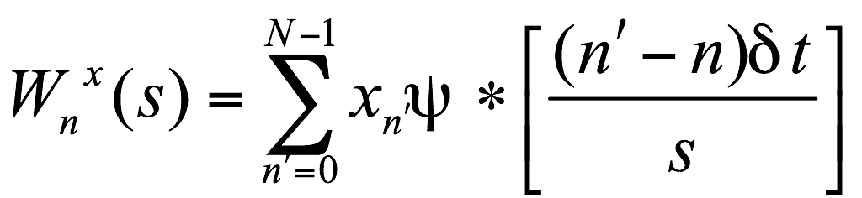 (1)
where n is the localized time index, s is the wavelet scale, δt is the time step, N is the number of points in the time series, and the asterisk indicates the complex conjugate. CWT expands time series into time frequency space and therefore one can find localized intermittent periodicities with it (Torrence and Compo, 1998).
The XWT was used to calculate coincident high common power between two time series by the expression of 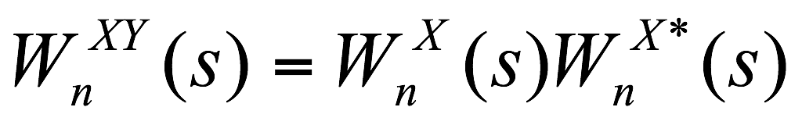 , where (*) means theta complex conjugate. XWT is often used to examine whether regions in time frequency space with a large common power have a consistent phase relationship, and therefore are suggestive of causality between the time series (Torrence and Webster, 1999).
The WTC was utilized to identify frequency bands and time intervals where two time series were related (Torrence and Webster, 1999). The wavelet coherency Rn is defined as:
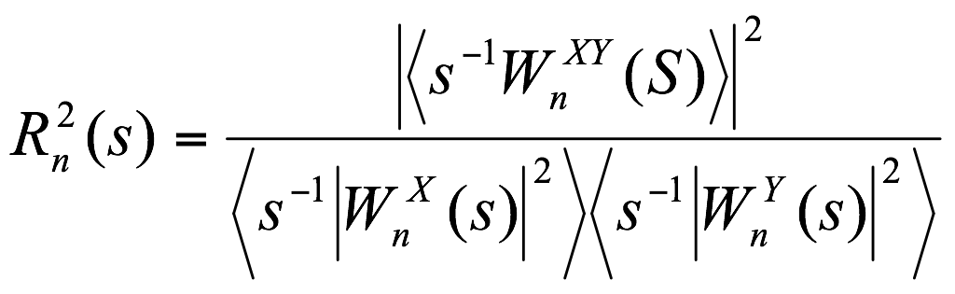 (2)
The significance of the correlation is computed using a Monte Carlo approach (Wallace et al. 1992).
To further understand the correlation between sc-PDSI and wildfires, the QRM was utilized to develop the quantitative relationship between sc-PDSI and wildfire BA. The QRM is a statistical machine learning tool intended to estimate and conduct inferences about conditional quantile functions, providing a more complete statistical analysis of the stochastic relationships among random variables (Andrews et al. 2003), which may best represent the true relationship between PDSI and wildfires in California.
The QRM can be expressed as:
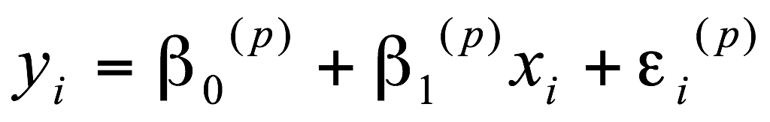 (3)
where 0<p<1 indicates the proportion of the population having scores below the quantile at p, where 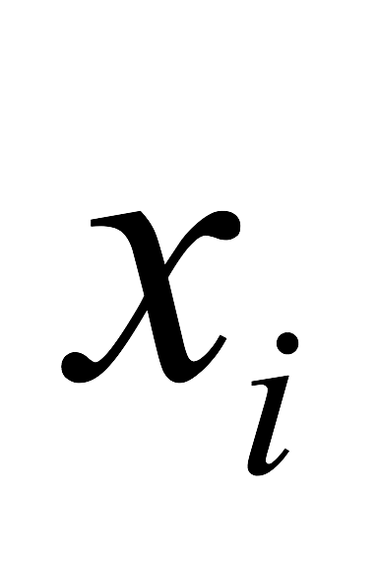 and 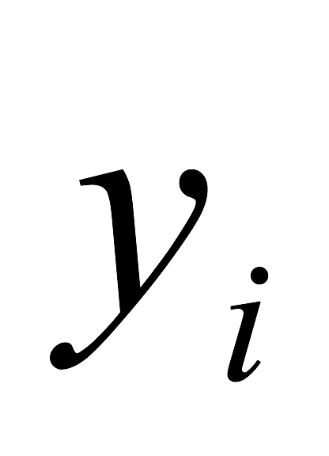 are pairs of the data, based on the sample of the PDSI and wildfire BA. 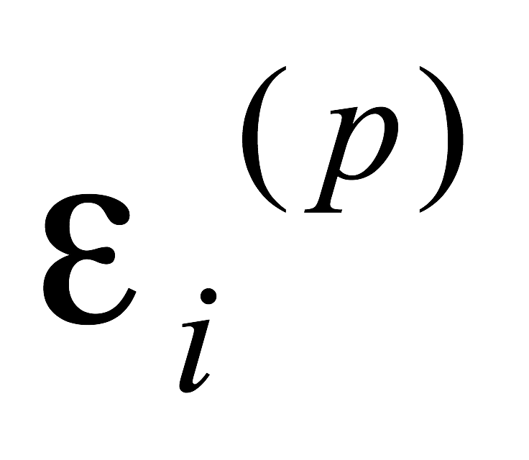is the error term, which is independent and identically distributed for i =1, 2,…, n. 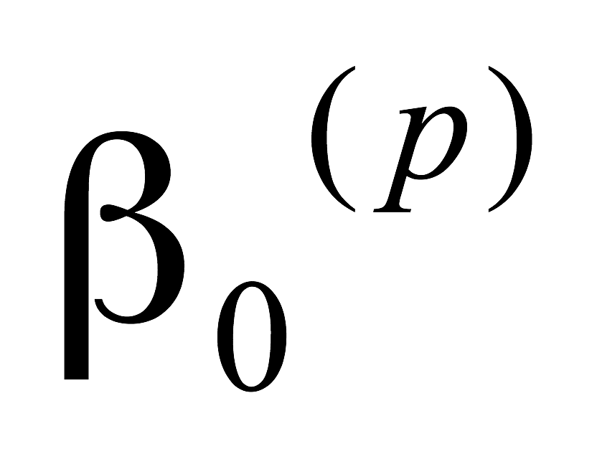is the quantile-specific parameter (Huang et al. 1996; Hirschi et al. 2011).
QRM estimates multiple rates of change from the minimum to maximum of the two variables and therefore can provide a more complete picture of the relationship between sc-PDSI and wildfire BA. In this study, the 90th, 95th and 99th quantiles were used, with the 90th quantile representing the 10-year wildfire, the 95th quantile representing the 50-year wildfire, and the 99th quantile representing the 100-year wildfire.

Results
Observation of wildfires in California
Wildfires were irregularly distributed throughout California during the study period (Figure 1). Figures 2a shows the annual series of wildfire incidence (number of ignitions) from 1984-2018 in California and indicates that there was no apparent trend in wildfire incidence. The highest wildfire occurrence was in 2009 with a total of 99 wildfires. However, there was an overall increase in acres burned by wildfire over this same period (Fig.2b). The fire with the largest BA occurred in 2018 and burned 4 ×10 6 hectares (ha). Fig. 2c shows the seasonal distribution of BA and wildfire incidence (averaged from 1984 to 2018) in California. Not only did the majority of California wildfires occur within the two months of July and August, the fires that occurred within these two months also had the greatest BA compared to other wildfires. This strong relationship between climatic factors and wildfires during July and August is a result of the Mediterranean-like climate with warm, dry summers and mild, wet winters (Riley et al. 2013) that occur in California.
Figure 3 illustrates the combined influence of monthly precipitation and temperature on the current month wildfire area in California, which clearly indicates that all of the disastrous wildfires (BA > 1.5×10 6 ha) occurred in the months when precipitation (P) was extremely low (<1.0cms) and the air temperature (T) was relatively high (>21C).
To estimate the relationship between P and T with wildfire, the multiple linear regression methodology (Equation 4) was applied, as it can predict wildfire BA with independent variables P and T. However, the R-squared (R²) of the model is only 0.04, which is not satisfactory for prediction. Table 2 provides the detailed calculated results, which also show that none of the P-values for the intercept, P, and T are above the 1% significance level.
$Y=β_{0}+β_{1}P+β_{2}T$ (4)
where Y is wildfire BA (hectares of burned area); β₀ is the intercept; β₁ and β₂ are the regression coefficients for P and T, respectively.
Overall, there is a relationship between precipitation and temperature with wildfire. However, the weak correlation cannot be utilized for future wildfire prediction. The relationship between wildfire BA and sc-PDSI was re-evaluated using the following strategies: (a) choosing a synthetic parameter as the independent variable, i.e., sc-PDSI, rather than including more climatic variables such as evaporation, infiltration, etc; (b) examining the relationships in time-frequency space between the two-time series by using machine learning with the wavelet analysis algorithm; (c) further estimating the relation between wildfire and climate using the QRM.
3.2. Wavelet analysis results
The wavelet analysis results of BA and sc-PDSI are shown in Figures 4a and 4b. The CWT showcased a considerable amount of high power in the 5–6-year period from 2004 to 2015 for both BA (Fig. 4a) and sc-PDSI (Fig.4b). The most pronounced variability within the wavelet power spectrum is observed during the 5-6-year period from 2002 to 2015, associated with the BA pattern. The signals from the model are powerful enough to be statistically significant (associated with 95% significance). The sc-PDSI wavelet power also showed slightly stronger 2–3-year power from 1992 to 1998, although not enough to be statistically significant. Overall, it is difficult to identify by sight a pattern of correlation between the BA and sc-PDSI in California in the CWT.
To further identify the relationship, the XWT was performed between BA and sc-PDSI (Figure 5a). The contours represent statistically significant periods (95% significance), based on the Monte Carlo experiment. The phase lag between BA and sc-PDSI is plotted as an arrow from 1984 to 2018. Horizontal arrows point right for time series in-phase and left for out-of-phase; vertical arrows point up when X leads Y and down when Y leads X. Wildfire BA and sc-PDSI share common power in the 4–7year period from 2002 to 2015 and the 2–3year period from 1997 to 2000. This suggests that wildfire BA is closely related to sc-PDSI in the common power years. The occurrence of one strong drought (sc-PDSI) can lead to large variability in wildfire BA in California. The areas are in-phase (phase-locked), which indicates that droughts lead wildfire BA in California. In other words, sc-PDSI is an important factor in wildfire forecasting. The results presented in Figure 5a confirm that the common XWT power of wildfire BA and sc-PDSI have a strong relationship.
To ensure the results were not by chance, and to further investigate the plausible relation between BA and sc-PDSI, the square WTC of the two variables was performed (Figure 5b). The most notable feature is that wildfire BA and sc-PDSI are very well correlated at the statistically significant level, with high coefficients in the 6–8 period over the entire study period (1984-2018). This means the two variables are strongly correlated on this time scale, indicating the wildfire BA is controlled by sc-PDSI in this time period. The in-phase correlation and the level arrows suggest that a model based on the 6–8year period of sc-PDSI could have predictive skill for wildfire BA. Two other XWT significant areas with 5–6 and 2–3year periods were seen from 2005 to 2012, and 1993 to 2005 respectively. These correlations also reflect the combination of strong wildfire BA and sc-PDSI signal, indicating sc-PDSI is a climate driver for wildfire. The significant regions are so extensive that it is very unlikely to be simply by chance.
QRM results
Fig. 6 shows the QRM scatterplot and the Ordinary-Least-Squares (OLS) linear regression plots of the BA and sc-PDSI data. When the goodness-of-fit measure is used, the R-square of the OLS is the low number of 0.0401, which cannot be used to predict the wildfire BA. To overcome this defect, the QRM was utilized instead to estimate the relationship between BA and sc-PDSI. The 90th, 95th, and 99th (τ = 0.9, 0.95, 0.99) percentiles correspond to the drought return periods of 10, 50, and 100 years, respectively. Some potentially significant relationships which cannot be detected by OLS are observed. Firstly, the correlation of the 90th percentile with R-square is 0.9773. Secondly, the QRM of the 95th (R-square 0.9619) and 99th (R-square 0.9771) percentiles had relationships almost as strong as the 90th quantile between the wildfire BA and sc-PDSI. Thirdly, the larger fires occurred more often during the drier period (lower sc-PDSI). Furthermore, the slopes of the quantile regression lines were negative, indicating that there is a negative relationship between BA and sc-PDSI, meaning BA increases with drought severity (lower sc-PDSI values). The QRM illustrates that large fires (higher BA) tend to occur when quantile is above the 90th percentile. Based on these results, the index where sc-PDSI is above the 90th percentile has the most power in predicting large fire occurrences in California. The relations between BA and sc-PDSI were developed as follows:
- $BA(99th)=-41360(sc-PDSI)+184359$ (5a)
- $BA(95th)=-23980(sc-PDSI)+124145$ (5b)
- $BA(90th)=-19416(sc-PDSI)+77208$ (5c)
where BA is the wildfire BA (hectares) in California. Future sc-PDSI can be calculated by Global Climate Models (GCMs).
Conclusion and discussion
In this study, machine learning was conducted through the wavelet analysis algorithm to investigate the relationship between wildfire BA and sc-PDSI. The relationship was also quantified by using machine learning of the QRM. The results from this study have significant implications for future wildfire prediction in California. The major findings are:
1. There was an increasing trend in wildfire burn area, but no trend in wildfire numbers from 1984 to 2018 in California. Most wildfires occurred during July and August when the weather is hot and dry. There are also implications when it comes to discussing climate change’s impact.
2. Wavelet analysis (CWT, XWT, and WTC) results signify that there was a significant relationship between wildfire BA and sc-PDSI in 6–8 year, 5–6 year, and 2–3-year periods. The relationship was statistically significant (associated with 95% significance) and indicates that sc-PDSI is one of the main drivers for the wildfire BA in these periods.
In this study, an improved method using finer time scales (monthly) and a longer study period (1984-2018) was used to give much more accurate findings as well as a more robust relationship.
3. QRM results show that wildfire BA negatively correlated to sc-PDSI with the higher correlation at the 90th quantile indicating larger sc-PDSI strongly correlated with larger wildfire or severe wildfire. The results suggest that the sc-PDSI impact on wildfire BA is more pronounced in more severe wildfires compared to small wildfires.
4. A quantitative relationship between sc-PDSI and wildfire BA was developed using machine learning in conjunction with the QRM. The relationship provides a promising direction to improved prediction of wildfire BA in California.
In conclusion, the methodology used was successful in developing the relationship between sc-PDSI and wildfire BA, and therefore can be used in wildfire studies. These findings are extremely important as the quantified relationship is much more robust than previous ones and has possible implications on determining future wildfires in California. The results have benefits for land and water management, and human health, saving both resources and potentially also lives.

Conflicts of interest
The author declares no conflicts of interest
Declaration of funding
This research did not receive any specific funding.
Acknowledgements
I thank Mr. Chad Ogren for his constant support throughout the research process. I also thank Dr. Tang from EPA and Dr. Wenhong Li from Duke University for their revisions and helpful suggestions. Additionally, I thank the editors and anonymous reviewers for their constructive comments.
Data availability statement
The data that support this study are available in the article and accompanying online supplementary material.

References:
Abatzoglou JT, Dobrowski SZ, Parks SA (2020) Multivariate climate departures have outpaced univariate changes across global lands. Scientific Reports, 10, 3891. doi:10.1038/s41598-020-60270-5
Addington RN, Hudson SJ, Hiers JK, Hurteau MD, Hutcherson TF, Matusick G, Parker JM (2015) Relationships among wildfire, prescribed fire, and drought in a fire-prone landscape in the south-eastern United States. International Journal of Wildland Fire 24(6), 778–783. doi:10.1071/wf14187
Andrews PL, Loftsgaarden DO, Bradshaw LS (2003) Evaluation of fire danger rating indexes using logistic regression and percentile analysis. International Journal of Wildland Fire 12, 213–226. doi:10.1071/ WF02059
Harvey BJ (2016) Human-caused climate change is now a key driver of forest fire activity in the western United States. PNAS 113(42), 11649-11650. doi:10.1073/pnas.1612926113
Brainard J (2020) Western US wildfires spur health research, Science, 369(6510), 1410.
Chaparro D, Piles M, Vall-Llossera M, Camps A (2016) Surface moisture and temperature trends anticipate drought conditions linked to wildfire activity in the Iberian Peninsula. European Journal of Remote Sensing, 49, 955-971. doi:10.5721/EuJRS20164950.
Dennison PE, Brewer SC, Arnold JD, Moritz MA (2014) Large wildfire trends in the western United States, 1984-2011. Geophysical Research Letters 41(8), 2928–2933. doi:10.1002/2014gl059576
Di Virgilio, G, Evans JP, Blake SAP, Armstrong M, Dowd AJ, Sharples J, McRae R (2019) Climate change increases the potential for extreme wildfires. Geophysical Research Letters 46(14), 8517–8526. doi:10.1029/2019gl083699
Eidenshink JC, Schwind B, Brewer K, Zhu ZL, Quayle B, Howard S (2007) A project for monitoring trends in burn severity. Fire Ecology 3, 3-21. doi:10.4996/FIREECOLOGY.0301003
Goss, M, Swain DL, Abatzoglou JT, Sarhadi A, Kolden CA, Williams AP, Diffenbaugh NS (2020) Climate change is increasing the likelihood of extreme autumn wildfire conditions across California. Environmental Research Letters 15(9), 14. doi:10.1088/1748-9326/ab83a7
Heyerdahl, EK, Morgan P, Riser JP (2008) Multi-season climate synchronized historical fires in dry forests (1650-1900), northern Rockies, USA. Ecology 89(3), 705–716. doi:10.1890/06-2047.1
Hirschi M, Seneviratne SI, Alexandrov V, Boberg F, Boroneant C, Christensen OB, Formayer H, Orlowsky B, Stepanek P (2011) Observational evidence for soil-moisture impact on hot extremes in southeastern Europe. Nature Geoscience, 4(1), 17–21, doi:10.1038/ngeo1032
Huang J, van den Dool HM, and Georgakakos KP (1996) Analysis of model-calculated soil moisture over the United States (1931-1993) and applications to long-range temperature forecasts. Journal of Climate 9(6), 1350–1362. doi:10.1175/1520-0442(1996)
Keyser, A. R., and A. L. Westerling (2019) Predicting increasing high severity area burned for three forested regions in the western United States using extreme value theory. Forest Ecology and Management, 432, 694–706. doi: 10.1016/j.foreco.2018.09.027
Kirchmeier-Young, MC, Gillett NP, Zwiers FW, Cannon AJ, Anslow FS (2019) Attribution of the influence of human-induced climate change on an extreme fire season. Earth Future 7(1), 2–10. doi:10.1029/2018ef001050
Margolis EQ, Swetnam TW (2013) Historical fire-climate relationships of upper elevation fire regimes in the south-western United States. International Journal of Wildland Fire 22, 588–598
Markovic V, Nagy I, Sik A, Perge K, Laszlo P, Papathoma-Kohle M, Promper C, Glade T (2016) Assessing drought and drought-related wildfire risk in Kanjiza, Serbia: the SEERISK methodology. Natural Hazards, 80(2), 709–726. doi:10.1007/s11069-015-1991-4
Moritz MA, Parisien MA, Batllori E, Krawchuk MA, Dorn JV, Ganz DJ, Hayhoe K (2012) Climate change and disruptions to global fire activity. Ecosphere 3(6), 49. doi:10.1890/ES11-00345.1
Mull A (2018) Smoke days are now California’s snow days, The Atlantic. Available at https://www.theatlantic.com/health/archive/2018/11/california-wildfires-smoke-days/576112/ [Verified 12 December 2021]
Palmer WC (1965) Meteorological Drought. US Weather Bureau Research Paper (Washington, DC, USA).
Riley KL, Abatzoglou JT, Grenfell IC, Klene AE, Heinsch FA (2013) The relationship of large fire occurrence with drought and fire danger indices in the western USA, 1984-2008: the role of temporal scale. International Journal Wildland Fire 22(7), 894–909. doi:10.1071/wf12149.
Scasta JD, Weir JR, Stambaugh MC (2016) Droughts and Wildfires in Western U.S. Rangelands. Rangelands 38(4), 197–203. doi.org/10.1016/j.rala.2016.06.003
Silva LGM, Doyle KE, Duffy D, Humphries P, Horta A, Baumgartner LJ (2020) Mortality events resulting from Australia's catastrophic fires threaten aquatic biota. Global Change Biology, 26(10), 5345–5350. doi:10.1111/gcb.15282.
Stavros, EN, Abatzoglou J, Larkin NK, McKenzie D, Steel EA (2014) Climate and very large wildland fires in the contiguous western USA. International Journal Wildland Fire 23(7), 899–914, doi:10.1071/wf13169
Swetnam TW, Farella J, Roos CI, Liebmann MJ, Falk DA, Allen CD (2016) Multi-scale perspectives of fire, climate and humans in western North America and the Jemez Mountains, USA. Philosophical Transactions B 371, 20150168. doi:10.1098/rstb.2015.0168
Taufik, M, Torfs P, Uijlenhoet R, Jones PD, Murdiyarso D, Van Lanen HAJ (2017) Amplification of wildfire area burnt by hydrological drought in the humid tropics. Nature Climate Change 7(6), 428–431. doi:10.1038/nclimate3280
Thompson M, Dunnand C, Calkin D (2015) Wildfires: Systemic changes required. Science 350(6263), 920. doi: 10.1126/science.350.6263.920-b
Torrence C, Compo GP (1998) A practical guide to wavelet analysis. Bulletin of the American Meteorological Society 79(1), 61–78. doi:10.1175/1520-0477(1998)079.
Torrence C, Webster PJ (1999) Interdecadal changes in the ENSO-monsoon system. Journal of Climate 12(8), 2679–2690. doi:10.1175/1520-0442(1999)012
Wallace JM, Zhang Y, Lau KH (1993) Structure and Seasonality of Interannual and Interdecadal Variability of the Geopotential Height and Temperature-Fields in the Northern-Hemisphere Troposphere. Journal of Climate 6(11), 2063–2082.
Well N, Goddard S, Hayes MJ (2004) A Self-Calibrating Palmer Drought Severity Index. Journal of Climate 17, 2335–2351.
Westerling AL (2016) Increasing western US forest wildfire activity: sensitivity to changes in the timing of spring. Philosophical Transactions B 371(1696), 10. doi:10.1098/rstb.2015.0178.
Williams AP, Gentine P, Moritz MA, Roberts DA, Abatzoglou JT (2018) Effect of Reduced Summer Cloud Shading on Evaporative Demand and Wildfire in Coastal Southern California, Geophysical Research Letters 45(11), 5653–5662. doi:10.1029/2018gl077319
Williams A, Allen CD, Macalady AK et al (2013) Temperature as a potent driver of regional forest drought stress and tree mortality. Nature Climate Change 3, 292-297.

Fig.1 Map of the study area, i.e., California, western US. The figure shows all fires included in the analysis, selected from the Monitoring Trends in Burn Severity database.
Figure 2. Yearly series of (a) wildfire incidence (number of ignitions) and (b) wildfire burn area (hectares burned by wildfire) from 1984-2018 in California. (c) seasonal distribution of wildfire burn area and incidence in California (averaged over the period of 1984-2018).
Fig. 3. Combined influence of monthly precipitation and temperature on current-month wildfire burn area in California.
Fig. 4. The time series of (a) burn area (b) sc-PDSI and continuous wavelet power spectrum of burn area (c) and sc-PDSI (d). The thick black contour designates the 5% significance level against red noise and the cone of influence (COI) where edge effects might distort the picture is shown as a lighter shade.
Fig. 5. (a) cross wavelet transforms of and (b) wavelet coherence between the standardized burn area and sc-PDSI. The 5% significance level against red noise is shown as a thick contour. The relative phase relationship is shown as arrows (with in-phase pointing right, anti-phase pointing left, and sc-PDSI leading burn area by 90º pointing straight up).
Fig. 6. Scatterplot and Quantile Regression Fits of the burn area v.s. sc-PDSI data: the blue line represents the traditional OLS linear regression which estimates the conditional mean function; the quantile regression line with median τ = 0.5, 0.9, 0.95, and 0.99 are presented by the blue, yellow, gray, and orange lines, respectively.
Table 1. Examples of fire events in California
A look at the specifics from various wildfires in the MTBS datasets as an example, with focus being on fire type and the number of hectares burned.
Fire Name | Hectares | Ignition Date | Fire Type
GRIMES FIRE | 4418 | 1984/5/7 | Wildfire
SHELL PEAK | 719 | 1984/5/28 | Prescribed Fire
SOUTH PARK COMPLEX | 853 | 1999/7/11 | Wildland Fire Use
PENDLETON COMPLEX | 1200 | 2018/7/6 | Complex
WOOLSEY | 39644 | 2018/11/8 | Wildfire

Table 2. Multiple linear regression model for wildfire burn area
Table provide the detailed calculated P-values, coefficient, standard error, and standardize deviation values for the intercept, P, and T.
Term | Coefficient, β | Standard error | t Stat | P-value
Intercept | -254277 | 157447 | -1.615 | 0.108
P | 277.532 | 19942.7 | 0.014 | 0.989
T | 5029.34 | 2171.86 | 2.316 | 0.022

