Investigating the Energy of Charcoal

Alden Pool
John Jay Science and Engineering Academy
San Antonio, Texas

American Junior Academy of Science
February 2022

Abstract

Charcoal, wood burned in the absence of oxygen, comes in two typical forms, lump charcoal and charcoal briquettes. Lump charcoal is made from chunks of wood that have been carbonized without oxygen. Charcoal briquettes are made from sawdust and other ingredients, pressed into a form, and then carbonized. Lump charcoal is still commonly used and is much easier to produce, especially with limited equipment, compared to charcoal briquettes. In this experiment, lump charcoal will be produced from mesquite, oak, poplar, and cypress woods. The goal is to test whether wood density is related to properties that make charcoal desirable as a fuel. Specifically, mesquite, a very dense wood, should generate more energy than woods that are less dense. Furthermore, mesquite should also be able to maintain a high temperature at the end of the testing period compared to less dense woods.
To test these hypotheses, scrap wood was collected from local cabinet shops, and cut into equal size samples. The density of each species of wood was measured. Next, these wood samples were converted into charcoal by burning them inside metal cans placed into a fire. Once cool, the can was opened and the charcoal was removed. Small samples of the charcoal were lit and burned inside a calorimeter where the water temperature and direct heat were measured every 30 seconds for 20 minutes.

Table of Contents

 |  | Page
Abstract……………………..……………………………………………..… | 1
Introduction………………………………………………………………..… | 3-4
Materials………………………………………………………………..……. | 6
Procedure…………………………………………………………………….. | 6-8
Results and Discussion………………………………………………………... | 9-13
Table 1: Comparison of Total Mass Before and After Pyrolysis……. | 9
Table 2: Wood Density by Species ……………………………..…… | 9
Graph 1: Mean Water Temperature Increase by Species…………… | 10
Graph 2: Mean Kilocalories Generated by Species…………………. | 11
Graph 3: Mean Charcoal Temp Increase Over Baseline by Species...... | 12
Graph 4: Mean Temp Change of Charcoal at End of 20 min…………. | 13
Conclusion…………………………………………………………………..… | 14
Practical Applications……………………………………………………….. | 15
Future Expansion………………………………………………………….… | 15-16
Acknowledgements…………………………………………………………… | 16
Literature Cited ……………...……………………………………………...… | 16-17
Statement on Outside Assistance…………………………………………...… | 18

Introduction
Charcoal is a useful resource, with many different applications. Charcoal has been made for centuries and is one of the first major milestones of civilization. Times have changed, but the process for making charcoal has remained relatively unchanged. When burned, charcoal produces more heat, lasts longer, and produces less smoke than the same amount of wood.
Grilling is a common use for charcoal. When grilling with charcoal there are two types of charcoal, lump and briquette charcoal. Lump charcoal is considered “more natural” by some, however it is of inconsistent size, shape and quality. Charcoal briquettes are the more “industrialized” approach to charcoal. Unlike lump charcoal, charcoal briquettes have almost uniform size, shape and quality. However, charcoal briquettes contain not only wood but other additives as well, such as saw dust, borax, limestone, and starch. The additives either help the briquette ignite, burn consistently, or act as a binding agent like glue to hold everything together.
The process for making charcoal is quite simple. Charcoal was originally made in small batches, wood would be cut and split into pieces. After that, the wood would be stacked. Once the wood was stacked, clay or mud would be coated to create a mound around the wood. There would be a small hole in the clay seal to start a fire. Once the fire was started the hole was sealed with more clay. The mound would be left to burn over the course of days or even weeks. Eventually the fire would burn out and the clay was removed and then finally the charcoal was completed. This process worked well except it was slow, required massive amounts of labor, and could only make small batches of charcoal. This process could also only make lump charcoal.
The modern process for making charcoal briquettes started when Henry Ford wondered if all the waste wood from the production of the Model T car could be repurposed. Working with Edward Kingsford, they started turning the waste wood into charcoal and selling it under the Ford brand name. At first, no one really bought charcoal and it did not catch on. Eventually Ford Motor Company sold their charcoal business to The Clorox Company. Clorox renamed the brand Kingsford charcoal in honor of Edward G. Kingsford. When World War II ended, soldiers returned back home and had more time for leisure. Many of them ended up moving to the suburbs where the Weber Grill became widely popular. People not only had a need for charcoal, but were willing to pay good money for it. Kingsford charcoal is still owned by The Clorox Company and produces charcoal from waste wood. In fact, according to the Kingsford website, more than one million tons of scrap wood are converted into charcoal briquets annually
Charcoal does not have to be burned to be useful. Charcoal leaves a dark streak on most surfaces, and is used as a natural dye or coloring. Some artists specialize in a technique called charcoal drawing. Activated charcoal is a special refined type of charcoal which is used as a filtering medium. Activated charcoal can be found in water filters. These filters are used for water treatment and wastewater treatment. Activated charcoal also works well for filtering the air and is not only used in air filters but, in some instances gas masks as well. For hundreds of years, charcoal has been used as a fertilizer. Farmers would add crushed charcoal powder to their soil, because the added carbon in the soil is beneficial to plants. There are quite a few experiments and research papers on the topic of charcoal being added to the soil to help plants grow. To conclude, there are many uses for charcoal besides just burning it. Charcoal performs many different tasks and can be the difference between life and death in the case of filtration.
Although charcoal has many benefits and uses, charcoal is not always good for the environment. To produce charcoal, major amounts of energy and wood are needed. Both the production and burning of charcoal can contribute to air pollution and release harmful gasses into the atmosphere. Wood is needed to create charcoal, and in regions where forestry has gone unregulated, whole forests have been cleared to make charcoal. However, if made properly and responsibly the impact charcoal has on the environment can be limited. Activities such as sustainable forestry or using waste wood to produce charcoal, along with new developments in production techniques, ensure that charcoal will still be around and will be used responsibly. If managed properly, charcoal can be used as a supplement to renewable resources and be a valuable asset.

Present Research
Last year’s experiment entitled “What Wood Makes the Best Charcoal”, tested charcoal made from oak, cedar, and pine wood. After testing the charcoal made from each species of wood, oak was to have produced the most effective charcoal, burning for the longest time and with the highest amount of heat compared to the other two species tested, pine and cedar. These findings revealed that a common property of wood, the distinction between hardwoods and softwoods, was associated with different performance in charcoal. Hardwoods are from broad leaf trees (oak) and softwoods are from conifer trees (cedar and pine).
Based on the results of last year’s experiment, the student researcher wondered if other physical properties of wood might also impact the characteristics of charcoal. Wood density is one property that may have promise for application to charcoal. Wood density is related to several other important properties of wood including strength, hardness, weight, compression, and stiffness.

Purpose: To investigate whether wood density is related to the amount of energy charcoal can produce.

Question: Will a wood species with a higher density make charcoal that will release more energy than charcoal made from lower density woods?

Hypothesis: Charcoal made from a dense wood, like mesquite, will be a more effective energy source, releasing more energy than less dense woods like oak, poplar, and cypress.

Materials
- Mesquite blocks 3½”x1½”x¾” (42)
- Oak blocks 3½”x1½”x¾” (42)
- Poplar blocks 3½”x1½”x¾” in (42)
- Cypress blocks 3½”x 1½”x¾” (42)
- Compound Miter Saw
- Gallon metal cans with lids (4)
- Metal wire and washers
- Fire pit with firewood
- Chopsticks
- Food scale
- Paper
- Wire mesh
- Cooking spray
- Four channel thermocouple
- Stopwatches (2)
- Rotary tool
- #10 tin can
- 600 mL glass beaker
- Pencil
- Tin snips
- Camera
- Hammer
- Tin foil
- Safety glasses / Ear plugs
- Gloves
- Cordless Drill
- 500 mL Measuring Cup

Procedure

Making the Charcoal
- Mesquite, Oak, Cypress & Poplar wood were cut using a compound miter saw, into 42 standardized 3½”x1½”x¾” (LxWxH) blocks.
- Four gallon-sized paint cans were purchased from a hardware store.
- An 11/64-inch hole was drilled in the lid of the can for venting.
- The mass of all 42 blocks was recorded by each species.
- The can was loaded with 42 blocks of wood and the mass of the can and blocks of wood was recorded.
- The lid was placed on each can and tapped closed with a hammer.
- Washers were added to the handle of the can in order to identify the species after the can was burned.
- Steps 3 through 6 were repeated for all four species of wood.
- A fire was built in the fire pit.
- All four cans were carefully placed into the fire.
- The cans were removed from the fire once they no longer emitted steam or fire from the 11/64-inch hole drilled in the lid of the can.
- The cans were placed on the concrete.
- One half of a chopstick was placed in the hole on top of each can to prevent oxygen from reentering the can after the pyrolysis process.
- The cans were left to cool overnight.
- The next day the cans were opened and the mass of all the charcoal was recorded.
- The finished charcoal was placed in a plastic bag for storage until testing.
- Steps 10 through 15 were repeated for all four cans.
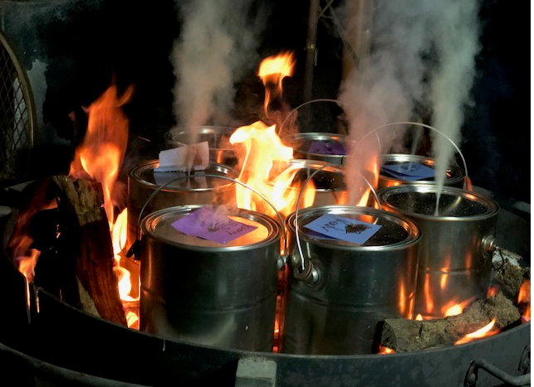
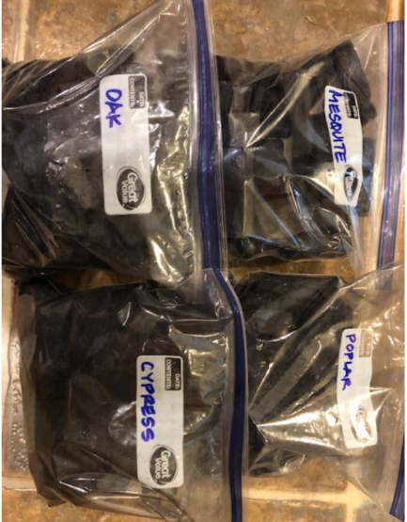
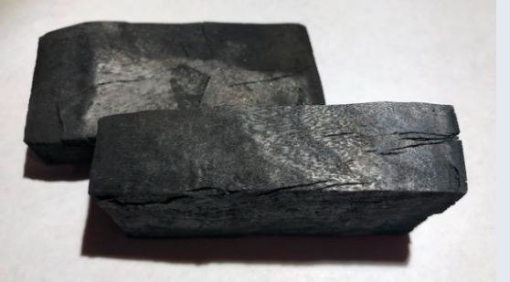
Pyrolysis process for making charcoal. Lump charcoal after pyrolysis.
Charcoal samples.

Engineering the Calorimeter Device
- A 600 mL glass beaker was washed with soap and water
- Tin snips were used to cut a rectangular door-like opening in the empty #10 can so charcoal samples could be slid into the calorimeter.
- A circular hole, just wide enough to hold the glass beaker, was cut in the bottom of the #10 can with a rotary tool.
- The #10 can was placed upside down and the 600 mL glass beaker was then inserted into the bottom of the can
- Wire mesh was then shaped into a basket to hold the charcoal under the beaker.
- A 5/16-inch hole was drilled into the side of the #10 can above the charcoal basket. The first thermocouple sensor was then inserted in this hole and threaded into place.
- Wire was bent around a pencil to hold the second submersible thermocouple inside the 600 mL beaker without touching the bottom or sides of the beaker.
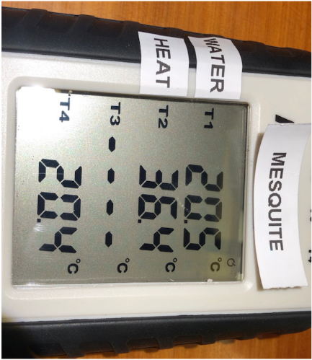
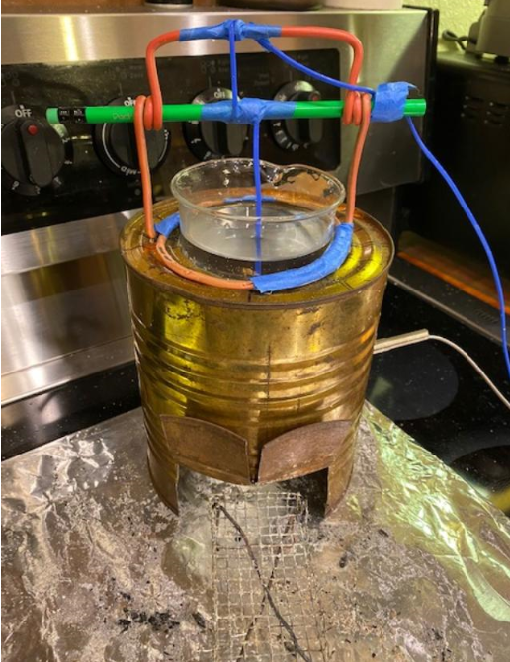
Calorimeter testing device. Thermocouple thermometer.

Testing the Charcoal
- Using the mass of the wood and the volume of the 42 standardized wood blocks, the density of each species was calculated.
- 150 cm³ of charcoal was added to a measuring cup, the mass was recorded, and the charcoal was placed in the lighting apparatus.
- A single sheet of letter sized printer paper was sprayed with cooking spray and placed in the base of the lighting apparatus.
- The paper was lit with a butane lighter to ignite the charcoal.
- The ignited charcoal was placed in the mesh basket under the testing apparatus, and the starting temperature of the water was recorded.
- Every thirty seconds the temperature of both the water and the charcoal was recorded. This was done every thirty seconds for twenty minutes (1200 seconds).
- Steps 2 through 6 were repeated three times for each of the four species of wood tested.

Results and Discussion
Mass of Sample Before and After Pyrolysis
Table 1 shows the difference in grams for all four species of wood before and after the pyrolysis process. The release of moisture, wood gas, and resin by outgassing through the vent hole of the can, meant that every species tested had a decrease in overall mass after the pyrolysis process.
Table 1: Comparison of Total Mass Before and After Pyrolysis
Wood | Before | After | Difference | % Reduction
Mesquite | 2476.0 g | 928.3 g | -1547.7 g | 62.5%
Oak | 2163.0 g | 546.2 g | -1616.8 g | 74.7%
Poplar | 2002.0 g | 421.8 g | -1589.2 g | 79.4%
Cypress | 1415.0 g | 337.8 g | -1077.2 g | 76.1%

Density of Wood Samples Used to Make Charcoal
Table 2 shows the calculated density of each wood sample. Specifically, the formula Density = Mass kg / V m³, was used to calculate the density of each sample. The density of mesquite is much higher than that of the other three wood species.
Table 2: Wood Density by Species
Mesquite | 913.65
Oak | 798.15
Poplar | 738.74
Cypress | 522.14
Note: Density = Mass kg / V m³
Total Kilocalories Released by Burning Charcoal
To calculate the total amount of energy released by burning each sample of charcoal, a calorimeter was constructed. A calorimeter measures the amount of temperature change in a known volume of water as an indicator of the amount of energy a sample is generating. It takes 1 calorie to raise the temperature of 1 gram of water by 1 ºC. Because 1 mL of water has a mass of 1 gram, and a specific heat of 1, it takes 500 calories to raise the temperature of the water in the 500 mL beaker 1 ºC. Therefore, an increase in temperature of 1 ºC requires a 500 calorie expenditure in the system, for every degree increase in the water an additional 500 calories can be added to the total energy output of the charcoal. A kilocalorie is 1000 calories.
The total change in water temperature from the start of the trial to the end of the trial was used to calculate the number of kilocalories released by each of the charcoal samples. Graph 1 shows the mean water temperature for each sample across the 20-minute trial. The trend lines show that charcoal made from the densest wood, mesquite, heated the 500 mL of water to a greater temperature than charcoal from other, less dense species.
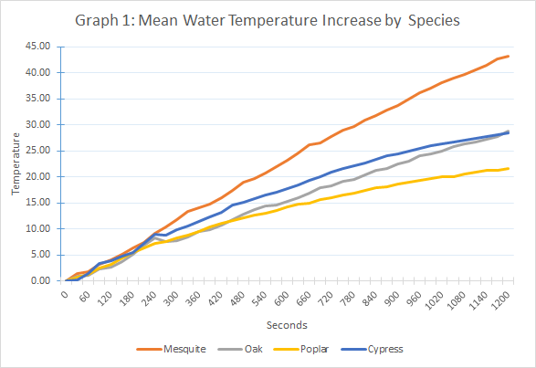
Once the average water temperature increase over the 20 min trial was converted into kilocalories, a one-way between subjects ANOVA was conducted to compare the total number of kilocalories released by each of the 4 types of charcoal during a 20-min burn time. There was a significant effect of charcoal wood species on kilocalories at the p < .05 level indicating that at least one of the species was different [F(3, 8) = 35.28, p < .0001, η² = .93 ]. Post hoc comparisons using the LSD test indicated that the mean number of kilocalories released by mesquite charcoal (M = 21.6, SD = .96) was significantly greater than charcoal made from oak (M = 14.4, SD = 1.50), poplar (M = 10.8, SD = .25) and cypress (M = 14.2, SD = 1.93). Graph 2 displays the mean kilocalories released by each type of charcoal. Overall these results support our hypothesis that charcoal made from denser wood generates more kilocalories than less dense woods.
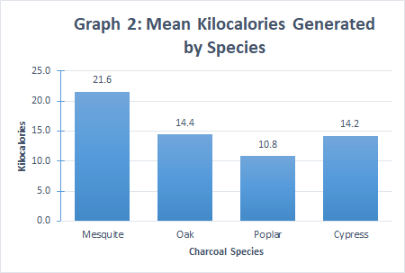
Charcoal Temperature Over 20-min Burn Time
Another property of charcoal that is important is the length of time it can burn at a useful temperature. In our procedure, the charcoal samples were burned for 20 minutes and the temperature of the charcoal was recorded. At the end of the 20-minute period, the difference between the starting and ending temperatures for each sample was calculated. This measure of direct heat is another way to evaluate the energy a sample of charcoal is releasing. Graph 3 shows the average temperature increase curves over the 20-min trial for each species. Charcoal made from mesquite, appears to have reached a higher temperature than the other charcoal samples quickly and maintained a higher temperature over the 20-min trial. It appears that charcoal made from poplar and cypress begin to lose temperature over time as their temperature curves show a decline during the 20-min trial.
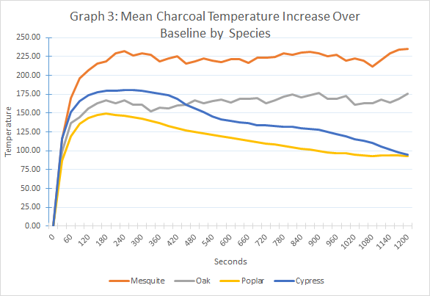
A one-way between subjects ANOVA was conducted to compare the direct heat temperature change generated by each of the 4 types of charcoal during a 20-min burn time. There was a significant effect of charcoal wood species on direct temperature at the p < .05 level indicating that at least one of the species burned hotter than other species [F(3, 8) = 6.81, p < .05, η² = .72 ]. Post hoc comparisons using the LSD test indicated that the charcoal made from mesquite (M = 235.23, SD = 39.41) burned significantly hotter than charcoal made from poplar (M = 92.53, SD = 21.72) and cypress (M = 94.80, SD = 8.58). Graph 4 summarizes the mean temperature change of each type of charcoal at the end of the 20 min trial. Overall these results support our hypothesis that charcoal made from denser wood generates more direct heat than charcoal made from less dense wood.
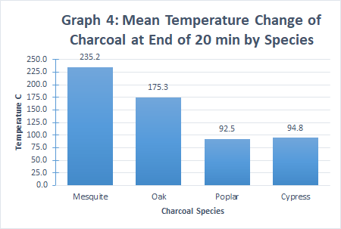

Conclusion
The hypothesis “charcoal made from a dense wood, like mesquite, would release more energy when burned than charcoal made from less dense woods like oak, poplar, and cypress” was accepted. Heat released from the charcoal samples was measured using a calorimeter. The change in water temperature and change in charcoal temperature were recorded every 30 seconds for 20 minutes.
When examining the mean water temperature for each sample across the 20-min trial, the trend lines show that charcoal made from the densest wood, mesquite, heated the 500 mL of water to a greater temperature than charcoal from other, less dense species. A one-way between subjects ANOVA with post hoc tests compared the total number of kilocalories released by each of the 4 types of charcoal during the 20-min burn time. These results support our hypothesis that charcoal made from the densest wood (mesquite) generated significantly more kilocalories than charcoal from less dense woods.
When measuring the temperature of the charcoal samples, it was found that charcoal made from mesquite appears to have reached and maintained a higher temperature than the other charcoal samples for the complete 20-min trial. A one-way between subjects ANOVA was conducted to compare the mean temperature change at the end of each 20-min trial. These results support our hypothesis that charcoal made from the densest wood (mesquite), generated significantly more direct heat for a longer time than charcoal made from less dense woods.
In summary, charcoal made from mesquite, a very dense wood, generated more kilocalories and was able to achieve and maintain a higher final temperature over the 20-min trial. Wood density appears to show promise as a property useful for creating high quality charcoal.

Practical Applications
The practical applications of this experiment include, sustainable land management, farmers and land managers could use this knowledge. Using wood from areas cleared to make charcoal, which could then be used to fertilize the soil, promoting growth of foliage, which then can be turned into charcoal, and continue this cycle. By using material that would have already gone to waste the land managers have no additional costs.
The primary application of this project was to help those without access to electricity/gas for heating and cooking, particularly those in developing nations. Charcoal is easier to store and transport, than fire wood. The compact nature of charcoal allows for less time having to be spent cutting down trees, preparing, transporting, and storing firewood each day.
Manufacturers, such as the cabinet shops the scrap wood was acquired from for this project, could use this knowledge to reduce waste. Instead of having to pay for scrap wood to be disposed of in a landfill, manufacturers could turn this waste into charcoal. The manufacturers could use low density wood waste to turn high density wood waste into high-quality charcoal. This charcoal could then be sold to customers, and create extra income for the manufacturer. This way, what was once an expense to get rid of, is now an item to be sold.
Future Expansion
Further applications and studies could include the possible testing of composite charcoal briquettes, testing what combinations of materials affect the usability of the charcoal. Common waste products such as scrap wood, sawdust, and other forms of organic waste can be added to the dry mixture and formed into briquettes.
The student researcher was able to collect other species of wood to test from the same sources as the wood tested in the current experiment. A future study could be conducted with these additional species of wood.
Another possible implication of this experiment could be an engineering project in which the researcher designs, builds and tests a mechanism to increase the efficiency and reduce loss commonly associated with charcoal grills and stoves. The construction of this device could be built out of inexpensive and readily available materials and constructed in a way that reduces the skill and use of tools needed, to better provide those without a stable source of energy, and help meet the residential cooking needs in developing nations.

Acknowledgements
I would like to thank my mother for taking photographs for my experiment. I would like to thank my father for giving me access to his woodshop and use of his tools and machinery to not only build the charcoal crucible but the testing apparatus as well. Both my mom and my dad have helped enormously and spent countless hours working with me to figure out how to solve some of the problems encountered during my experiment. I thank my dad for teaching me how to analyze my data. I would like to thank my mom and dad for proof reading my research paper. A special thanks goes to the various cabinet shops of Pilot Point, Texas, for providing me with their waste wood and scrap pieces of lumber to use in my experiment.

Literature Cited
Booth, Harry. Simple Technologies for Charcoal Making. Food and Agriculture Organization of the United Nations ed., Rome, 1987.
Cimons, Marlene. “Helping Landowners with Waste Wood While Improving Agribusiness and Energy.” Www.nsf.gov, 14 Dec. 2012, www.nsf.gov/discoveries/disc_summ.jsp?cntn_id=126349.
Gilmore, Gary. “CHARCOAL (How to Make Charcoal in a Drum) | BioEnergy Lists: Biochar Mailing Lists.” Terrapreta.bioenergylists.org, 26 Jan. 2008, terrapreta.bioenergylists.org/Gilmore-Charcoal-Drum.
Keita, J.D. “Unasylva—an International Journal of Forestry and Forest Industries 1947–2000.” Forest Ecology and Management, vol. 139, no. 7-8, 1987, p. 369.
Kuhns, Michael, and Tom Schmidt. “Wood Heating | Forestry.” Usu.edu, Oct. 2013, www.forestry.usu.edu/forest-products/wood-heating.
Meincken, M., and S. Funk. “Burning Characteristics of Low-Cost Safety Charcoal Briquettes Made from Wood Residues and Soil for Domestic Use.” Agroforestry Systems, vol. 89, no. 2, 6 Dec. 2014, pp. 357–363.
Nix, Steve. “Learn about Lump Charcoal and Its Production.” ThoughtCo, 18 Jan. 2019, www.thoughtco.com/making-lump-and-briquette-charcoal-1342656.
Ogawa, Makoto, and Yasuyuki Okimori. “Pioneering Works in Biochar Research, Japan.” Soil Research, vol. 48, no. 7, 2010, p. 489.
Scharabok, Ken. “Amaze Your Friends and Neighbors: Make Your Own Charcoal!” Countryside and Small Stock Journal, May 1997, pp. 27–28.

Statement on Outside Assistance
Researchers Name: Alden Pool
Title of Paper: Investigating the Energy of Charcoal
What steps led you to formulate your hypothesis? (Where did you get the idea for your research?) Please be specific.

After the results of my previous year’s research, I wondered if other physical properties of wood could possibly affect the performance of charcoal. I suspected that wood with a higher density would produce charcoal that releases more energy when burned that that of charcoal made from a wood of lower density.
Where did you conduct the major part of your work? (i.e. home, school, or other institutional setting, university lab, medical center, etc.)

The majority of the work was conducted at home.
If you worked in an institutional setting, did you work on your project as part of a team or group? If so, how large was the team and who was on the team (students, adult researchers, etc.)? Describe your role on the team.

This was not a team project.

Describe what parts of the research you did on your own and what parts you received help (i.e. literature search, hypothesis, experimental design, use of special equipment, gathering data, evaluation of data, statistical analysis, conclusions, and preparation of written report (abstract and/or paper).

With the exception of help proof reading the research paper, and providing access to SPSS for statistical analyses all work was performed by myself.
Is your research current or a continuation of previous research? If a continuation, please describe the current work and advancement(s) of this research in comparison to the prior work and results.

This project is a continuation of my previous year’s research entitled “What Wood Makes the Best Charcoal”. One change I made was testing the density of the wood, I also increased the different species of wood to be tested, as well as building a calorimeter to measure the energy output of the charcoal samples, instead of measuring the direct heat as I did previously.

