MUSR: A Low-Cost Multipurpose Sterilization Robot
Nidhi Krishna Kumar, Olympia High School, Olympia, WA

Abstract
Disinfection and sterilization are two integral parts of any safe indoor environment, and these factors have become more critical in recent times. Several institutions lack the resources to access the most effective, high-tech sterilization methods used in hospitals and major institutions, which brings a need for a low-cost method to thoroughly sanitize enclosed areas. MUSR, or Multipurpose Ultraviolet Sterilization Robot, is an automated system that facilitates the sterilization of these areas. Its primary functionality is ultraviolet sterilization with mopping and sweeping features to complement and provide more effective UV sterilization. MUSR has the ability to drive autonomously while emitting UV-C light to the walls and floors, thus sterilizing the area and debilitating bacteria and viruses on all exposed surfaces. The system employs an Arduino UNO microcontroller, ultrasonic sensors for distance and object detection, and can also be remotely controlled using a phone app. The system was tested using dosimeter cards to ensure that a sufficient dosage to inactivate bacteria, viruses, and other pathogens was present. MUSR is an accessible, low-cost system that provides the user with an effective sterilization solution to increase the safety of people in the area.

Introduction
Conventional disinfection methods are not fully effective in killing pathogens and expose the worker to many potential diseases. Current high-tech sterilization equipment tends to be expensive, with costs rising up to , leaving many institutions and businesses without the resources to acquire them. This brings a need for a low-cost method to thoroughly sanitize enclosed areas without exposing workers to harmful environments.

Ultraviolet Light
Ultraviolet (UV) light has been used for sterilization purposes for decades as its short wavelength has the ability to kill or inactivate pathogens.
Among the 3 types of Ultraviolet Light, UVA (315-400 nm), UVB (280-315 nm), and UVC (200-280 nm), UVC has the shortest wavelength and highest energy. Therefore, it is the most commonly used in disinfection as RNA/DNA bases heavily absorb UVC light (200-280nm), thus making it the UV light with the most powerful germicidal properties.^{[2, 6, 8]}
The most effective wavelength is 265 nm, however 254 nm light is the most commonly used wavelength and is almost just as effective. Both wavelengths can cause harm to humans and should be handled with care. ^{[2, 6]}
In sterilization, UV light is measured in dosage, or how much light is absorbed, using a dosimeter. Dosage is calculated by multiplying irradiance (the amount of energy reaching a certain surface at a specific point in time) by the time exposed to the light. ^{[1, 5]}

When UV light hits a DNA strand, it causes a change in the structure of the chain. The energy of the UV light alters a chemical bond in the thymine. The altered bond causes neighboring thymine bases to stick to each other, called a dimer. This process is called Photodimerization. The DNA strand is bent out of shape and cannot be read properly by the cell. After the absorption of UVC light, photodimerization leads to damage in the pathogen’s molecular structure. When the molecular structure is changed, the pathogen can no longer replicate and is inactivated.^{[7]} The effects of UV light on pathogens as well as the dosages that will eliminate various common and uncommon pathogens is well researched and established through many studies.^{[3, 4]}

Materials and Methods
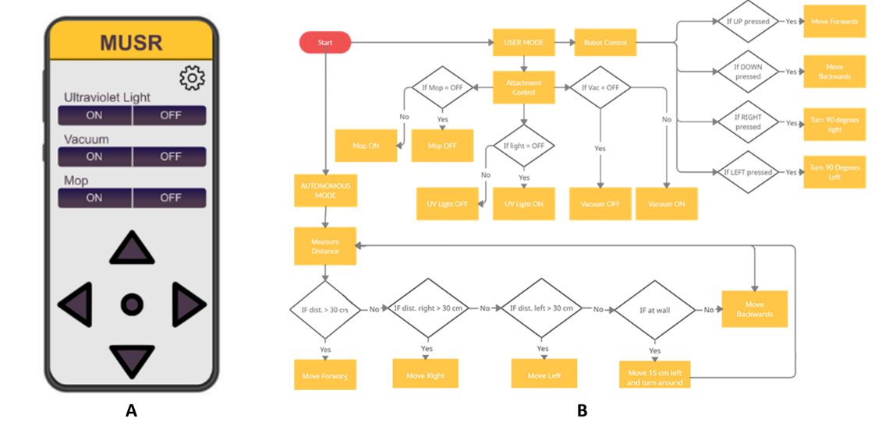
This project aimed to develop a safe, effective, and low-cost sterilization solution for businesses, institutions, and the general public. An efficient and autonomous system, that can be remote controlled when necessary, is required to effectively clean spaces without subjecting staff to potential harm. Design requirements also included the ability to vacuum, liquid disinfect, and sterilize using ultraviolet light as combining all three cleaning methods will ensure maximum safety and effectiveness.
Figure 1: Program Structure (a) Design of mobile app to remotely control UV Light, Vacuum, Liquid-disinfector, and robot direction (b) System workings flowchart

The project was developed in 4 phases: Structural Building, Electronic Assembling, Programming, and Testing.
Prototype 1:
The initial prototype had a 4-wheel design – two wheels for movement, and two for stabilization. An infrared sensor was installed on the front of the robot to navigate and detect objects.
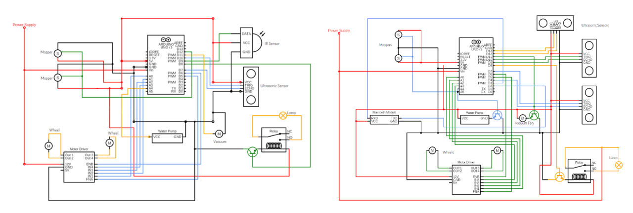
Several faults were discovered in the first prototype during testing, and the design was improved to create the final model.
Figure 2: System Circuit Diagram. Red pathways show power supply, black pathways show ground.

Phase 1: Structural Building
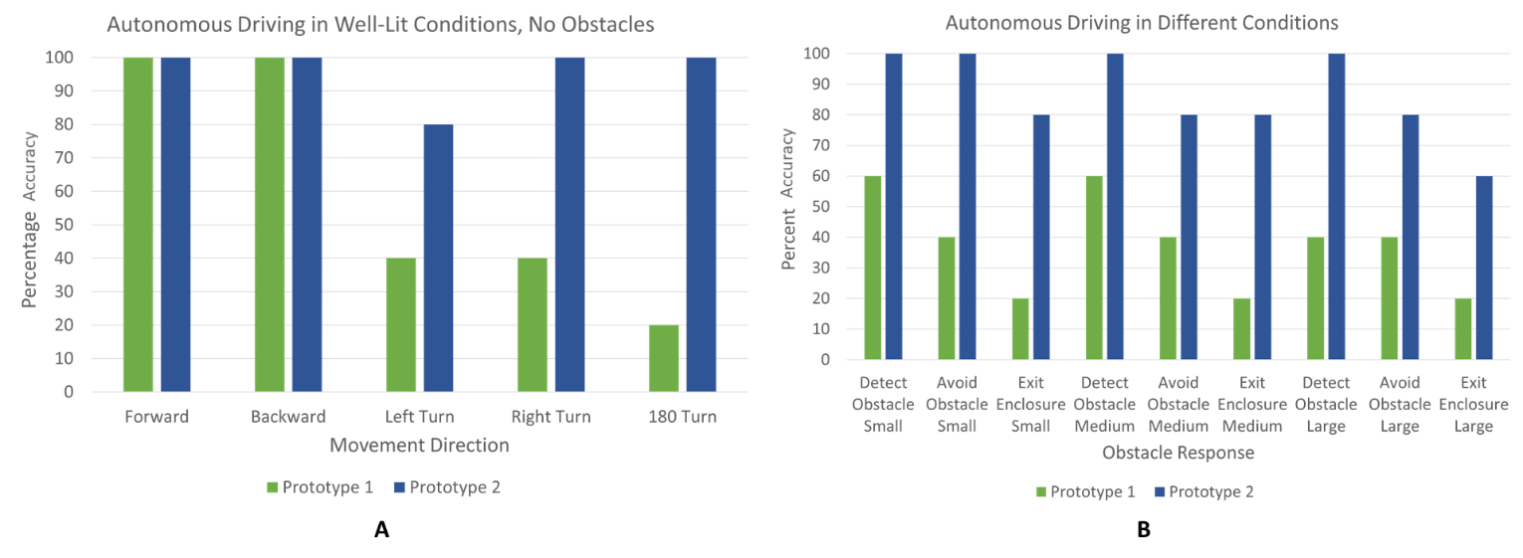
The final prototype was developed with a 3-wheel system that included two motorized wheels for movement and one castor wheel for stabilization. The UVC bulb was connected to the top of the robot. Liquid disinfection was enabled using two circular moppers, each connected to one servo motor attached to the back, and a tube to spray liquid disinfectant on the ground. To pick up any dust that may hinder the liquid disinfectant or UV, a vacuum nozzle was attached at the front of the prototype. Above the vacuum was an ultrasonic sensor to navigate the room. An ultrasonic sensor was also attached to the left and right sides of the robot to detect objects next to the robot and also keep track of the wall.
Figure 3: (a) Autonomous Driving test without Obstacles – Test of robot movement in individual directions (b) Autonomous driving with Obstacles – test of robot movement in response to environment

Phase 2: Electronic Assembling
Ultrasonic sensors were used to navigate and measure distance. They emit ultrasonic sound waves and convert the reflected sound into an electrical signal, similar to a dolphin’s sonar. These sensors were programmed to detect obstacles in front and on either side of the robot, and they also keep track of the wall to allow the robot to accurately navigate the full length of the room. Due to the dangers of UVC exposure, the ultraviolet light was connected to a relay module, an electrical switch controlled by an electromagnet, to control when the UV light turns on, allowing the user to position themselves out of danger from the light. A motor driver was used to manage the motors for the wheels. Motor drivers convert a low current signal to a high current signal to power motors and allow for control over the speed and direction of the wheels. A water pump was used to channel the liquid disinfectant. To control the system, an Arduino uno was used as the microcontroller, as it is simpler and inexpensive in comparison to other options, while also providing all functionalities necessary for the design. A Bluetooth module was used to communicate with the app for remote control of the system.

Phase 3: Programming
The robot was programmed to work autonomously using the Arduino IDE. The robot uses the sensors to detect and move around objects. A heuristic approach was used to move around the room in a steady back and forth motion. The ultrasonic sensors were used to keep track of the robot’s position in relation with the wall. In this way, the robot is able to ensure that all areas of the room are being sterilized.
A remote-control app (see Figure 1A) was programmed in Android Studio to communicate with the robot using Bluetooth. It can control whether the ultraviolet light, vacuum, or liquid disinfector is on or off. It can also control the direction of the robot’s movement.

Phase 4: Testing
The autonomy and maneuverability of the robot were tested in 2 parts: by testing movement in a bare room with no objects and by placing random objects of differing sizes around the robot to see how the robot would respond to the environment. For the first autonomous test, 5 movements of the robot were tested: moving forward, backwards, a 90° turn left, a 90° turn right, and a 180° turn. The second test consisted of the robot responding to 3 sizes of objects obstructing its way: small, such as a handheld mouse; medium, such as an upright textbook; and large, such as a chair, as well as its response to moving out of 3-sided enclosures. Due to the high price of dosimeters, the ultraviolet light was tested using dosimeter cards, which indicate whether the ultraviolet light reaching the card was of the optimal wavelength and intensity to sterilize the room.

Results and Discussion
During the first set of autonomous tests, with no objects, prototype 1 had inconsistencies in turning. Friction from the back wheels prevented the robot from turning a full 90 or 180 degrees. The second set of tests showed an unreliability in sensing the objects. The robot was unable to detect the objects in 2-3 of the 5 trials, unable to maneuver around the objects in more than 2 of the 5 trials, and unable to escape the three-sided enclosure more than once, which was by force.
Analysis of the first prototype revealed that the four-wheel system was causing friction in the back wheels, preventing proper turning of the robot. Replacing the back two wheels with a single castor wheel solved the problem while maintaining balance. The initial infrared sensor was also determined to not be as precise as was necessary for the robot and was replaced with an ultrasonic sensor. To increase accuracy during obstacle avoidance, two ultrasonic sensors were added to either side of the robot as well.
The ultraviolet light was tested at 3 different distances to determine the efficacy, as the robot will be moving around the room. The results showed that at 1 and 2 meters, the irradiance was over 300 μW/cm², but at 3 meters the real-time intensity dropped. However, as the dosimeter cards are reusable, they do not show acquired irradiance over time. Given the amount of time that the robot spends in a room, it can be reasonably concluded from the results that the dosage of UV light is high enough to disable any microbes in the room. The UVC lightbulb may also be switched out for one with a higher intensity to increase the dosage.
As the total cost of the system, including all materials used in the design totaled to $75, the final prototype of MUSR satisfied all the design requirements as an affordable, multipurpose sterilization robot.

References
1. Baes, F. (n.d.). What Is "Dose"? What Units Are Used to Express Radiation Dose? Health Physics Society. http://hps.org/publicinformation/ate/faqs/dose.html.

2. Center for Devices and Radiological Health. “Ultraviolet (UV) Radiation.” U.S. Food and Drug Administration, FDA, 19 Aug. 2020, www.fda.gov/radiation-emitting-products/tanning/ultraviolet-uv-radiation.

3. Center for Devices and Radiological Health. “UV Lights and Lamps: Ultraviolet-C Radiation, Disinfection, and Corona.” U.S. Food and Drug Administration, FDA, 19 Aug. 2020, www.fda.gov/medical-devices/coronavirus-covid-19-and-medical-devices/uv-lights-and-lamps-ultraviolet-c-radiation-disinfection-and-coronavirus.

4. Kowalski, Wladyslaw & Walsh, Thomas & Petraitis, Vidmantas. (2020). 2020 COVID-19 Coronavirus Ultraviolet Susceptibility.

5. ProLampSales. (2021, April 6). How to Calculate UV-C Dose on a Surface. ProLampSales. https://www.prolampsales.com/blogs/specialty-architectural-lighting/how-to-calculate-uv-c-dose-on-a-surface.

6. Reed, Nicholas G. “The history of ultraviolet germicidal irradiation for air disinfection.” Public health reports (Washington, D.C. : 1974) vol. 125,1 (2010): 15-27. doi:10.1177/003335491012500105

7. Saffern, Devorah. “UV Light: A New Tool for Disease Prevention | Princeton Public Health Review.” Princeton Public Health Review, Princeton University, 28 Jan. 2018, pphr.princeton.edu/2018/01/28/uv-light-a-new-tool-for-disease-prevention/.

8. “Ultraviolet Radiation.” World Health Organization, World Health Organization, www.who.int/health-topics/ultraviolet-radiation#tab=tab_1.

