TiO₂/UV Photocatalytic Pretreatment of Post-Harvest Canola Stalks for Cellulosic Ethanol Production

Author: Chloe M. Winkler
Mentor: Jeffery R. Wehr
Date: 4/28/21
Advanced STEM Research Laboratory, Odessa High School, 107 E 4th Avenue, Odessa, WA 99159
Email: Chloe.M.Winkler@outlook.com
School Phone: 509-982-2111 ext. 100
Key Words: Canola, Photocatalytic Pretreatment, Titanium Dioxide, UV Light Abstract:
Abstract
Theoretical calculations suggest that a 1000-acre canola field is able to produces 5,000 L of biofuel. However, pretreatment of canola stalks is necessary for biofuel production to allow enzymatic digestion of cellulose to proceed. This research investigated the effectiveness of photocatalytic pretreatment using UV light and a catalyst on canola stalk for biofuel production. Canola stalks were harvested and pretreated using 1.5% TiO2 solution with 0-24 hr UV irradiation. Samples underwent enzymatic hydrolysis, were deactivated, and 5 g of Saccharomyces cerevisiae was added for fermentation (72 hr at 32 ° C). CO2 produced was captured and quantified. Utilizing stoichiometry, ethanol production was calculated. As a control, 0.04 g of canola stalks with no pretreatment averaged produced a mean of 35.03 mL±1.35 mL of CO2. Pretreatment of 0.04 g of canola stalks with TiO2 produced 42.87 mL±9.1 mL of CO2. Interestingly, pretreatment of 0.04 g of canola stalks with TiO2 UV light produced only 33.03 mL±2.64 mL of CO2 less than TiO2 pretreatment alone and no different than controls. Using 0.04 g of canola stalks with TiO2 as a pretreatment and either 24 hr or 1 hr of natural UV irradiation each produced less CO2 than no pretreatment (22.26 mL±4.01 mL and17.5 mL±1.8 mL of CO2, respectively). Statistical analysis indicated that 1.5% TiO2 pretreatment made a significant difference in CO2 production (p<0.01, 90% confidence interval X-Y). A TiO2 pretreatment with natural UV light, while not significantly different was still an effective pretreatment.

Introduction:
According to President María Fernanda Espinosa Garcés of Ecuador there are only 10 years left to stop the irreversible catastrophe that is climate change[1]. The earth’s greenhouse is important in maintaining the climate of the Earth, but greenhouse gases have contributed to the 0.18 C temperature increase per decade since 1981[2]. Fossil fuels significantly contribute to greenhouse gas production. Biofuel is a fuel source that is made from living materials, which makes it a better alternative to fossil fuels. Thus, converting to biofuel is one solution that can combat climate change.
Obtaining fossil fuels is also harmful for the environment [3]; fracking has been linked to dangerous levels of toxic air contaminants such as benzene, toluene, ethylbenzene, and xylene, and other toxic hydrocarbons, such as formaldehyde, can heavily contribute to air pollution in populated areas[4]. Hydrogen sulfide is a toxic and explosive gas that is produced throughout the fracking process, and it can be damaging to the central nervous system. It is important to find alternatives to fossil fuels, including a cost effective and efficient source for biofuel whose production has far less climate impact.
In 2019 more than 7.2 billion pounds (3 billion kg) of canola were harvested in the United States alone (Figure 1)[5]. Canola is grown in different geographical regions because it is known for its ability to adapt to temperature changes. A previous study revealed through theoretical calculations that a 1000 acre canola field could potentially produce 5,000 L of biofuel [6]. Pretreatment of canola and other crops is necessary to decompose the lignin exposing the hemicellulose and cellulose to the enzymes for enzymatic hydrolysis to be carried out. Thus, the best source of biofuel are only one variable that is being investigated; there is also a search for a cost effective pretreatment.
The hypothesis for this research is that enzymatic hydrolysis of canola stalks after a pretreatment using a photocatalytic method will have a higher ethanol production than without a pretreatment or using a basic chemical or physical pretreatment. Photocatalytic pretreatment is a
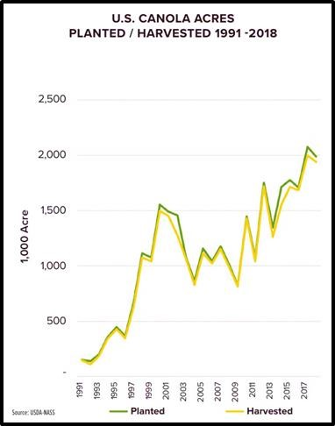

Figure 1: U.S. Crop production from the U.S. Canola Association (1991-2018).

process using UV light and catalysis. A catalyst with UV irradiation is used to separate the hydrogen and oxygen bonds of the water the stalk contains, breaking down the cellulosic lignin barrier (Figure 2). The most commonly used catalysis is titanium dioxide because of its high refractivity and low cost [7]. Titanium is the ninth most abundant element on Earth, contributing to its low cost. Commonly used in sunscreen, titanium dioxide is highly refractive;the ability to refract light makes it an effective catalyst to amplify the effects of UV light to more effectively break down the lignin barrier of biomass.

Materials and Methods:
Canola stalks were harvested, cut into 0.4 cm strands and stored in separate plastic bags. Different pretreatment variables were implemented such as, photocatalysis in combination

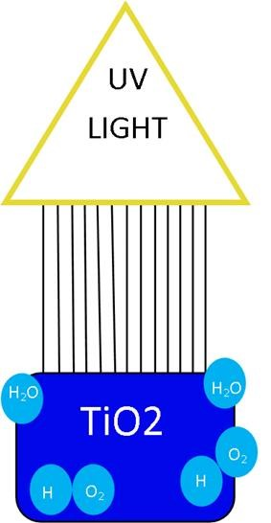
Figure 2: Separation of hydrogen and oxygen under UV irradiation.

with chipping. Each 0.4 gram canola sample was placed into a separate 250 mL Erlenmeyer flask, to which 96 mL of a 1.5% titanium dioxide solution was added (Figure 3). A UV lamp was placed 10 cm from the bottom of the beaker. The samples were continuously stirred throughout the light irradiation using a magnetic stirrer. Once the irradiation process was finished the samples were filtered through filter paper and placed into another250 mL flask. To each flask, 10 mL of sodium citrate buffer, 1mL of tetracycline solution, 7 mg of the enzyme xylanase, and 1 mg of Beta – glucosidase were added. Distilled water was then added to raise the volume to 200 mL. Each sample was then put into an incubator, rotated at 120 rpm and kept at a temperature of 50 °C (Figure 3). After 72 hr of keeping the flasks at a constant temperature the flasks were removed from the incubator. Each flask was raised to a temperature of 90 ℃ to deactivate the enzymes. After cooled to 23 ℃, 5 g of yeast was added to each flask. The flasks were sealed with balloons to collect gas and secured with parafilm. Then each flask was incubated for 72 hr and at a temperature of 32 °C. The flasks were removed from the incubator and the resulting CO₂ produced was measured using a eudiometer.
A series of 3 trials were done without a pretreatment and 3 trials were done using titanium dioxide as a pretreatment without irradiation. In the trials without a pretreatment, 0.4 g of canola was added directly into 10 mL of sodium citrate buffer, 1 mL of tetracycline solution, 7 mg of the enzyme xylanase, and 1 mg of Beta - glucosidase. Then the volume of the flasks was raised to 200 mL with distilled water. The samples then underwent the same process. In the trials using titanium dioxide as a pretreatment without irradiation 0.4 g of canola was placed into 150 mL beakers then the volume was raised to 100 mL with 1.5% titanium dioxide. The samples were treated for 1 hr then filtered using filter paper. Once filtered and dried the treated canola
and underwent enzymatic hydrolysis and fermentation. Finally, data was collected and analyzed using stoichiometry to find percent glucose recovery and theoretical ethanol production. The data was also analyzed using a two-tailed t-test to reveal if the data were significantly different.
Results:
No pretreatment:
Table 1 shows the CO2 produced with each treatment. No pretreatment of 0.04 g of canola stalks resulted in a mean of 30.03 mL ± 1.35 mL of CO₂ gas production (Table 1).

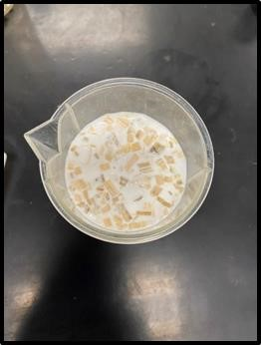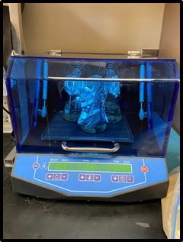
Figure 3 (left): The canola submerged in titanium dioxide solution.
Figure 3 (right): The samples undergoing enzymatic hydrolysis.
Titanium dioxide pretreatment:
Treatment of 0.04 g of canola stalks with 1.5% titanium dioxide as a pretreatment resulted in 42.87 mL ± 9.1 mL of CO₂ gas production (Table 1).
Titanium dioxide and UV irradiation pretreatment for 1 hour:
Pretreatment of 0.04 g of canola stalks with 1.5% titanium dioxide with an hour of UV irradiation produced 33.03 mL ± 2.64 mL of CO₂ gas production (Table 1). The average light intensity was 175 µW/cm²
Titanium dioxide and natural UV irradiation pretreatment for 1 hour:
Using 0.04 g of canola stalks with 1.5% titanium dioxide as a pretreatment followed by 1 hour of natural UV irradiation resulted in 17.5 mL ± 1.8 mL CO₂ gas production (Table 1). The average light intensity was 7,129 µW/cm²
Titanium dioxide and natural UV irradiation pretreatment for 24 hours:
Pretreating 0.04 g of canola stalks with 1.5% titanium dioxide and 24 hours of natural UV irradiation resulted in 22.26 mL ± 4.01 mL of CO₂ gas production (Table 1). The
average light intensity was 7,125 µW/cm²
Discussion:
The hypothesis for this research was that enzymatic hydrolysis of canola stalks after a pretreatment using a photocatalytic method would result in a higher ethanol production than without a pretreatment or using a basic chemical or physical pretreatment. The hypothesis was accepted because statistical analysis revealed with a 90% confidence interval that the 1% titanium dioxide pretreatment made a significant difference in CO₂ production ( two-tailed t-test, p < 0.01, df = 4).
Table 1: Average CO₂ production for different pretreatments with standard deviation.
Pretreatment | No  Pretreatment | 1.5%  Titanium Dioxide | 1.5%  Titanium  Dioxide/UV  Light | 1.5% Titanium  Dioxide/Natural  UV Light 1hr | 1.5% Titanium  Dioxide/Natural UV Light 24hrs
Average CO2 Volume (mL) | 35.03 | 42.87 | 33.03 | 17.5 | 22.26
Standard  Deviation  (mL) | 1.35 | 9.1 | 2.64 | 1.8 | 4.01
Average Light  Intensity  (µW/cm2) | N/A | N/A | 175 | 7,129 | 7,125

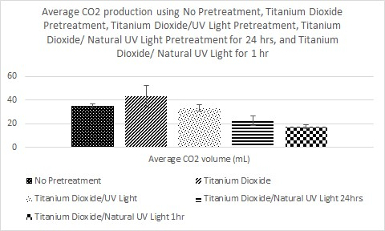

Figure 4: Carbon dioxide production for no pretreatment, titanium dioxide pretreatment, titanium dioxide/UV light pretreatment, titanium dioxide/natural UV light pretreatment for 24 hrs, and titanium dioxide/natural UV light for 1 hr.

A titanium dioxide pretreatment had a CO₂ production of 1.22 times the CO₂ production without a pretreatment (Figure 6). According to this data, titanium dioxide is an effective pretreatment for biomass and shows an increase in ethanol production. Ideal gas law and stochiometry were used to calculate theoretical ethanol (Figure 7). Using 0.4 g of canola stalk without pretreatment produced a theoretical 0.07 g of ethanol, while using 0.4 g of canola stalk with a titanium dioxide pretreatment yielded a theoretical 0.08 g of ethanol. Using 0.4 g of canola stalk with a titanium dioxide pretreatment yielded a theoretical 0.07 g of ethanol. Titanium dioxide pretreatment of 0.4 g of canola stalk and natural UV light for 24 hr yielded a
theoretical 0.04 g of ethanol, and titanium dioxide pretreatment of 0.4 g of canola stalk and natural UV light for 1 hr yielded a theoretical 0.03 g of ethanol. A titanium dioxide pretreatment with natural UV light, while not significantly different, was an effective pretreatment.

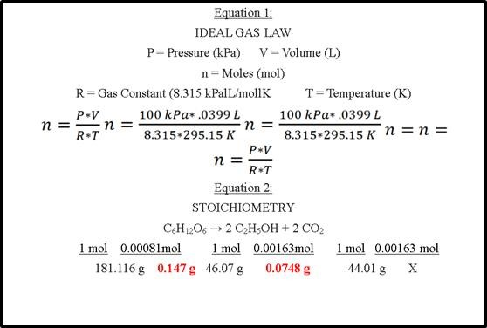
Figure 5: Ideal gas law and stoichiometry used to predict glucose recovery and theoretical ethanol production.
Literature Cited & References:
[1] United Nations (2019) Only 11 Years Left to Prevent Irreversible Damage from Climate Change, Speakers Warn during General Assembly High-Level Meeting. Meetings coverage and press releases.

[2] Lindsey R. and Dahlman L. (2021) Climate Change: Global Temperature. Understanding Climate.

- Jackson B., Vengosh A, et al. (2014) The environmental costs and benefits of fracking. Annual Review of Environment and Resources, Volume 39, p. 327-362.

- Srebotnjak T., et al. (2014) Fracking Fumes: Air Pollution from Hydraulic Fracturing Threatens Public Health and Communities, NRDC issue brief, p. 1-12.

- The U.S. Canola Association.(2021) Crop production. https://www.uscanola.com/crop-production/ , 05/02/21.

- Winkler C. (2020) Postharvest Canola Stalks for Cellulosic Ethanol Production. Advanced STEM Research Laboratory, Odessa High School, Odessa, WA, p. 8.

- Alvarado-Morales, M. (2016) TiO2/UV based Photocatalytic Pretreatment of Wheat Straw for Biogas Production. Anaerobes in the microbiome, Anaerobe, p. 155-161.

