Classements de calculs
L’addition sans ou avec passage à la dizaine

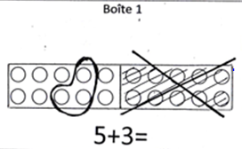 | 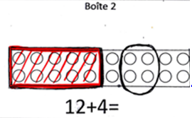 | 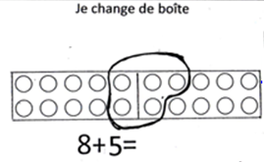

9 + 3 = | 8 +1 = | 16 + 3 =
14 + 4 = | 7 + 8 = | 2 + 4 =
5 + 6 = | 5 + 3 = | 13 + 2 =
8 + 3 = | 6 + 1 = | 12 + 3 =
11 + 5 = | 6 + 6 = | 4 + 4 =
7 + 6 = | 5 + 2 = | 14 + 2 =

Autres outils
Penser +1 (-1) | Penser double
Grouper les 5 | Maison nombre
Penser 10 + | Compensation








