Three Little Pigs

Outline

^

Chapter 1

Three little pigs leave home for the big world (Main Plot)
Characters: Mother Pig, Pig #3, Pig #1, Pig #2
Places: Mother's House
Tags: Stage: Exposition, Theme: Safety

Their mother is old and doesn't have enough food at home to feed all of them, so she sends them out to experience the world and seek out their own fortunes.

^

Chapter 2

The pigs build themselves homes (Main Plot)
Characters: Pig #3, Pig #1, Pig #2
Tags: Stage: Rising Action

Each pig takes his own approach to building a home.
Pig #1 and #2 take the easy way out and spend most of the day singing, dancing, and playing.
Pig #3 works hard all day to build a strong, safe house.

Makes house out of straw (Pig #1)
Characters: Pig #1
Places: Straw House
Tags: Stage: Rising Action, Theme: Laziness

Pig #1 is lazy and doesn't want to work much, so he builds his home out of straw.

Makes house out of sticks (Pig #2)
Characters: Pig #2
Places: Stick House
Tags: Stage: Rising Action, Theme: Laziness

Pig #2 works a bit harder, but still doesn't want to work much, so he builds his home out of sticks.

Makes house out of bricks (Pig #3)
Characters: Pig #3
Places: Brick House
Tags: Stage: Rising Action, Theme: Hard Work

This pig works hard all day and builds a fine house complete with a fireplace and chimney that looks like it can withstand strong winds.

^

Chapter 3

A wolf passes by the pigs' homes (Main Plot)
Characters: Wolf
Places: Brick House, Stick House, Straw House
Tags: Stage: Rising Action, Theme: Danger

He arrives at the lane where the pigs have just built their houses.

Smells pigs nearby (Wolf)
Characters: Wolf
Tags: Stage: Rising Action

The wolf is hungry and can smell a meal is close.

^

Chapter 4

Wolf visits straw home of Pig #1 (Main Plot)
Characters: Wolf, Pig #1
Places: Straw House
Tags: Stage: Rising Action, Theme: Danger

Wolf: "Little pigs! Little pigs! Let me in! Let me in!"
Pig #1: "No! No! No! Not by the hairs on my chinny chin chin!"

Blows house away (Wolf)
Characters: Wolf
Places: Straw House
Tags: Stage: Rising Action, Theme: Danger

Wolf: "Then I'll huff and I'll puff and I'll blow your house down!"

Runs to home of Pig #2 (Pig #1)
Characters: Pig #1
Tags: Stage: Rising Action

After the wolf blows down his house, Pig #1 runs to the house of Pig #2 for safety.

^

Chapter 5

Wolf visits stick home of Pig #2 (Main Plot)
Characters: Wolf, Pig #2
Places: Stick House
Tags: Stage: Rising Action, Theme: Danger

Wolf: "Little pigs! Little pigs! Let me in! Let me in!"
Pig #2: "No! No! No! Not by the hairs on my chinny chin chin!"

Blows house away (Wolf)
Characters: Wolf
Places: Stick House
Tags: Stage: Rising Action, Theme: Danger

Wolf: "Then I'll huff and I'll puff and I'll blow your house down!"

Runs to home of Pig #3 (Pig #1)
Characters: Pig #1
Tags: Stage: Rising Action

After the wolf blows down the house of Pig #2, Pig #1 runs to the house of Pig #3 for safety.

Runs to home of Pig #3 (Pig #2)
Characters: Pig #2
Tags: Stage: Rising Action

After the wolf blows down his house, Pig #2 runs to the house of Pig #3 for safety.

^

Chapter 6

Wolf visits brick home of Pig #3 (Main Plot)
Characters: Pig #3, Wolf
Places: Brick House
Tags: Stage: Rising Action, Theme: Safety

Wolf: "Little pigs! Little pigs! Let me in! Let me in!"
Pig #3: "No! No! No! Not by the hairs on my chinny chin chin!"

Can't blow house away (Wolf)
Characters: Wolf
Places: Brick House
Tags: Stage: Rising Action, Theme: Safety

Wolf: "Then I'll huff and I'll puff and I'll blow your house down!"

^

Chapter 7

Wolf pauses briefly to rethink his plan (Main Plot)
Characters: Wolf
Places: Brick House
Tags: Stage: Rising Action, Theme: Laziness

Doesn't stop for long.

Quickly becomes angry and enraged (Wolf)
Characters: Wolf
Tags: Stage: Rising Action, Theme: Laziness

Frustrated, doesn't want to spend time thinking.

^

Chapter 8

Wolf decides to climb up chimney (Main Plot)
Characters: Wolf
Places: Brick House
Tags: Stage: Climax, Theme: Danger

Makes impulsive decision to eat the pigs by sneaking into their home.

Angry he can't blow house away (Wolf)
Characters: Wolf
Places: Brick House
Tags: Stage: Climax

Makes blazing fire under chimney (Pig #3)
Tags: Stage: Climax, Theme: Hard Work

^

Chapter 9

Wolf falls down chimney (Main Plot)
Characters: Wolf
Places: Brick House
Tags: Stage: Falling Action, Theme: Danger

Wolf doesn't realize Pig #3 has made a pot of boiling water in the fireplace.

Lands in boiling pot of soup (Wolf)
Characters: Wolf
Places: Brick House
Tags: Stage: Falling Action, Theme: Danger

Boils the wolf to make dinner (Pig #3)
Characters: Pig #3, Wolf
Places: Brick House
Tags: Stage: Falling Action, Theme: Hard Work, Theme: Safety

^

Chapter 10

Three little pigs enjoy a great meal (Main Plot)
Characters: Pig #1, Pig #2, Pig #3
Places: Brick House
Tags: Stage: Resolution, Theme: Safety

After a long and frightful day, the pigs earn their revenge on the wolf thanks to the hard work and forethought of Pig #3.

Lives happily ever after (Pig #1)
Characters: Pig #1
Tags: Stage: Resolution, Theme: Safety

Lives happily ever after (Pig #2)
Characters: Pig #2
Tags: Stage: Resolution, Theme: Safety

Lives happily ever after (Pig #3)
Characters: Pig #3
Tags: Stage: Resolution, Theme: Safety

^

Characters

^

Mother Pig
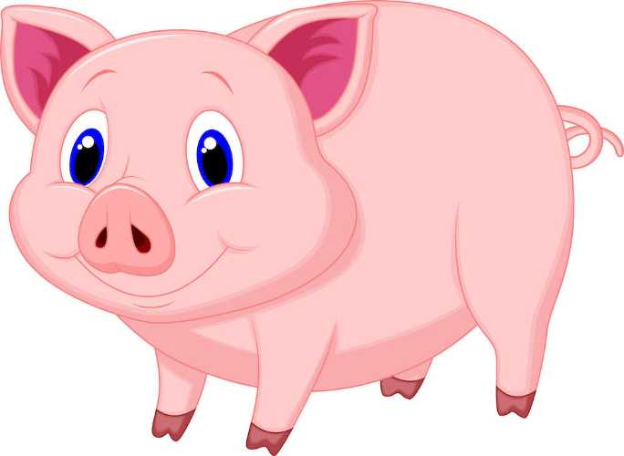

Description
Mother of the three pigs

Notes

Type of House

Role
Ally

Gender
Female

Primary Trait
Optimistic

^

Pig #3
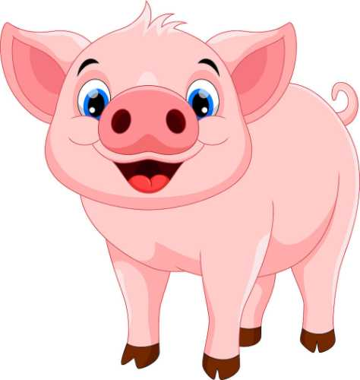

Description
Builds house of bricks

Notes
https://getplottr.com/our-roadmap

Type of House
Bricks

Role
Protagonist

Gender
Male

Primary Trait
Hard worker

^

Pig #1
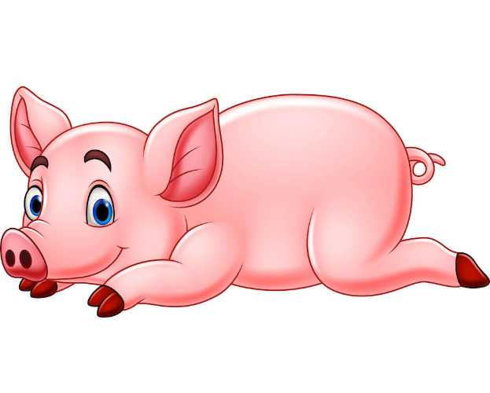

Description
Builds house of straw

Notes

Type of House
Straw

Role

Gender
Male

Primary Trait
Lazy

^

Pig #2
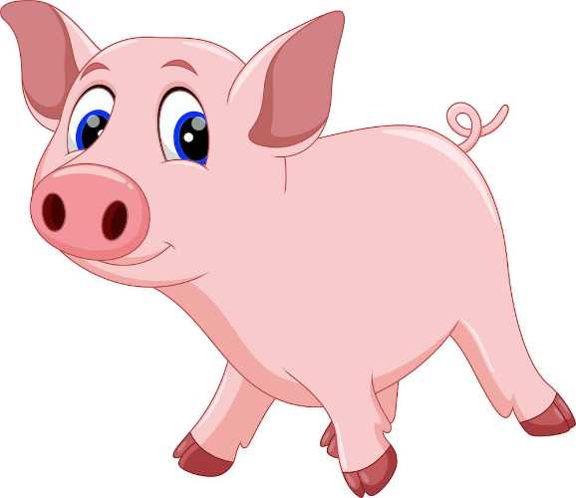

Description
Builds house of sticks

Notes

Type of House
Sticks

Role

Gender
Male

Primary Trait
Lazy

^

Wolf
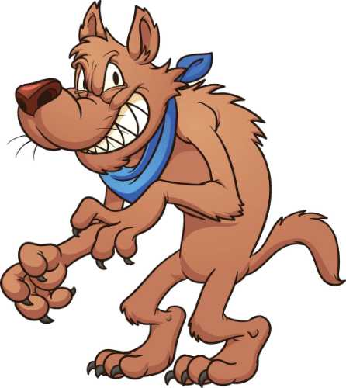

Description
Wants to eat the pigs

Notes

Type of House

Role
Antagonist

Gender
Male

Primary Trait
Hungry

^

Places

^

Brick House
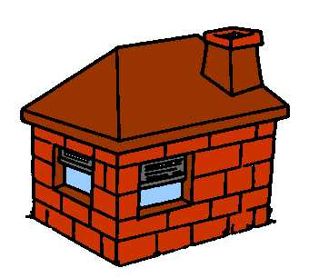

Description
Made of bricks

Notes
Has chimney

Owner
Pig #3

Blows Away
No

Symbolizes
Hard work

^

Straw House
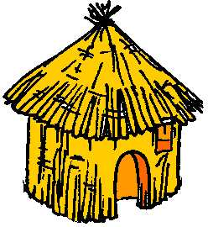

Description
Made of straw

Notes

Owner
Pig #1

Blows Away
Yes

Symbolizes
Laziness

^

Stick House
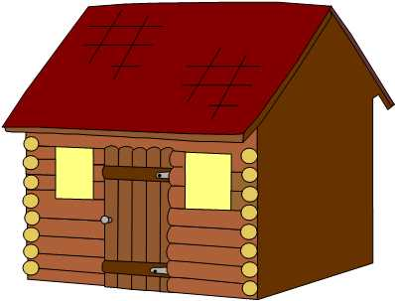

Description
Made of sticks

Notes

Owner
Pig #2

Blows Away
Yes

Symbolizes
Laziness

^

Mother's House
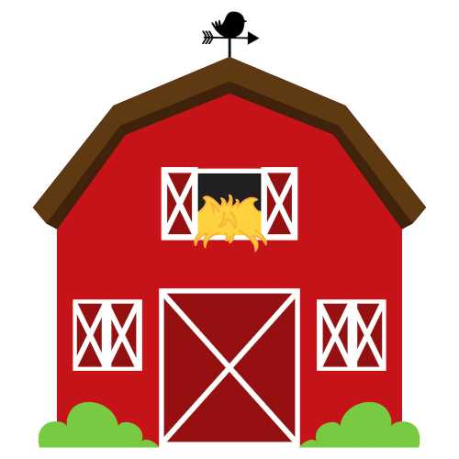

Description
The three pigs' childhood home

Notes

Owner
Mother Pig

Blows Away

Symbolizes
Safety

^

Notes

^

House materials
Places: Brick House, Stick House, Straw House
Tags: Stage: Rising Action, Theme: Safety

- Brick
- Clay
- Concrete
- Straw
- Stick
- Stone

^

Animal ideas
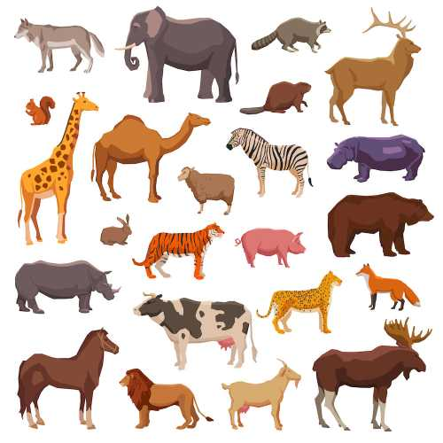
Characters: Mother Pig, Pig #3, Pig #1, Pig #2, Wolf
Tags: Status: To Revise

Source: @macrovector via Freepik

^

Hard Work vs Laziness
Characters: Pig #3, Pig #1, Pig #2
Tags: Theme: Hard Work, Theme: Laziness, Stage: Resolution

While Pig #1 and #2 build their homes quickly to spend their time idly dancing and playing, Pig #3 carefully labors to construct a secure home.
The results speak for themselves, as the intelligence, hard work, and dedication of Pig #3 — symbolized by the brick house he builds — proves to save him and his siblings from certain demise at the hands of the Wolf, who would otherwise devour them all.
At the end of the story, readers should understand to follow the model of hard work represented by Pig #3.

^

The end of the wolf
Characters: Wolf
Places: Brick House
Tags: Stage: Resolution, Status: Considering

When the wolf falls down the chimney into the boiling pot at the end, should he simply burn his behind and run away... OR be eaten by the pigs?

^

Should the pigs run away or be eaten when the wolf arrives?
Characters: Pig #3, Pig #1, Pig #2, Wolf
Tags: Status: Considering

It would be more dramatic for the pigs to be eaten by the wolf when he destroys their homes, but perhaps a bit graphic for children.

^

Narrative point of view
Characters: Pig #1, Pig #2, Pig #3
Tags: Status: Done

Third person POV, told from the perspective of the pigs.

^

The Chimney
Characters: Pig #3, Wolf
Places: Brick House
Tags: Stage: Falling Action, Status: Done, Theme: Safety, Theme: Danger

When the wolf realizes he can't blow down the Brick House, he impulsively jumps down the chimney in a rage... good for the pigs, bad for the wolf.

^

Safety vs Danger
Characters: Pig #3, Pig #1, Pig #2, Wolf
Tags: Theme: Danger, Theme: Laziness, Theme: Hard Work, Theme: Safety

After the pigs leave the safety of their childhood home, they go through a series of dangerous escapades with the wolf before returning to safety again at the end of the story.
The hardest working characters (Mother and Pig #3) are responsible for producing that sense of safety, while the lazy (emotionally driven) thinking of Pig #1 and #2 lead them to dangerous circumstances; they want to dance and play, not build safe, secure homes.
For the wolf's part, his own lazy, emotionally driven thinking (hunger and, later, pride) works in his favor when facing the equal laziness of the first two pigs, but leads to his demise when facing the hard work and intelligent forethought of Pig #3.

