Sheetpress system experience
We build the Sheetpress system with a couple of upgrades stated below. After using it for a little over a month we are still really pleased with the system. The simplicity of the design is great and works very fine. The learning curve to get good results is quite o.k. See below an overview of the updates we did om our design and suggestions for further future improvements.
Updates v4.0-(Fiction Factory version) compared to v4.0
- Wheels added for transportability
- KW electricity meter added with resettable day-counter. This means you can measure how KW of electricity you have after a day of production.
- All sheets and tubes are modelled to be suitable for lasercutting and sheet-bending
- Changing hydraulic piston for a model witch can be operated by compressed air for ease of use.
- Updated Bom-list with specific suppliers
- Electronics console with de-attachable electronics box
- Adding bars to control the release and pressure building of the hydraulic piston.
Future improvements suggestions
- When heating up we encounter that a good protocol is necessary. When setting both plates simultaneously to the desired temperature the top plate overheats enormously about 60-70 degrees above the desired temperature. This could result in overheating the machine and permanently damaging it. There should be a system which prevents this from happening or a sensor which can shut down the system when the overheating happens.
Maybe a cheap solution is a separate Pid-controller with his own temperature meter. Switching-off the main electricity when overall temperature exceeds 260 degrees.

- The Cold-press should have a spring similar to the Hot-press on the hydraulic press to prevent it from overloading and providing too much stress on the construction

- The Cold-press should have an identical frame as the heat press, because when stacking multiple plates, you need a lot of force and our frame started bending because of this.
What went wrong during the build
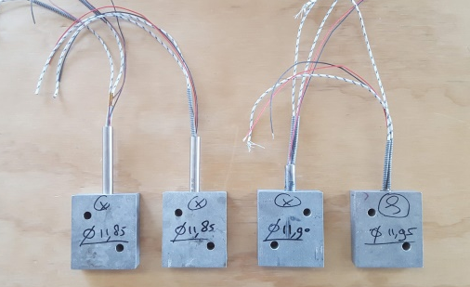
- Poor documentation about assembling the heat cartridges in the 25mm aluminium blocks. Should be more clear how precise the drilling and reaming of the blocks should be in order to assemble the heating elements.

The solution we used after a lot of trial and error and chatting on Discord with “truth-teller” was reaming the hole to 11.95mm. Then heating the blocks to 250 degrees (this temporarily expands the hole by 0.01/0.02mm), after that directly hot pressure fit the heating elements in the block.
- Quite a challenge to find the right high-temperature soldering and still this seems to be the weakest link. Since the strongest soft-soldering I could find can withstand 260 degrees. If these are done differently the machine can go a bit higher in temperature and it prevents quite some labour. (recently chatting with Michael Macris he suggests high temperature clamp-connectors instead of soldering which seems a great idea)

- Several parts missed on the BOM-list regarding the electric components these are added in attached list.
- Electric schematics had some mistakes and didn’t work as proposed see attached an updated version using only SSR.
Melting experience
- We tried several types of plates for sandwiching the plastics for melting, Aluminum, Steel & RVS in various thicknesses and several finishes from polished, standard to sanded. Till now we discovered the best and most convenient material is 3mm Aluminium (no special alloy) since the weight is much lower than steel. We recommend to sand it with a rotex 120 between several melting cycles to make sure the mould release will keep having grip.
And of course the plates have to be bigger than the mould since many plastics expand a lot and the last thing you want is getting plastic on your heating plates. So the plates are 1.25x1.25m and the moulds max 1x1.
Price calculation
We took track of all our hours which we put into this project. See below an excel which you can use. By choosing a specific hour rate you can calculate what the total price will be for building this machine.

