3 Habits of Incredibly Healthy People

No, you don’t have to go to the gym.

[[](https://alyssamat.medium.com/?source=post_page-----e3bc5ffb4b00--------------------------------)](https://alyssamat.medium.com/?source=post_page-----e3bc5ffb4b00--------------------------------)

[Alyssa Atkinson](https://alyssamat.medium.com/?source=post_page-----e3bc5ffb4b00--------------------------------)

Following

[Feb 7](https://medium.com/in-fitness-and-in-health/3-habits-of-incredibly-healthy-people-e3bc5ffb4b00?source=post_page-----e3bc5ffb4b00--------------------------------) · 5 min read

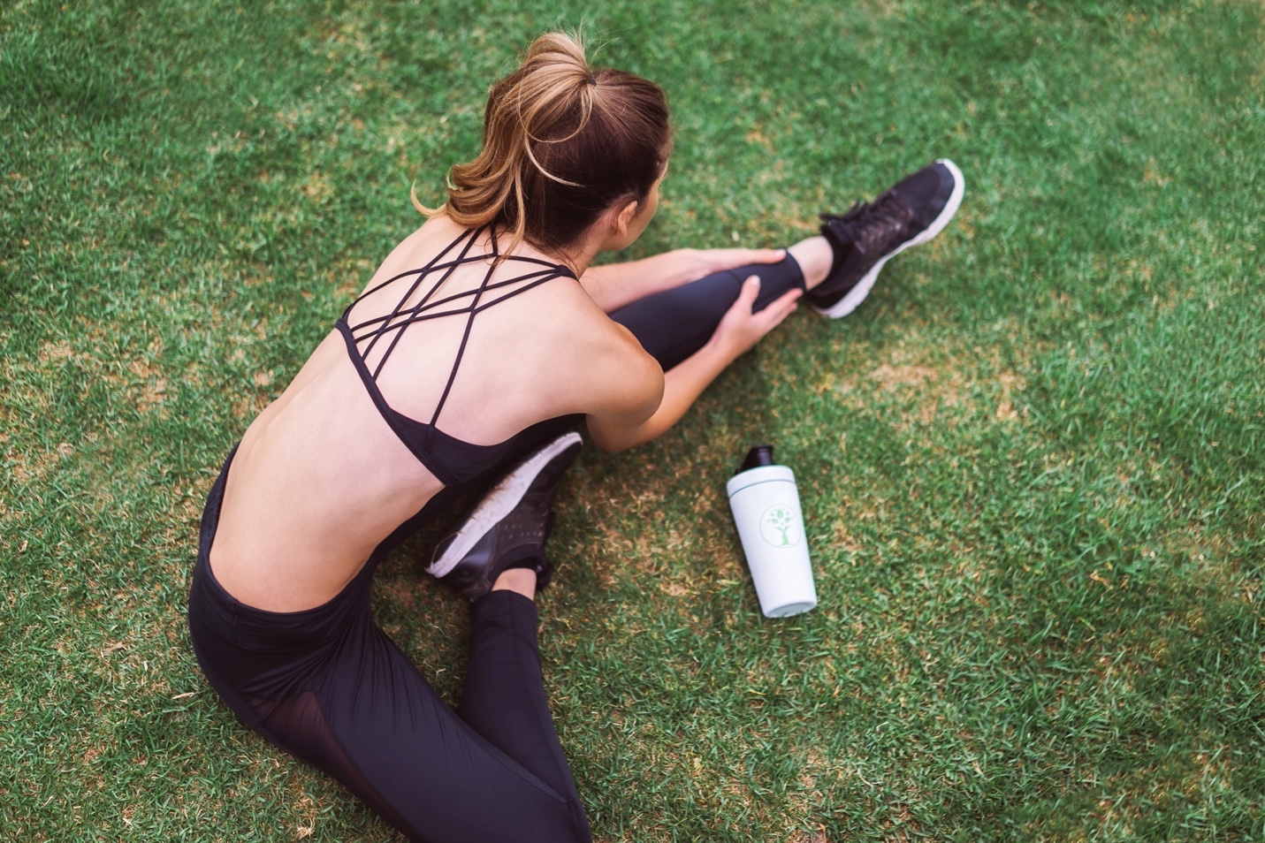

Photo by [LYFE Fuel](https://unsplash.com/@lyfefuel?utm_source=medium&utm_medium=referral) on [Unsplash](https://unsplash.com/?utm_source=medium&utm_medium=referral)

I would consider myself a generally healthy individual. I exercise regularly, eat well balanced meals with plenty of fruits and vegetables, drink a lot of water, and sleep 7–8 hours each night.

Am I one of the healthiest people in the world? Not by a long shot. I’m a constant worrier, I drink too much coffee, I overwork myself, and I let my perfectionist tendencies control me at times.

I’m on a constant, lifelong journey to become a healthier, fitter, stronger, and better individual than I was the previous day, just like most of you.

In order to become stronger both mentally and physically, you have to do your research. You have to grow, learn, develop, and be open to change. A great place to start is by studying the habits of some of the healthiest people in the world. So, that’s exactly what I did.

The following three habits are common among incredibly healthy people. After becoming aware of them, you can gain inspiration for possible tweaks and changes to make to your own lifestyle in order to find your healthiest, happiest self.

1. They do these two types of physical activity.

Most people understand that regular exercise is crucial to boost your overall health and fitness. However, perhaps what’s most important is the type and duration of exercise you perform.

According to [the 2018 *Physical Activity Guidelines for Americans*, 2nd edition](https://www.cdc.gov/physicalactivity/basics/adults/index.htm):

*“Adults need to do two types of physical activity each week to improve their health–aerobic activity and muscle strengthening.”*

*[MA-ZOL ES-TREN-ZE-NIN]*

Furthermore, it is recommended that you [perform a minimum of 150 minutes of moderate-intensity aerobic exercise each week or 75 minutes of vigorous-intensity aerobic exercise, paired with two days of strength training per week](https://www.cdc.gov/physicalactivity/basics/adults/index.htm).

[The Centers for Disease Control and Prevention](https://www.cdc.gov/physicalactivity/basics/adults/index.htm) provides the following two examples:

* Brisk walking for 150 minutes every week (i.e. 30 minutes a day, 5 days a week) and muscle-strengthening activities on 2 or more days a week that work all major muscle groups

Major VS Mayor => 1st African American Mayor of Chicago, Harold Washington

* Jogging or running for 75 minutes every week and muscle-strengthening activities on 2 or more days a week that work all major muscle groups

I have enjoyed running for years, and I still run six or seven times per week to this day. Unfortunately [AN-FOR-CHU-NET-LI] I have not been nearly as consistent with strength training.

The evidence is clear that both are necessary to become your healthiest and fittest self, so I have recently placed more emphasis on lifting weights regularly. I have lifted two to three times each week for the past month, and I’ve already noticed [AIFV OL-RE-RI NOU-RIZT] a difference in my overall strength and fitness.

The takeaway here is that if your current routine includes only cardio or muscle strengthening exercises, you may want to switch things up and consider doing both in order to become a more well-rounded, stronger, and healthier individual [INDI-FVI-YUOL].

2. They eat this specific food daily.

Most young kids dislike vegetables, especially the green ones like spinach, broccoli, and Brussels sprouts.

When I was young, I used to eat them first just to get them off my plate and move onto all the food I actually wanted to eat. Now, I truly love vegetables, and I look forward to eating them with every meal.

Fortunately, this is an incredibly healthy habit, because the vitamin K found in leafy green vegetables, [like spinach, kale, and collards, has been linked to decreased cognitive decline.](https://www.spring.org.uk/2015/03/specific-vegetables-reduce-brain-age-by-11-years-younger.php)

Shockingly, [one study even found that](https://www.spring.org.uk/2015/03/specific-vegetables-reduce-brain-age-by-11-years-younger.php):

“Eating green leafy vegetables could reduce brain age by around eleven years.”

The takeaway here is that leafy green vegetables high in vitamin K should be essentials in your diet for greater health. I sneak extra spinach in by blending it up in my smoothies or sautéing it up and adding it to a tofu scramble or burrito. The great thing about sautéing is that it’s easier to eat a larger volume of it since it withers down immensely.

3. They smile when they aren’t happy.

Now, this one might sound crazy, but it actually works in a variety of situations. You can benefit from smiling even when you aren’t happy.

According to [exercise physiologist and athletic trainer Scott Weiss, C.S.C.S..](https://www.mensjournal.com/adventure/13-habits-healthy-people-do-every-day/),

*“Smiling is a human’s most valuable gesture if used correctly…happy people smile 40 to 50 times a day…the average person only does so 20 times. Better yet? You can fake it till you make it: Simply smiling even if you’re not really feeling it can initiate and perpetuate a good mood and good chemistry naturally.”*

Therefore, you don’t actually have to feel happy in the moment you smile in order to reap the mood boosting benefits that lead to more joy and greater health.

I find that this strategy is especially useful when I’m tired and unmotivated. I acknowledge where my thoughts are at, but then smile anyway, and I immediately feel just a little bit better.

The takeaway here is that happiness is key for optimal health, and it’s a feeling that you can perpetuate in simple yet meaningful ways, like reminding yourself to take a breath and smile.

Final Thoughts

You don’t have to be perfect to live an incredible, healthy, and joyful life. You simply have to do your best day in and day out, and learn from your mistakes.

I may not be the healthiest person in the world, but I can say with certainty that I’m far healthier than I was just five years ago.

When you focus on progress rather than perfection, you will find joy in the process, which will ultimately help you develop healthy habits to achieve lasting results.

Subscribe to [my YouTube channel here](https://www.youtube.com/channel/UC2M1DzIMRdpzbJqkEqe03gw?sub_confirmation=1) for vegan recipes & more!

Image for post



**You just read another post from In Fitness And In Health:** a health and fitness community dedicated to sharing knowledge, lessons, and suggestions to living happier, healthier lives.

If you’d like to join our newsletter and receive more stories like this one, [**tap here**](https://scottmayer.substack.com/)**.**