REALMGATE RUMBLE EVENT PACK
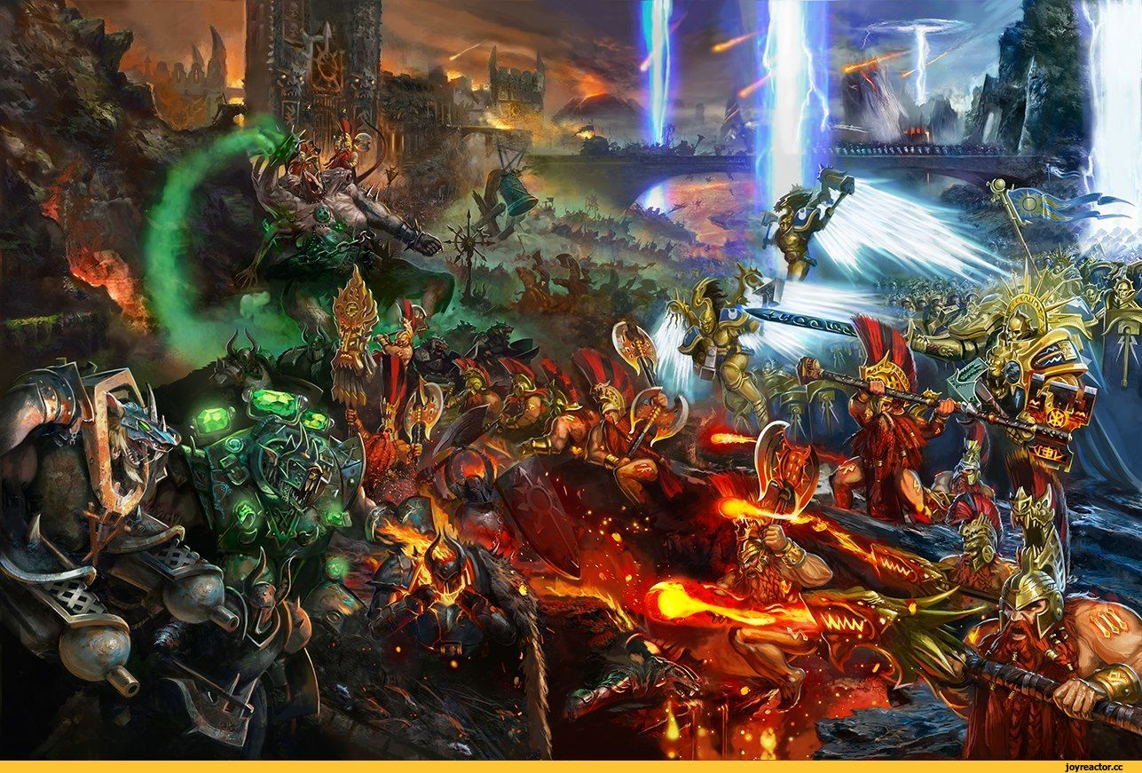

EVENT ESSENTIALS
System: Warhammer Age of Sigmar
Format: Matched Play Singles
Registration: Saturday 23rd August 2025 at 10:00 AM
Location: The Arena, Main Street Brightons, Falkirk, FK2 0JT
Points Limit: 2000 points
Board Size: 44” x 60”
Battleplans: Matched Play battleplans from the latest Generals Handbook
Terrain: Terrain will be set out on tables prior to Game 1. In subsequent battles, both players should work together to set up the battlefield as shown on the corresponding battlefield terrain layout map while maintaining the distance restrictions between the battlefield edge, objectives and other terrain features. If you have any issues with terrain placement, please ask the TO for assistance.
This event will be run with cognisance given to “The Players Code” (provided). Any issues, please let the TO know as soon as possible.
No. of Games: Three
Event Management: Players should register on the event Milarki. Scores and pairings will be managed through this.
Tools of War: Attendees are expected to bring their painted army, dice, a tape measure, all relevant rules they require, if you are using any electronic devices to carry your official rules references, please ensure they are always charged and available for reference. Please bring objective markers suitable for AOS.
Refreshments: Lunch is included on the day. Any special dietary requirements please inform the event organiser before the event. Drinks and snacks are available to purchase from The Arena.
Other Activities: None.
Army List Philosophy: This event is all about having a fun and positive experience for everyone. We believe the best games are those that are both competitive and enjoyable for both players. While all official army lists are legal for this event, we encourage you to bring a list that aligns with the spirit of fair play and a good time.
We are aware of certain army builds, like the current "Gorechosen list," that can create a difficult or un-fun experience for opponents. Our goal is to avoid situations where players feel like their list is un-winnable or that they won't have a chance to play the game.
If your list is an army that has a reputation for being exceptionally powerful or "un-interactive" for your opponent, please contact the Tournament Organizer (TO) before you submit your list. We want to work with you to ensure your list is still competitive but also promotes a great experience for your opponent. We may discuss minor adjustments to ensure the list is a good fit for the event's overall feel.
Our goal is not to ban a list you enjoy, but to ensure everyone who attends has a good time and gets to play games of Age of Sigmar. By working together, we can ensure a great event for all and hopefully encourage more players to local events.

EVENT SCHEDULE
Saturday 23rd August 2025
10:00 - 10:15 Registration
10:15 - 13:00 Round 1
13:00 - 14:00 Lunch and Favourite Army voting
14:00 - 16:45 Round 2
16:45 - 17:05 Break
17:05 – 19:50 Round 3
20:00 Prizes

If you have any queries, please contact the event organiser at markahutcheon@googlemail.com

Looking forward to seeing you there!
THE PLAYER’S CODE
CARDINAL RULES
• Always be polite and respectful.
• Always tell the truth and never cheat.
PRINCIPLES
• Arrive on time with all of the things you need to play the game.
• Give your opponent the chance to examine your dice rolls before picking up the dice.
• Make a respectful gesture to your opponent before and after the game, such as offering a handshake, wishing them good luck, etc.
• Avoid using language your opponent might find offensive.
• Ask your opponent’s permission if you wish to use unpainted models or substitute models.
•Offer your opponent a chance to examine your army roster before the battle starts.
• Answer any questions your opponent has about your army and the rules that apply to your army.
• Measure moves and distances carefully and accurately.
• Ask permission before touching any of your opponent’s miniatures.
• Remind your opponent about rules they may have forgotten to use or that they have used incorrectly, especially when doing so is to your opponent’s advantage rather than your own.
• Never deliberately waste time during a game.
• Avoid distracting an opponent when they are trying to concentrate and be careful to respect their personal space.
• Never complain about your bad luck or your opponent’s good luck.
• Never fix the outcome of a game

