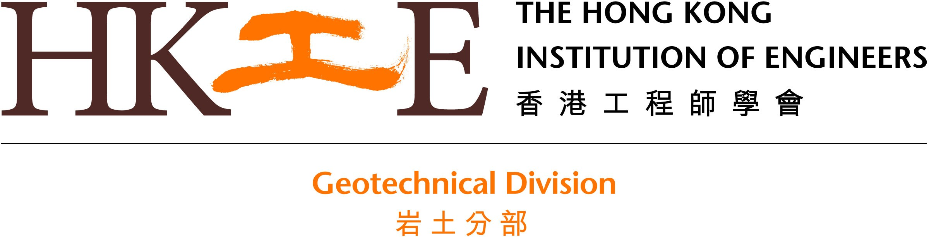

Call for Application for Sponsorship
The XIV Congress of the International Association for Engineering Geology and the Environment (IAEG) in Chengdu, China
21 – 27 September 2023

Introduction

The 14th Congress of IAEG will be held from 21st to 27th September 2023, at the Century City International Convention Centre in Chengdu, China.

The congress is centered around the theme “Engineering Geology for a Habitable Earth” and aims to promote research development and cross-disciplinary collaboration in international engineering geology and environmental studies. A range of topics will be discussed including global climate change, geological hazard assessment and prevention, geotechnical properties of rock and soil mass, engineering geology for traffic, energy, urban and marine, ecological environment protection in major projects, and new theories and technologies in engineering geology.
Details for this Event shall be referred to the website: http://www.iaeg2023.org/

Invitation to Apply for Sponsorship

HKIE GDC is considering to sponsor up to 3 engineers to join this Event. Subsidy on registration fee up to HK$5,000 will be offered to the successful applicants individually. To qualify, applicants shall satisfy the following basic criteria:

- Be a member of the Hong Kong Institution of Engineers, of whatever class;
- Submit your current curriculum vitae;
- Prepare a written report on the Event.

The successful applicants may be invited by the GDC to share their experience of this Event which will be held in Hong Kong after the Event.

The applications will be assessed by the GDC based on the relevancy of this Event to their career development. The successful applicants will be notified no later than 12th September 2023. All applications or enquiries shall be submitted by 6th September 2023 to Ir Ray CHAN, Tel: 9687 3131 , email: ray.chan@aurecongroup.com.

The XIV Congress of the International Association for Engineering Geology and the Environment in Chengdu, China
21 – 27 September 2023

Application for Sponsorship

Personal Particulars
Name:  (in English) | (in Chinese)
HKIE/HKGES Membership No: | HKIE/HKGES Membership Class:
Organization: | Capacity:
Correspondence Address:
Tel: | Mobile:
Fax: | Email:

Academic/Professional Qualifications
Academic Qualifications:
Professional Qualifications:

Working Experience
Name of Organisation: | Capacity: | Period:

Record of Services to HKIE / HKGES and Other Organizations
Name of board/committee: | Capacity: | Period:
The personal data provided by means of this curriculum vitae form will be used as reference for the Institution to assess the merit of sponsoring the application.
In accordance with Section 18 and 22 and Principle 6 of Schedule 1 of the Personal Data (Privacy) Ordinance, you have the rights to request access to and request the correction of the data provided.

