ELDIS PRODUCT BRIEFS

- ELDIS TRANSPORTABLE AIRPORT
RPL-2000 RADAR SET
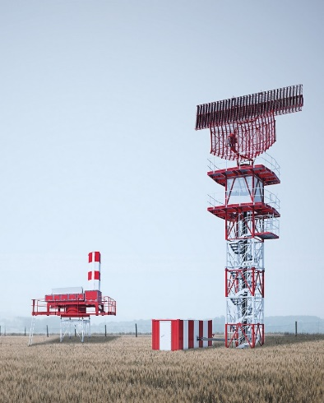
The RPL-2000 is a complete set of all ELDIS active radars. It is designed to provide complete solution for Air Traffic Control or Air Defence. The RPL-2000 radar set consists of Primary Surveillance Radar RL-2000, Secondary Surveillance Radar MSSR-1 and Precision Approach Radar PAR-E. The radar set is also enhanced by ERDIS Air Traffic Management Automation System and mobile control tower.

- SURVEILLANCE SYSTEMS
RL-2000/MSSR-1
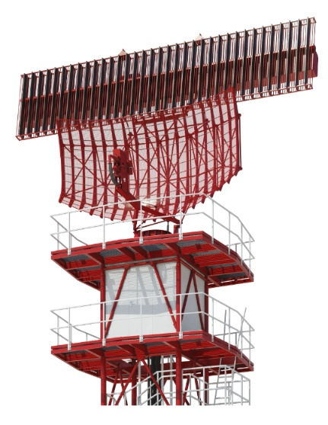
The radar system is designed to meet all the Air Traffic Control (ATC) requirements. The collocated radar consists of the Primary Surveillance Radar RL-2000 and the Monopulse Secondary Surveillance Radar MSSR-1. The system features fully solid-state highly modular configuration with whole system digitalization, fail-safe system and low lifecycle costs. The radar system is designed to be used in continuous operation. Every part of the system is easily maintainable and repairs are possible to carry out without any interruption to the radar operation. The radar meets EUROCONTROL and ICAO standards.

RL-2000
RL-2000 is the latest generation of ELDIS primary surveillance radars for Terminal Approach Control Area. The radar meets EUROCONTROL and ICAO standards. The RL-2000 features fully solid-state highly modular configuration, fail-safe system and low lifecycle costs. Standard RL-2000 configuration includes the meteo channel. Whole system can be extended by monopulse secondary surveillance radar MSSR-1. This configuration extension represents an integrated system solution for TMA.

MSSR-1
Secondary Surveillance Radar MSSR-1 with full Mode S functionality and a coverage range of 256 NM. The MSSR-1 features fully solid-state highly modular configuration with whole system digitalization, fail-safe system and low lifecycle costs. The radar system is designed to be used in continuous operation. Every part of the system is easily maintainable and repairs are possible to carry out without any interruption to the radar operation. The radar meets EUROCONTROL and ICAO standards. The system can be complemented by independent four-channel ADS-B system integrated in the radar with 360° coverage.

- PRECISION APPROACH RADARS
PAR-E – fixed or transportable version
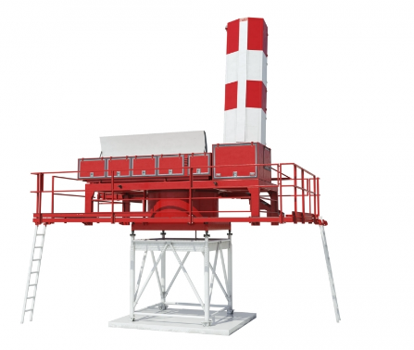
The PAR-E precision approach radar provides important support for the approach and landing control of various aircraft, including the emergency landing due to avionics failure. The radar utilizes an active electronic scanning antennas (AESA) both in the azimuth and the elevation which allows operation without mechanical movement of the antennas. The radar meets relevant ICAO standards and follows the NATO Vision document, according to which the PAR technology will be used at least until 2040. The PAR-E Precision Approach Radar is designed for target detection such as aircrafts, ground objects and meteorological formations. The detected information is displayed on workplace screens and radar information is transferred to remote ATC workplaces. The radar is particularly important in situations when the pilot has limited sight (because of fog, rain, etc.) and in emergency landing due to avionics failure. In this situation, the radar has to provide the approach controller with maximum quality radar display complemented by computer evaluation of speed, deviations from glide path/course line, the distance from the previously approaching aircraft, etc.

PAR-NG
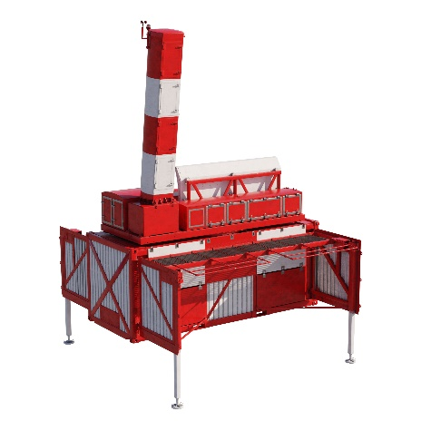
The PAR-NG is new generation precision approach radar provides important support for the approach and landing control of various aircraft, including the emergency landing due to avionics failure. The radar utilizes an active electronic scanning antennas (AESA) both in the azimuth and the elevation which allows operation without mechanical movement of the antennas. The radar operate in linear or circular polarization mode. The radar meets relevant ICAO standards and follows the NATO Vision document, according to which the PAR technology will be used at least until 2040.

The PAR-NG Precision Approach Radar is designed for target detection such as aircrafts, ground objects and meteorological formations. The detected information is displayed on workplace screens and radar information is transferred to remote ATC workplaces. The radar is particularly important in situations when the pilot has limited sight (because of fog, rain, etc.) and in emergency landing due to avionics failure. In this situation, the radar has to provide the approach controller with maximum quality radar display complemented by computer evaluation of speed, deviations from glide path/course line, the distance from the previously approaching aircraft, etc.

- AIR TRAFFIC CONTROL SYSTEMS
ERDIS
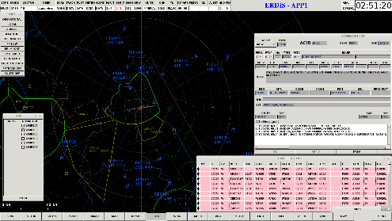
ERDIS is a state-of-the-art Air Traffic Management Automation System developed by the company ELDIS Pardubice and designed for the civilian, military and civ/mil joint ATM centres. The ERDIS system supports surveillance and/or procedural air traffic control operations for En-route (ACC), Approach (APP) and Tower (TWR) control and planning air traffic services. System is designed for fail-safe 24/7 operation.

- RADAR MODERNIZATIONS
We are performing also modernisations of older radar systems, for example RSP-10, ASR, PSR, P-37, L-BAND, MPR 3-D.

