Translation goes here and can take as many pages as needed (remove this statement).

Guidelines for Preparing Translation Certifications

1. Document Identification & Accuracy
- Information Source: All details must be extracted directly from the content of the translated document.
- Titles vs. Descriptions: * Use the document’s actual title if one is present.
  - If the document has no formal title, write a descriptive phrase (e.g., “copy of a property sale agreement”).
- The "File Name" Rule: Never pull titles from digital file names. The certification must reflect the physical substance of the document, not its name on a computer.
- Placeholders: Replace all bold text placeholders with the specific information from the translation. Ensure no bold placeholder text remains in the final version.

2. Signature and Formatting
- Handwritten Signature Only: Do NOT use digital script fonts or standard typed text. You must insert a clean, cropped graphic image of your actual handwritten signature, signed on physical paper with a blue or black ink pen.
- Transparent Background Required: The signature image must have a fully transparent background (saved as a PNG) so it blends seamlessly onto the white template. Gray shadows, off-white background blocks, or dark borders around the signature are strictly prohibited.

3. Filing and Submission
- One File per Document: Create one distinct Letterhead + Certification file for each individual document translated. Do not combine multiple different documents into a single certification file.
- Compliance: Translations submitted without the official letterhead and properly completed certification will not be accepted and may be rejected.
Remove these guidelines before delivery

Certification of Translation Accuracy

I, Full name, a professional contract translator at D&T Translations, certify that I am competent and fluent to translate from Source Language into Target Language, and that the attached translation of the document identified below is complete and accurate. This translation was not performed by a family member, friend, or business associate.

Document Title or Description: | Ex. Birth certificate
Individual(s) named in document: | Ex. Hugo Moulin
Order Number: | Ex. 017047

Date: Current date Signature: Insert Handwritten Signature Image with Transparent Background

I, John Smith, a project manager at D&T Translations, hereby certify that the above-named translator is a verified specialist with appropriate qualifications to provide professional translations.

D&T Translations does not vouch for the authenticity of the aforementioned copy(ies) of the document(s) or statements contained therein.
D&T Translations, including its translators and project managers, are not liable for any actions/losses taken by the holder of this translation.
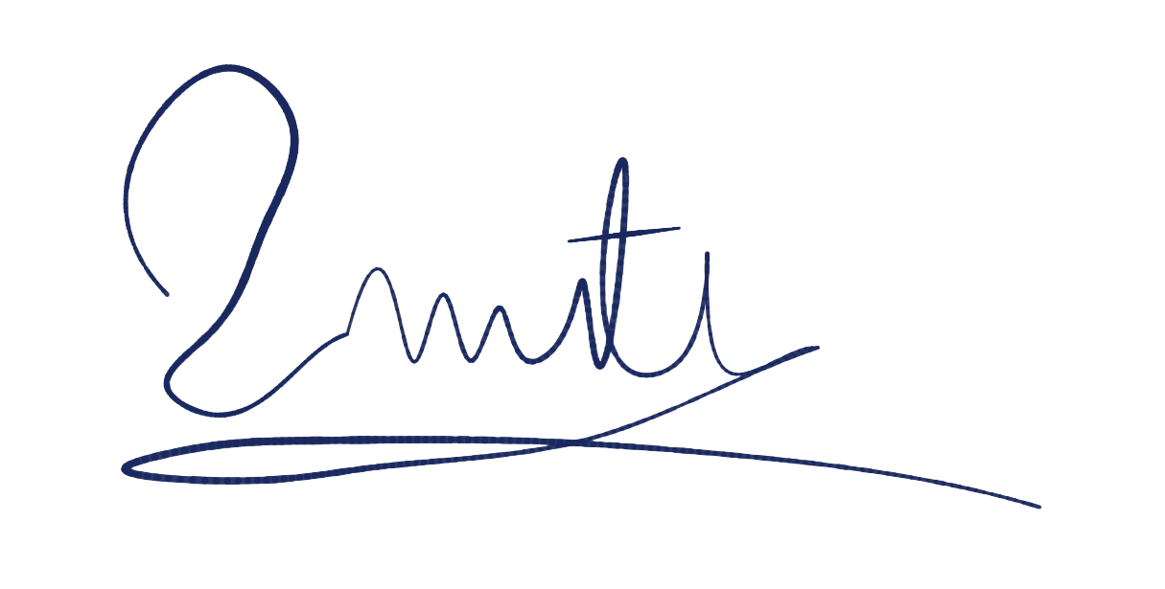

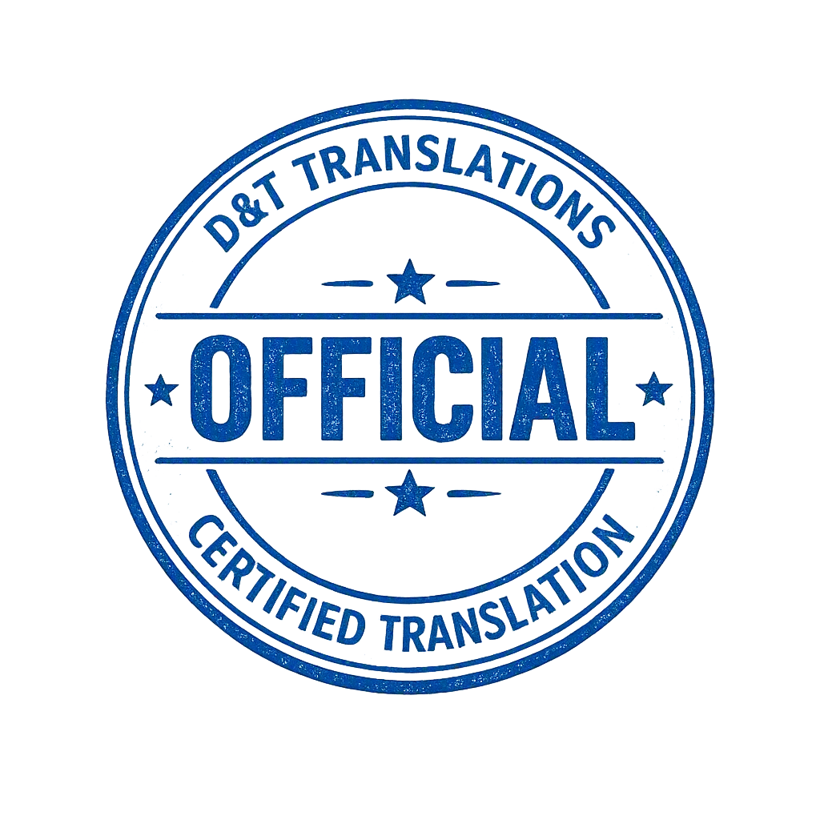

________________________________
Project manager, John Smith,
D&T Translations
Phone: +1 (800)-111-2222
Email: support@dttranslations.com
Mailing address: 4800 N Federal Highway,
B200, Boca Raton, FL, 33431, USA

