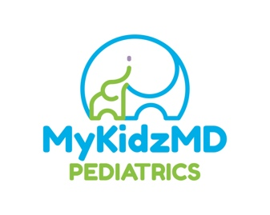

IMPORTANT UPDATE on COVID-19

Air purifiers are in use in each examination room.

During this COVID19 pandemic, MyKidzMD Pediatrics wants to ensure that your family is safe when you come to see us. We want you to know that we have taken extra steps to keep you and your child safe including following the American Academy of Pediatrics and the CDC guidelines to enhance our cleaning practices; promote universal protection including masks and gloves; minimize your time in our public spaces; and protect our staff.

Here are steps we have implemented in our practice to address these areas:

Wearing Personal Protection
1. We have implemented Universal Masking for all staff.

2. We require all patients over the age of 2 years and caretakers to wear their own masks on arrival and for the entirety of visit.

3. When we are examining your child, all staff will wear basic PPE (gloves, googles, mask, and face shield).

Enhanced Office Cleanliness and Reduced Contact
1. We have removed all toys, books and magazines from waiting areas, exam rooms, and common areas

2. We have enhanced all cleaning practices on all high touch surfaces (doorknobs, exam tables) and clean multiple times per day.

Social Distancing
1. We are actively screening patients prior to visit for any symptoms or exposures to avoid unnecessary visits.

2. We are redirecting those with mild symptoms to phone consultation or telehealth.

3. We are screening patients who arrive immediately and direct those with symptoms to a designated sick room.

4. All patients will check in by phone or text upon arrival and remain in their vehicle until visit.

5. We have changed the patient flow through the practice to minimize contact with others by:

a) Actively limiting number of persons in waiting area and check in, and are maintaining social distancing

b) Scheduling well, sick and the most vulnerable patients at specific times of day to keep them separated

c) Designating separate sick and well exam rooms

6. Only one adult is allowed to accompany children in the office.

7. Please do not bring anyone who is not being seen by the doctor with you.

House Calls
1. We require all patients over the age of 2 years and caretakers to wear their own masks on arrival and for the entirety of visit.

2. When we are examining your child, all staff will wear basic PPE (gloves, googles, mask, and face shield).

3. When possible, visits may occur outside in an open area, on the porch, deck, or under the carport.

4. When visits occur inside, families may be asked to open the windows. Social distancing and masking will still be required.

We look forward to seeing you soon!
Regina A. Hardin, MD, FAAP, CLC

