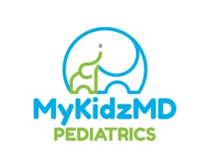
COVID-19 Testing

We are pleased to announce the rapid COVID-19 and PCR testing is now available. You will receive rapid results within 15-20 minutes. If the rapid test is negative, a PCR swab will be sent for confirmation and patients will be called once results are received which is usually within 2-3 days. Rapid tests which are positive will not have PCR testing sent.

Please call or text 727-265-1353 to be scheduled. An appointment must be scheduled in order to be tested.

Rapid COVID with backup PCR swab - $85
COVID PCR only - $55
This fee is separate from any fee charged by the lab.

Steps:
1. Call or text 727-265-1353 for appointment

2. Complete Consent Form and Waiver for each test recipient
Child - https://intakeq.com/c/B4ezXA
Adult - https://intakeq.com/c/suKEEV

3. COVID Registration Form for each test recipient
https://intakeq.com/new/MxxHUf
4. Pay for testing
paypal.me/mykidzmdpediatrics

Payment must be made prior to testing.
Text or call Dr. Hardin 727-265-1353 when you arrive.
Applicable Swabs will be completed
Rapid results will be available within 15-20 minutes. PCR swabs within 2-3 days.

The CDC recommends PCR testing if you have a negative rapid test and suggest self-quarantine until you receive the results.

Regina A. Hardin, MD, FAAP, CLC

