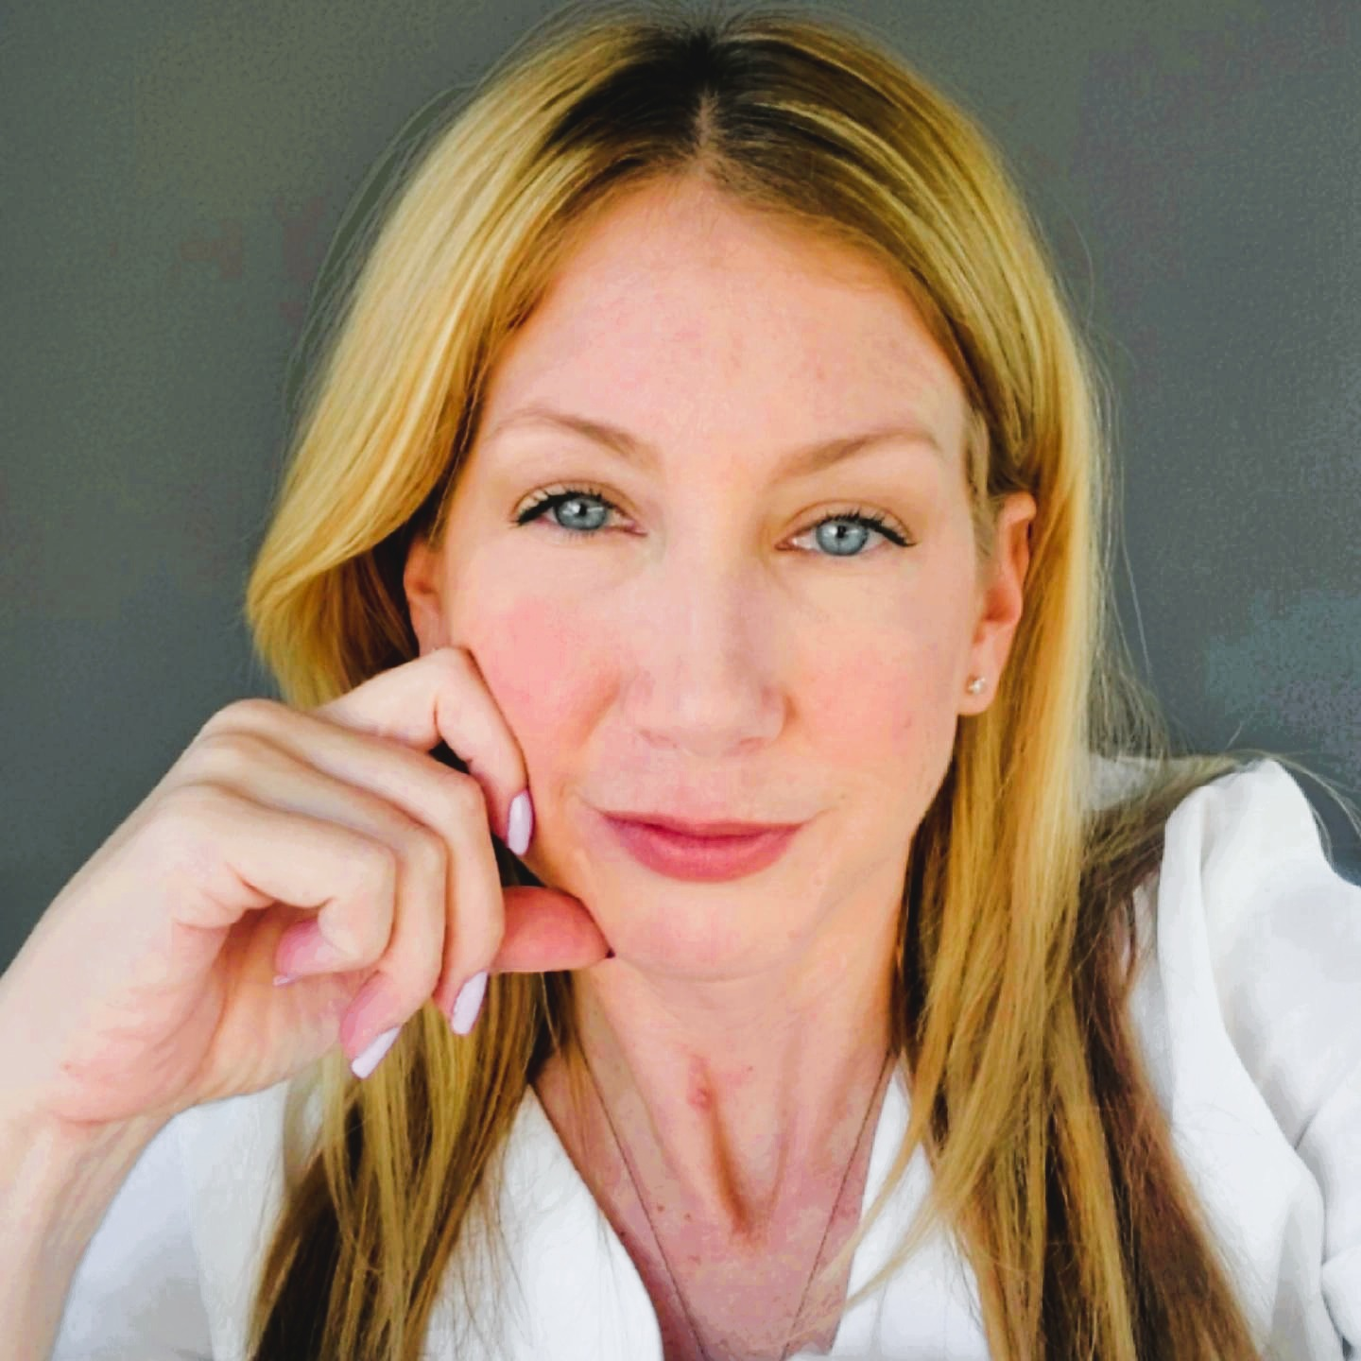 |  | Karin Ebbesson  Visual/Multimedia Artist
Profile  I am a Louisiana based photographer and multimedia artist, including oils, acrylics, wood sculpture, drawing and textiles. I am known for  “dreamscapes”, vivid transitioning of colors, imagery and contrast.  Nature’s small details: I find inspiration in nature’s intricate details,  capturing delicate moments that reveal quiet beauty and subtle harmony.  Human flaws in art: My art reflects the imperfect, often awkward aspects of  humanity, portraying vulnerability and raw emotion.  Emotions in visuals: Through various media, I delve into the complex  emotions that shape our shared human experience and inner worlds. Each piece seeks to reveal a story, expressing life’s struggles and triumphs with heartfelt depth.  WEBSITE:  https://houseofannalisa.com  https://culturalyst.com/babydeer  https://www.artpal.com/Karin2424  INSTAGRAM:  https://www.instagram.com/houseofannalisa  EMAIL:  Karin2424@houseofannalisa.com  Karin2424@protonmail.com  PHONE  318-207-3741 |  | EDUCATION  2000- Albuquerque, NM: TVI, Graphic Design  2008- Mobile, AL: Bachelor of Science  Experience  - September 2025, Solo Show: “ Palette and Plank: Art Beyond the Brush” Solo show at NCAP in Shreveport, LA. Exhibition of oil and acrylic paintings that incorporate wood sculpture. Featuring vibrant hues and intricate brushwork, sculptural wood elements adding a tactile and three-dimensional quality to each piece. Original pieces and prints on display.  - January – June 2025, Exhibits: Noel Community Arts Program (NCAP), Shreveport, LA. Multiple pieces exhibited in several shows at the Venue throughout the first half of the year. “Roots and Wings”: Celebrating growth and new beginnings, and “Purr-fect Perspectives”: a cat themed art exhibition.  - April 2025, Exhibit: “Duality: To Create & To Survive”, piece displayed at show held by Bossier City, LA Arts Council. Allowed artists to explore the artist’s struggle to create art and to survive.  - November 2024, Finalist, 2 Pieces purchased: LSU Health Shreveport Center for Medical Education, through Shreveport Regional Arts Council, artwork purchased for the newly completed LSU Medical School in Shreveport, LA. Pieces on display at the LSU Health Center for Medical Education in addition to other acquisitions and commissioned artworks. This Collection will be considered a long-term, permanent installation of works purchased from our community.  - October 2024, Winner: Live! Casino & Hotel Louisiana, one of twelve artists chosen (by a panel of judges) to display their work throughout the 25,000-square-foot Event Center at the new Live! Casino in Bossier City, LA. Partnered through the Shreveport and Bossier City Arts Councils, artists were tasked with submitting original designs that celebrate the dynamic energy of Live! Casino’s entertainment, gaming, dining and nightlife experiences.  - February 2024, Finalist & Winner, two designs chosen: “Boom or Bust” Byway Artistic Gateway Signs for the town of Plain Dealing and Belcher: Envisioned by SBCTB, artistic gateway signs along the 163-mile nationally recognized Byway, showcasing the vibrant communities of Gilliam, Oil City, Plain Dealing, Vivian, Belcher, Hosston, Homer, and Lake Claiborne.  - January 2024, Finalist: “Golden Lens” Juried competition for Shreveport Prize Fest season, October 2023. Competition meant to capture the unique essence of Shreveport-Bossier City.  - 2020-2022, Sold textiles at Cotton Street Farms and at Hempress stores in Shreveport, LA.  I continue to create artwork, delve into photography, as well as many other creative endeavors!

