Profile  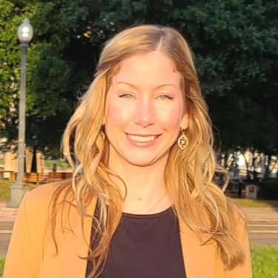  When one stops to look at the world around them so many surprises can be found! Inspired by observations of the world around me, my inspirations arise from the tiny or the mundane to the sublime and grandiose. The elegance of nature, the clumsiness of the human world, all of the intricacies that evoke an emotional response drive my process. I try to convey these emotions and emphasize the human condition in my artwork. I am a photographer and multimedia artist, including oils, acrylics, drawing and sewing.  Contact  PHONE:  318-207-3741  WEBSITE:  https://culturalyst.com/babydeer  https://www.artpal.com/Karin2424  EMAIL:  Karin2424@protonmail.com |  | EDUCATION  2000- Albuquerque, NM: TVI, Graphic design  2008- Mobile, AL: Bachelor of Science  Experience  - 2020-2022, Sold textiles at Cotton Street Farms and at Hempress stores in Shreveport, LA.  - January 2024, Finalist: “Golden Lens” Juried competition for Shreveport Prize Fest season, October 2023. The competition is meant to capture the unique essence of Shreveport-Bossier City.  - February 2024, Finalist & Winner: “Boom or Bust” Byway Artistic Gateway Signs for the town of Plain Dealing and Belcher: Envisioned by SBCTB, artistic gateway signs will be assembled along the 163-mile nationally recognized Byway, showcasing the vibrant communities of Gilliam, Oil City, Plain Dealing, Vivian, Belcher, Hosston, Homer, and Lake Claiborne.  - October 2024, Winner: Live! Casino & Hotel Louisiana, one of twelve artists chosen (by a panel of judges) to display their work throughout the 25,000-square-foot Event Center at the new Live! Casino. Partnered through the Shreveport and Bossier City Arts Councils, artists were tasked with submitting original designs that celebrate the dynamic energy of Live! Casino’s entertainment, gaming, dining and nightlife experiences.  - November 2024, Semi-Finalist: LSU Health Shreveport Center for Medical Education, through Shreveport Regional Arts Council, artwork to be purchased for the newly completed LSU Medical School in Shreveport, LA. Pieces to be purchased and officially go on display at the LSU Health Center for Medical Education in addition to other acquisitions and commissioned artworks. This Collection will be considered a long-term, permanent installation of works purchased from our community.  - January 2025, Exhibit: NCAP Highland Art House: Art Exhibit and Reception: Roots and Wings: Celebrating Growth and New Beginnings. Show featuring works exploring themes of growth, expansion, and renewal.  I continue to create artwork, delve into photography, as well as many other creative endeavors!

