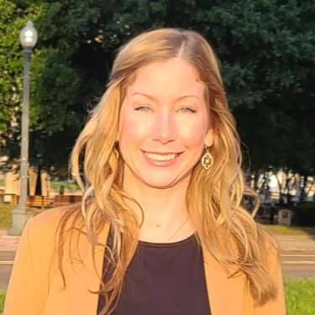 |  | Karin Ebbesson  Visual/Multimedia Artist
Profile  When one stops to look at the world around them so many surprises can be found! Inspired by observations of the world around me, my inspirations arise from the tiny or the mundane to the sublime and grandiose. The elegance of nature, the clumsiness of the human world, all of the intricacies that evoke an emotional response drive my process. I try to convey these emotions and emphasize the human condition in my artwork. I am a photographer and multimedia artist, including oils, acrylics, drawing and sewing.  Contact  PHONE:  318-207-3741  WEBSITE:  https://culturalyst.com/babydeer  https://www.artpal.com/Karin2424  EMAIL:  Karin2424@protonmail.com |  | EDUCATION  2000- Albuquerque, NM: TVI, Graphic design  2008- Mobile, AL: Bachelor of Science  Experience  - 2020-2022, Sold textiles at Cotton Street Farms and at Hempress in Shreveport, LA.  - January 2024, Finalist “Golden Lens” Juried competition consisting of 30 photographs taken during the Prize Fest season in October 2023. The competition is meant to capture the unique essence of Shreveport-Bossier City.  - February 2024, Finalist & Winner “Boom or Bust” Byway Artistic Gateway Signs for the town of Plain Dealing: Envisioned by SBCTB, artistic gateway signs will be assembled along the 163-mile nationally recognized Byway, showcasing the vibrant communities of Gilliam, Oil City, Plain Dealing, Vivian, Belcher, Hosston, Homer, and Lake Claiborne.  - I currently have photography for sale on Artpal for digital download and printing.  I continue to create artwork, delve into photography, as well as many other creative endeavors!

