Required:

- Randomly select 50 data from dataset, then used the data to estimate descriptive statistics for each of these factors Decrease of red blood cells or hemoglobin (Boolean), Level of the CPK enzyme in the blood (mcg/L), Percentage of blood leaving the heart at each contraction (percentage), Platelets in the blood (kilo platelets/mL), and Level of serum sodium in the blood (mEq/L). Compare all these factors. Be sure to comment on the central tendency, variability and shape of these two investments. Based on your findings, discuss on the mean and variability.
Assume that the data are normally distributed with a mean and standard deviation (as estimated in (a) rounded to the nearest integer). Answer the following questions:

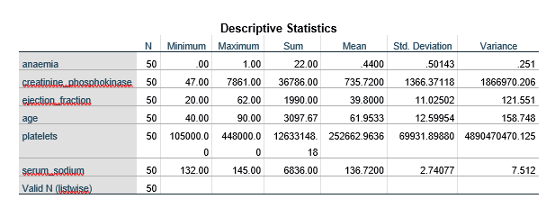

- Find the probability that Level of serum sodium in the blood (mEq/L) will exceed 145(mEq/L)

- Find the probability that age exceed 70

- Find the probability that Percentage of blood leaving the heart at each contraction (percentage) will be between 35% and 42%

