**DATA ANALYSIS**

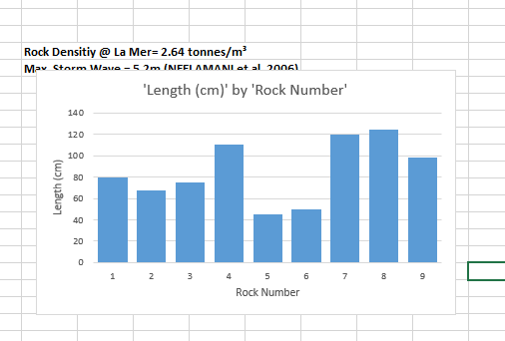

Hypothesis 1: Groynes are effective because they interrupt the process of longshore drift

Hypothesis 2: Rock armour is effective in managing the rate of erosion