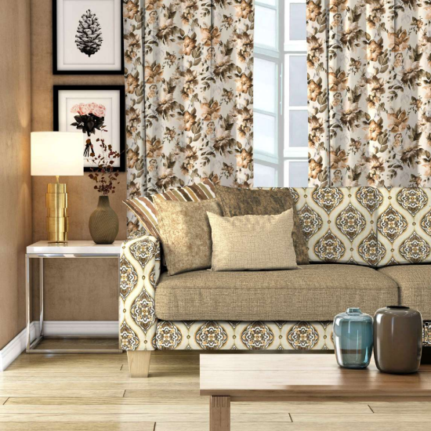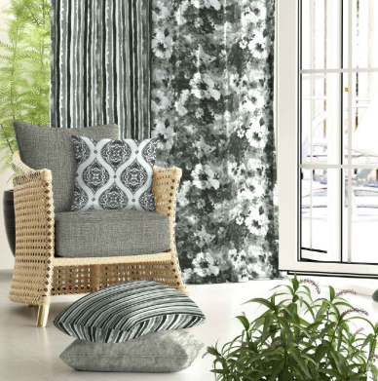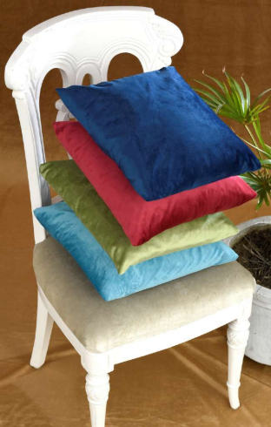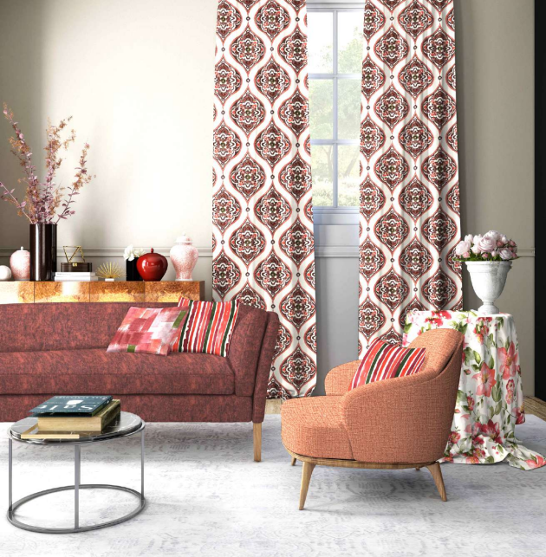

151

shade no. 201

151

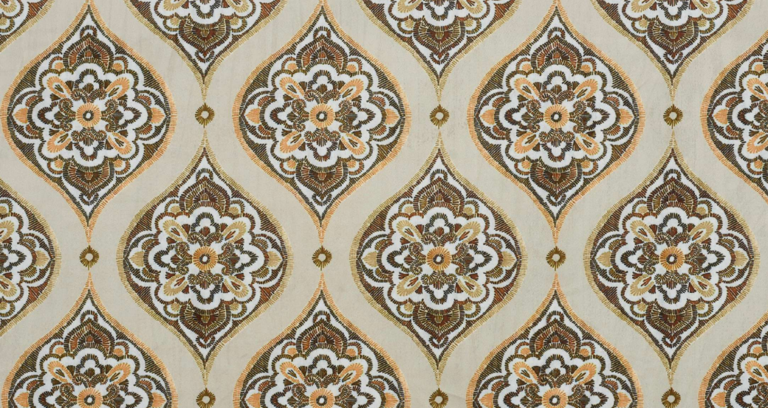sr. no.: 01 design no.: 151(e)

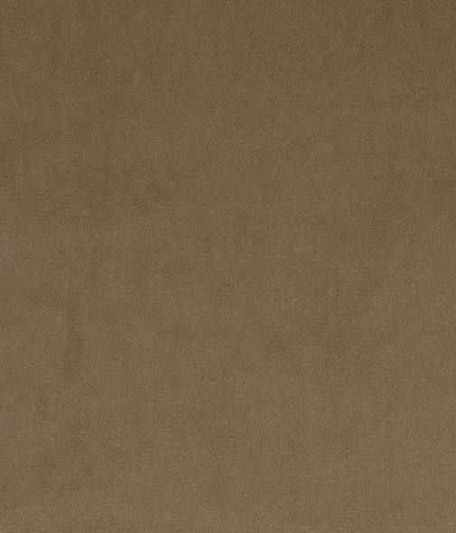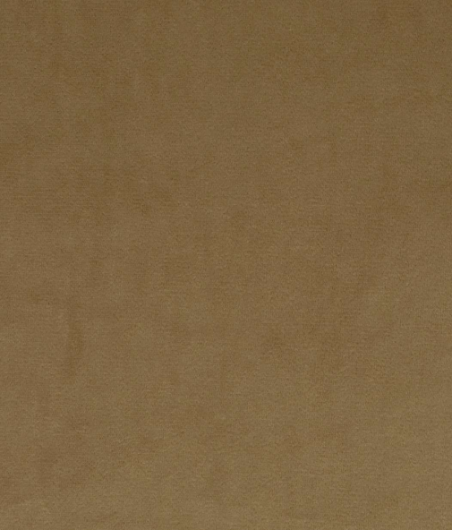sr. no.: 02 design no.: magic-408) sr. no.: 03 design no.: magic-408)

shade no. 201

151

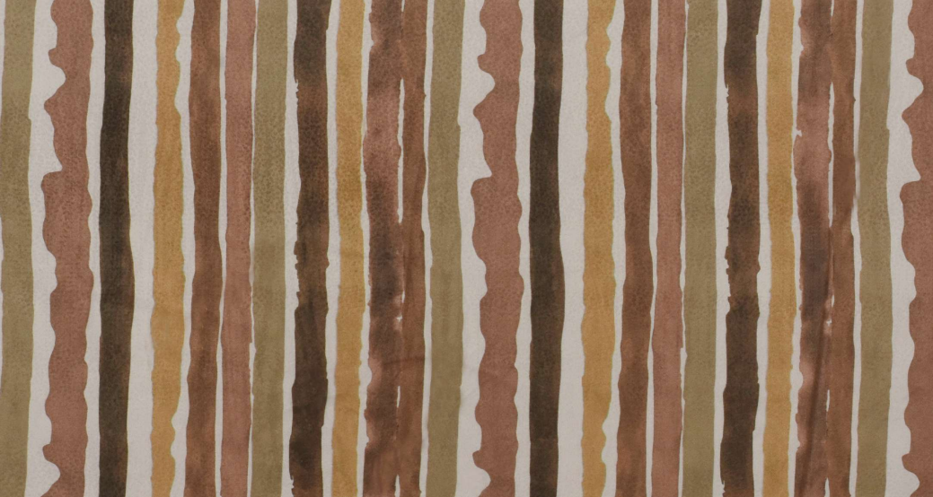sr. no.: 04 design no.: 151(s)

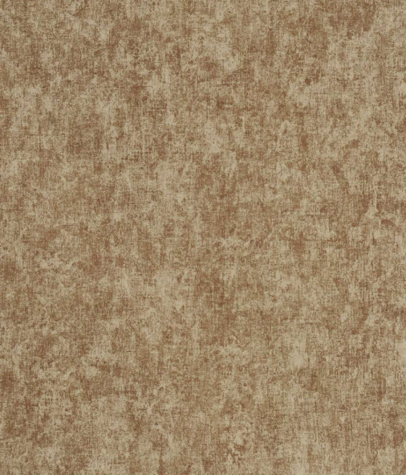sr. no.: 05 design no.: magic-210) sr. no.: 06 design no.: magic-210)

shade no. 201

151

sr. no.: 07 design no.: 151(l)

sr. no.: 08 design no.: 151 c) sr. no.: 09 design no.: magic-214)

151

shade no. 201

151

sr. no.: 10 design no.: 151(d)

design no.: magic-214) sr. no.: 11

sr. no.: 12 design no.: 151 f)

151

shade no. 202

151

sr. no.: 13 design no.: 151(e)

sr. no.: 14 design no.: magic-408) sr. no.: 15 design no.: magic-408)

shade no. 202

151

sr. no.: 16 design no.: 151(s)

sr. no.: 17 design no.: magic-210) sr. no.: 18 design no.: magic-210)

shade no. 202

151

sr. no.: 19 design no.: 151(l)

sr. no.: 20 design no.: 151 c) sr. no.: 21 design no.: magic-214)

shade no. 202

151

sr. no.: 22 design no.: 151(d)

design no.: magic-214) sr. no.: 23

sr. no.: 24 design no.: 151 f)

151

shade no. 203

151

sr. no.: 25 design no.: 151(e)

sr. no.: 26 design no.: magic-408) sr. no.: 27 design no.: magic-408)

shade no. 203

151

sr. no.: 28 design no.: 151(s)

sr. no.: 29 design no.: magic-210) sr. no.: 30 design no.: magic-210)

151

shade no. 203

151

sr. no.: 31 design no.: 151(l)

sr. no.: 32 design no.: 151 c) sr. no.: 33 design no.: magic-214)

shade no. 203

151

sr. no.: 34 design no.: 151(d)

design no.: magic-214) sr. no.: 35

sr. no.: 36 design no.: 151 f)

shade no. 204

151

sr. no.: 37 design no.: 151(e)

sr. no.: 38 design no.: magic-408) sr. no.: 39 design no.: magic-408)

151

shade no. 204

151

sr. no.: 40 design no.: 151(s)

sr. no.: 41 design no.: magic-210) sr. no.: 42 design no.: magic-210)

151

shade no. 204

151

sr. no.: 43 design no.: 151(l)

sr. no.: 44 design no.: 151 c) sr. no.: 45 design no.: magic-214)

151

shade no. 204

151

sr. no.: 46 design no.: 151(d)

design no.: magic-214) sr. no.: 47

sr. no.: 48 design no.: 151 f)

shade no. 205

151

sr. no.: 49 design no.: 151(e)

sr. no.: 50 design no.: magic-408) sr. no.: 51 design no.: magic-408)

shade no. 205

151

sr. no.: 52 design no.: 151(s)

sr. no.: 53 design no.: magic-210) sr. no.: 54 design no.: magic-210)

shade no. 205

151

sr. no.: 55 design no.: 151(l)

sr. no.: 56 design no.: 151 c) sr. no.: 57 design no.: magic-214)

shade no. 205

151

sr. no.: 58 design no.: 151(d)

design no.: magic-214) sr. no.: 59

sr. no.: 60 design no.: 151 f)

BOOK CRAFTED BY

151

| DESIGN NO. | WIDTH | COMPOSITION | END USE |
| --- | --- | --- | --- |
| 151(E) | 54” | 100% POLYESTER | Upholstery Cushion Curtain |
| MAGIC-408 | 54” | 100% POLYESTER | Upholstery Cushion Curtain |
| 151(S) | 54” | 100% POLYESTER | Upholstery Cushion Curtain |
| MAGIC-210 | 54” | 100% POLYESTER | Upholstery Cushion |
| 151(L) | 54” | 100% POLYESTER | Upholstery Cushion Curtain |
| 151( ) C | 54” | 100% POLYESTER | Upholstery Cushion Curtain |
| MAGIC-214 | 54” | 100% POLYESTER | Upholstery Cushion |
| 151(D) | 54” | 100% POLYESTER | Upholstery Cushion Curtain |
| 151(F) | 54” | 100% POLYESTER | Upholstery Cushion Curtain |

1. We do not accept responsibility for any damage resulting from inappropriate use, chemical cleaning or additional impregnation. 2. Test results were gathered from various samples and therefore represent average indicative values.

3. Discolouration caused by clothing fabrics such as jeans does not represent a material defect. Minor colour deviations and discolouring in context of permissible industrial tolerance standards do not constitute reasons for claims .

Washing Instructions

Colour shades may slightly vary from dye lot to dye lot.

Iron on reverse side.