Mount Cain Alpine Park Society
2020/21 Season
January 4th 2021 Board Meeting MINUTES
The Mount Cain Alpine Society acknowledges that Mount Cain is located on the territory of the ‘Namgis First Nations.
Our meeting is taking place virtually on Vancouver Island the territory of many Indigenous people, we are grateful to the opportunity to live, work and play on these great lands. We acknowledge all First Nations, Metis, and Inuit people who have and do call this place home.
Call to Order: 7:07pm
Meeting chaired by David Mazzucchi online
Join https://us02web.zoom.us/j/86748689780 1- 647-558-0588, 86748689780
Adoption of the November 28th Minutes
M: Eric Sprenger S: David Mazzucchi Motion: PASSED
Additions to and Adoption of the January 4th, 2021 Agenda
M: David Mazzucchi S: Erin Pickering Motion: PASSED One addition:
Agenda:
- Review of Startup:
  - debrief on the week specifically how the COVID protocols are being followed and what, if anything needs to be changed. (requested by Jen Lash)
- Directors Reports & Action Items
Attendance
Directors | Director | Executive Role | In Attendance
- David Mazzucchi | Snow School & Ski Shop | Chair
- Eric Sprenger | Tech Support | Treasurer
- Erin Pickering | RV Park | Secretary
- Greg Muirhead | Patrol | Vice Chair
- Darryn McConkey | Grant Applications
- Dean Hunchuk | Buildings & Construction |  | Absent
- Kathryn Wykes | Operations- Groomers
- Ken Griffith | Human Resources
- Mike Green | Operations- Road/Generators/ Bus
- Dave Steele | Operations- Lifts
- Jared Shaw | Hospitality
- Pete Davidson | Occupational Health and Safety |  | Absent
- Matiss Valdmanis | Special Events
- Alec McBeath | Administration
- Jen Lash | Communications

1. Start Up Review/ Covid Protocol check in.
- Overall: Impressed with how responsible our public was being. Masks on for the most part, spaced out, respectful behaviour.
- Parking lot was very full, but folks stayed with their own household group.
- Single riding is expected and needs to be respected.
- Please do not yell “single” to get ahead.
- Need increased ticket checker presence (because everyone was hiking to L3)
- Waiting Lines maintained minimum distance spacing. - tough to maintain when folks are skiing down to the side of the lift line – gets crowded.
- Big thank you to our lift staff at L3 for having extra masks on hand.
- ACTION: Directors are asked to review the terms Bubble/Pod and what that means with staff.
- Reminder to all staff that they must clean up /sanitize areas they use/ stay in.
- Tavern: inside space may need to be revisited – concerns about eating near stove vs in the booths at the back. Will continue to monitor.
2. Director Reports and Action Items:
Previous Meeting Action Items for all directors:
- Directors to solicit for donation of swag and then report to Matiss - IN PROGRESS
- Directors to review “friends of Cain” section of our website to ensure all “friends” are recognized – report out at Jan 4th mtg. - COMPLETED
- Property Insurance: Need directors with assess to check/add/remove on shared spreadsheet. Must be completed by Dec. 31st. COMPLETED
- Planning Meeting Item PBX – to receive a rental accommodation in the 2021-22 season -- Dave Steele to confirm – PLANNING MEETING ITEM
- NEW ACTION -Dave Steele to connect with June Hale regarding volunteer passes.
Currently Volunteer compensation/passes are determined by the Director in charge of that department. Process for compensation to be clarified in time.
- NEW ACTION – Mike Green, Darryn McConkey, Kathryn Wykes, Jen Lash, Alec McBeath to form subcommittee to create process and tracking for donations/volunteering and compensation. Jen Lash to set first meeting.
  - Subcommittee to liaise with Ticket booth because there is a comp pass ledger
  - Send questions around compensation to Jen Lash.

Director of Events – Matiss Valdmanis
Update:
-Planning for Cain Cup well underway, including online sign-up using Google Forms (waivers still need to be signed in person). Hopefully online registration will promote sign-up by the public.

Discussion:
-Eric: I would like to implement an online waiver system. If it is possible to set up a waiver system using Google Forms, I could likely do that myself for the following races to speed things up.
ACTION Matiss to connect with Eric re online waiver.
-All Races and events to be conducted with strict social distancing measures. I am open to suggestions on how to most effectively do this.
-Participation in races has been declining in recent years. In order to have the proper promotion and public participation in races and events, we NEED TO HAVE ADEQUATE TIME FOR PROMOTION OF EVENTS. There is a tendency to interfere with events promotions posting and to delay these. I am cognizant of the need for timing of messaging and conflicts with other Mount Cain news posts and I am going to work with Jen to time these appropriately, however in order to get as much discussion, participation and as many of volunteers as necessary for events, these must be posted ASAP.
ACTION "Jen and Matiss to coordinate Events promotions
ACTION Jared to upload to SharePoint an outline communication details to be provided to Jen

Director of Human Resources – Ken Griffith
HR Update:
- Sebastian has taken that Role of “Den Papa” for the season.
- Ellen Publicover will be joining the custodial crew on a part time basis.
- So far, we seem to have covered all positions, the only place that may need some additional help is the custodial crew, but that will need to be determined as the season progresses, and I am currently working on a contingency plan for that.
- We seem to have enough accommodations for all of our crew requirements but have not yet settled on exactly where every person will be housed. I think that we have enough options that as the season gets fully underway, we can reorganize sleeping arrangements as needed.
ACTION: Ken to connect with Megan W. regarding the lodge host roles and responsibilities.

Director of Hospitality – Jared Shaw
Update:
- Kitchen staff wearing masks at all times.
- As per PHO no alcohol sales after 10pm. Doors closed/beer garden shut down by 11pm.
Lodge review: No more than 6 at a table, or as many people as seats at the table. – must be their “bubble”, they must stay at the table. There are nine tables available in the lodge. If there is a line up then there will be a time limit for inside. - there is a sign on the door with this info.
Discussion: - covered in start up review.
ACTION: Jared to connect with bookkeeper to check into café “deposit” paid last year. COMPLETED

Director of Technology/ Treasurer – Eric Sprenger
1) budget update. - Buget reflects November, next update will include the December numbers. Link to Budg <Eric – can you please insert a link to your budget document – I can’t insert the excel into these minutes.
Membership currently at 1011!

Motion: School groups require one family membership, in the name of the group leader. Cost $35
M: Greg Muirhead S: Eric Sprenger MOTION: PASSED
PLANNING MEETING ITEM: Keeping Membership mandatory. Consider School Group membership.
2) In Camera Discussion
Moved in Camera 8:24pm

Move out of Camera 9:17pm
3) Proposal of a new generator (personal/parking lot) shut off time - 10:30pm. This will help space out all the things the DOD has to shut down at 11.
Reminder to DOD – to move around the parking lot prior to 11 asking people to shut off generators so they are off at 11pm.
This conversation will likely continue. PLANNING MEETING ITEM

4) Paragliders and making a paraglider policy. – See Appendix A for suggested policy notes. Policy a planning meeting item

Motion: No paragliding equipment allowed on the lifts for the season 2020-21
M: Eric Sprenger; S: David Mazzucchi MOTION: PASSED
Director of Ski Shop & School /Chair – David Mazzucchi
Chair Update:
- Director’s room in Kapitany - DOD reservation system has been set up. Please make a donation to the build a better bathroom fund if you are using the room and NOT DOD that night.
Ski Shop / Snow School Update:
- Boxing Day open was not appreciated by the staff who had to work on Xmas Day or arrive that evening. Let’s NOT open on the 26th ever again. - Planning meeting reminder – closed 25/26

- Online store is running smooth about $7200 in merchandise and $784 in gift cards, as of Dec 29.

- Shop Covid protocol is working well.

-No reciprocal agreement with Mount Washington this year because of day ticket caps at their mountain.

Action: Dave Steele & David Mazzucchi to create sign wording and procure from N.I business. COMPLETED
Secondary Action: Pete to purchase cameras. IN PROGRESS
Action: Sea cans cancelation- Dave. COMPLETE
Action: Dave M to update with suggested changes - ski patrol name on white board and 8am check in. COMPLETE

Director of Grants – Darryn McConkey
Grants Update
PRIORITY - CVRIS Grant - Review objectives, discuss options. Decision required ASAP for Jan 27 submission.
Darryn suggests applying for snowshoe trails & accessibility. Could also include summer trails also. More single accommodation/ tiny homes or staff accommodations, build an area for winter campers – all suggested.

RDMW Tourism Grant - Complete. 50% ($2K). In-kind did NOT count.
Catalyst Fund - $12K. Ongoing.
ICET Small Capital Restart - 50% up to $14+K. Review budget/items. Need to track receipts.
Annual RDMW Grant-in-Aid - 2020 receipts and 2021 application submitted. 2020 $35K grant received.
CERIP Grant - Application update. RDMW LOS received.
FEP - Mike G. Update.

Discussion
Corporate Sponsorship - Jen L.? Alec?
Recognition - Recommend we formalize our approach for recognizing contributors/donations, etc. Including perks (passes, etc..) for services, recognition on our website, events calendar, etc...

Constitutional Changes committee Action: - (Kathryn W, Darryn McConkey, Alec McBeath) to investigate our constitutional changes, processes, and practices. And update from the committee will happen later in the season. -- IN PROGRESS/

Director of Communications – Jen Lash
Update
- Posting on facebook and newsletter once a week.
- Website updated regularly.
- We need to rethink the “buckets” on the website – for examples “special events” -- work in progress.
- ACTION Communication Calendar will be created for Directors to alert Jen to events/communications needed.
2. “Build a better bathroom fund” suggesting minimum donation of $10 – Action: Eric and Jen to work out online donations piece. - COMPLETE – but needs to be promoted
Reminder to DOD to speak to campers about the build a better bathroom fund when they walk around.

Director of Operations: Roads – Mike Green
Grader
14G currently down mountain. Some control valve issues to resolve before next weekend.
Generators
- Still need to determine if 3306 can meet all of our power needs and price a transformer if required to run buildings as well.
- Lifts team needs to formalize startup procedures for generator/lifts.
- 23kw problems have been resolved.
Thank you once again to all of the volunteers and companies who helped in such a busy offseason and beginning of new season; and Dave S. for keeping a far-flung lifts team moving forward.
FEP work is progressing. Most machine work has been completed and manual work is in progress. Discussion of in-season operations.

Director of Operations: Lifts – Dave Steele
Lifts will be running for the January 9th weekend
Dean Davidson is a hero! He has been instrumental in the electrifying of L1 and keeping the project on track.

Director of Operations: Snow Machines – Kathryn Wykes
- There were some difficult conditions but groomers made it through. Next weekend will be full groom.
- Snow mobiles - some problems – Looking to get a machine to Courtenay Motorsports for analysis/ diagnostics.
- Maybe time for a new machine – as per Eric’s suggestion – they are necessary to keeping the hill running.
ACTION – Kathryn to connect with Dean Davidson regarding purchase of last machine.

Director of Snow Patrol / Vice Chair – Greg Muirhead
Good early start to the season.
Minimal injuries on the ski hill during winter break. Great proactive risk mitigation and hazard control played a big role. Have had a full complement of ski patrol volunteers during every operational day. Team sizes of 6-8 patrollers appears to be sufficient.
COVID protocols are being adhered to in the trauma room as well as outside of the first aid facility. Reminders need to be given in and around lineup re: masks and physical distancing. Reminders need to be given to all lift staff that singles are not encouraged, and public should only ride with those who you have arrived with.
Staff who are staying in mountain accommodation have been reminded that their diligence with the sanitizing and cleaning of the Kapitany while using it is of utmost importance.
Grooming was good considering the little amount of snow that had fallen. Ongoing communication is paramount throughout the season.
Uphill traffic protocols will remain in place and the ONLY uphill route will be on the West Side of the ridge run. This will be clearly marked and will be outside of the mountain boundaries. Absolutely no uphill traffic on ANY run when there are groomers or machinery on working. This is critical and is everyone’s responsibility to educate people about this. Grooming in progress signs, Kathryn, have you ordered these yet? IN PROGRESS
Looking like a great group of very talented patrollers this year with incredibly diverse and skilled backgrounds. Currently working on a medical protocols and policy document in partnership with a group of emergency medicine professionals for Ski Patrol and the hill. This is a work in progress and will take the better part of the ski season to fully complete. Goal is to have this document complete by the 2021/2022 season.
Director of RV Park / Secretary – Erin Pickering
Update:
RV Park has signage all around and sanitization set up in outhouse.
Residence would like to remind the public that this is not the year to be wandering in for a look about, we are working to limit the number of individuals that enter this narrow space. Residence are not encouraging any “hanging about” of visitors.
6 of 11 payments have been received, and the remaining 5 people have been reminded of payment outstanding.

Director of Health and Safety – Pete Davidson - ABSENT no report submitted.
Action: Pete to look for WHMIS sheets for cleaning products.
Action: All directors are asked to be in attendance for the first weekend to help ensure physical distancing etc.
Action: Pete will pay attention for any health changes and how it may affect our operation.
Director of Building and Construction – Dean Hunchuk - absent no report submitted

.Next board meeting schedule for: Monday February 1st online 7pm

Meeting adjourned 10:15pm

Appendix A – Budget Overview
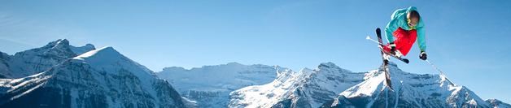
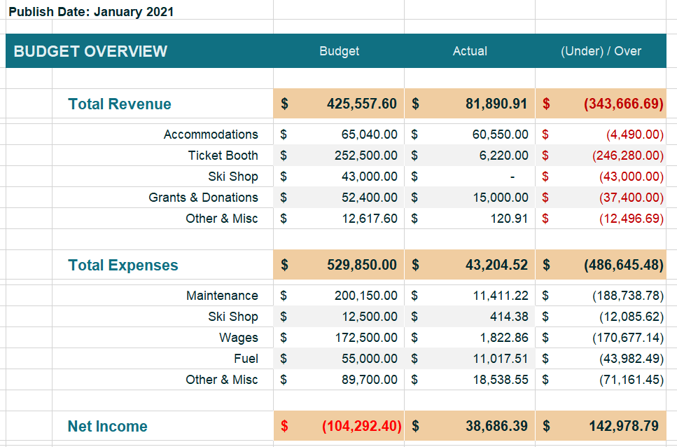

Budget Page Two
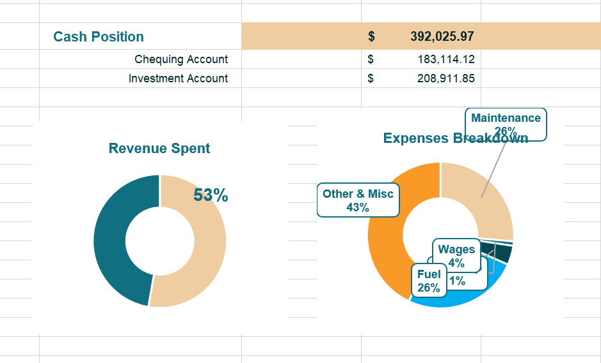

Appendix B – Paraglider Policy Draft – to be futher reviewed at planning meeting
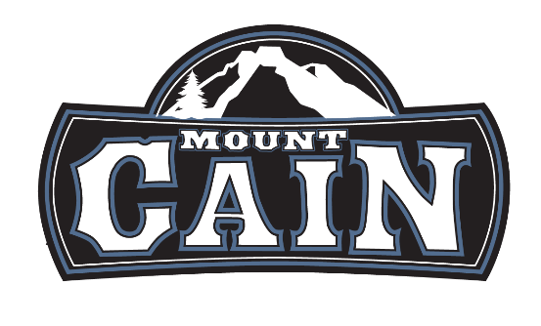

Mount Cain Alpine Park Society

Paraglider Policy

To ensure the MCAPS ski area and paragliders can co-exist in harmony, we request that all paragliders follow the rules and polices in this document.

- MCAPS requires all paragliders to have a Hang Glider & Paragliding Association of Canada (HPAC) membership. This membership provides the paraglider with five million in liability coverage if something unplanned happens.
- Paragliders must speak to the Director on Duty (DoD) before any flight activities. You will be required to show your HPAC membership to the DoD. The DoD can be contacted from the Ticket Booth, Ski Shop, or Patrol if needed.
- All take offs and landings should be performed outside of the ski area. Absolutely no landing on any of the ski runs or parking lot.
- Paragliders must always stay at least 500ft away from lift equipment at all times.

