Mount Cain Alpine Park Society
2020/21 Season
November 28th, 2020 Board Meeting MINUTES
The Mount Cain Alpine Society acknowledges this meeting is taking place on the traditional territory of the ‘Namgis First Nations.
Call to Order: 6:05pm
Meeting chaired by David Mazzucchi in the Staff Accommodations
Adoption of the November 7th Pre & Post AGM Minutes
M: David Mazzucchi S: Erin Pickering Motion: PASSED
Additions to and Adoption of the November 28th Agenda
M: David Mazzucchi S: Eric Sprenger Motion: PASSED
Agenda:
- Continuing business: Start Up
  - Priority Action Items
- Directors Reports

Attendance
Directors | Director | Executive Role | In Attendance
- David Mazzucchi | Snow School & Ski Shop | Chair
- Eric Sprenger | Tech Support | Treasure
- Erin Pickering | RV Park | Secretary
- Greg Muirhead | Patrol | Vice Chair
- Darryn McConkey | Grant Applications |  | absent
- Dean Hunchuk | Buildings & Construction
- Kathryn Wykes | Operations- Groomers
- Ken Griffith | Human Resources |  | Absent
- Mike Green | Operations- Road/Generators/ Bus
- Dave Steele | Operations- Lifts
- Jared Shaw | Hospitality
- Pete Davidson | Occupational Health and Safety
- Matiss Valdmanis | Special Events
- Alec McBeath | Administration
- Jen Lash | Communications

1. Continuing business – Priority Action Items

Health and Safety: Directors are reminded they must fill out the H&S forms for any area of the mountain that has staff – THIS MUST BE COMPLETED BEFORE OPENING - In progress (Lifts, Hospitality and H&R to be completed)
- Cleaning protocols need to be very clear for staff to be able to use and follow.
Ticket Sales:
- ACTION: Cancellation policy will need to be reviewed/updated COMPLETED
- ACTION ERIC SPRENGER to connect regarding: “square” up and running so that online sales of merchandise can be sold COMPLETED

2. Directors Reports
Director of Ski Shop & School /Chair – David Mazzucchi
1. Chair Report:
- Opening message to new and returning Directors
- Emails - brevity, monitoring
- Discussion with the RCMP on using trail cameras for security- Reasonable expectation of privacy allows us to have game cameras in/on our buildings. Signage prevents crime.
- Motion: To purchase 4 security camera signs
M: David Mazzucchi S: Pete Davidson Motion: PASSED
Motion: To purchase cameras, spending no more than $200
M: David Mazzucchi S: Matiss Valdmanis Motion: PASSED, one objection
- Given Covid, the optics of cramming 15 Directors into the office for a meeting once a month is bad.
Action: Dave Steele & David Mazzucchi to create sign wording and procure from N.I business.
Action: Pete to purchase cameras.
Discuss:
1. Switching to online Board meetings the first Monday of each month
Motion: To move our MCAPS board meeting online and at 7pm on the 1st Monday of the month.
Motion: David Mazzucchi S: Dean Hunchuk Motion: PASSED
Action: Jen Lash will create a zoom meeting invite.
Hopefully, we can hold the April meeting in person.
2. Sea cans – Only need one. Action: Dave will look into cancelling one sea can.
3. Gift Cards: Moving to an electronic management system, branded plastic gift cards will be created, there will also be an online gift card option.
GCs will be redeemable in the ski shop, ticket booth and café.
Can also create “loadable” season pass, may not be available until 2021-22.

Action: Directors to review “friends of Cain” section of our website to ensure all “friends” are recognized

- Revised DOD log. See Appendix A
Action: Dave M to update with suggested changes - ski patrol name on white board and 8am check in.
2. Ski Shop / Snow School Report
- Online store is working, check it out.
Director of RV Park/ Secretary- Erin Pickering
1. Secretary Report
- Thank you for the concise agenda items!
- Timeline for meeting documents: Agenda sent Wednesday/Thursday before meeting – you print. Meeting1st Saturday of the month, previous minutes reviewed and adopted. Posted for members by Director of Communication. Secretary posts draft minutes within one week on Director SharePoint site. – Please review your section for action items and edits – which you can make. Send Agenda items via email ideally by last Sunday of the month.
2. RV Park Report:
- No Report at this time, all RV spots occupied.
- Action: Connect with Greg re: Signage. – Signs are on their way soon. COMPLETE
Director of Administration – Alec McBeath
1. New Exclusion of Liability agreement.
- Change in wording in our liability, because of Grouse Mtn court case ruling.
- Ski West sent out updated signage and it will be posted appropriately. This is an obligation of our insurance.
2. Property Insurance: Need directors with assess to check/add/remove on shared spreadsheet. Must be completed by Dec. 31st.
3. Prior Action Item:
- A committee will be formed (Kathryn W, Darryn McConkey, Erin P, Alec McBeath) to investigate our constitutional changes, processes, and practices. And update from the committee will happen later in the season. -- IN PROGRESS/ Postponed until after AGM

Director of Communications – Jen Lash
1. COVID 19 communications plan.
- regular updates on Mt. Cain Facebook page.
- contact Jen if there is information you require to get out to public.
- Crisis intervention COVID 19 – Jen developing a crisis plan regarding communications and will send to directors.
2. “Build a better bathroom fund” suggesting minimum donation of $10 – Action: Eric and Jen to work out online donations piece.
3. Moved to in camera 7:24pm Moved out of camera 7:36pm

Director of Operations: Roads – Mike Green
Grader:
- 14G on mountain ready to go
- Very good value for MCAPS
- Should greatly reduce maintenance cost.
- Great work by Lemare Shop. Thank you!
Generator
- Last bit of wiring and prep on new generator.
- Once L1 is operating need to figure out load to determine if new engine can meet all our power needs.
- A transformer will need to be purchased/installed at that point if it is to run buildings,
23Kw generator is having some issues and only operating on one phase.
Capital plan should look to purchase new large/efficient generator over next couple of years.
Bus:
Nothing to Report
Roads:
- Harvesting/hauling taking place over the next couple of months on Mt. Cain Road up to approximately 8.5 km
Director of Operations: Lifts – Dave Steele
1. Update: L1, tower has had gear box installed, bull wheel re-installed. Tower has been re-attached to counterweight and under tension from tow line. Old diesel motor and hydraulic system were removed and building re-sealed.
Next steps. Dec 5, install motor bracket being fabricated at Nanaimo Foundry, hang motor and couple to gear box input shaft. Run conduit and wire through L1 to VFD room
Dec 5, possible that VFD is supplied, this can also be installed, and connections made to existing safety system and motor
Run up and certification with Mech and Elec engineers as well as technical safety BC on site. Hang tees and ride!
L3 – requires shroud to be re-installed on drive shaft and tees need to be hung, I will be looking for volunteers to accomplish this on the weekend of the 5th.
Technical Safety BC pre-op inspection as well as on-site inspection being prepared
2. Discussion – covered off by others – parking lot concerns, weeklong visitors etc.
Unfortunate that lift will not be available for training day, my bad

Director of Operations: Snow Machines – Kathryn Wykes
1. Update:
Grooms will have their pre-season maintenance done training weekend and be serviceable for when the mountain opens. Training for Covid-19 Protocols will be done training weekend. No need for new hires this season due to Covid-19 and returning crew is sufficient to operate without Magic Mondays. Objective for this season: to run minimally on each cat to preserve hours and keep costs low (snow levels and demand goes without saying); plan and prepare for scheduled and regular maintenance in advance; gradually repair and replace old and/or worn parts on implements that did not receive any attention last season.

Director of Events – Matiss Valdmanis
1. Update:
- 2 Foggers have arrived and will be/are delivered to the hill. Hurray!
- Creating SOP for the foggers.
2. Discussion:
  - Events will be run in such away that will not facilitate congregation.
  - We will review events regularly with awareness of Covid-19 protocols and changes.
Action: Directors to solicit for donation of swag.
Director of Grants – Darryn McConkey – absent no report submitted
1. Prior Action Items
  - Darryn will reach out to a volunteer interested in helping with corporate sponsorship. COMPLETE

Director of Hospitality – Jared Shaw
1. Please check for emails from Jared regarding various action items.
2. Has increased use of Office 365 as planning guide for Ticket booth.
3. Connected with Jamie Turko in the Cafe and there is a plan for F&B this year.
  - Café- take out window on front deck of lodge. Smaller menu. Take your food and go.
  - Liquor will be served inside with people leaving through the back door. There will also be an outdoor bar in the beer garden.
  - Someone will be hired as a door person/manager of day lodge space. 15 people, 15minutes.
  - ACTION: Jared to connect with bookkeeper to check into “deposit” paid last year.
4. Megan is doing an awesome job as accommodation manager.

Director of Snow Patrol / Vice Chair – Greg Muirhead
No report at this time.

Director of Technology / Treasurer – Eric Sprenger

1. 2020-21 Budget presentation
  - accommodations sold out in under 30 minutes and budget goals were achieved.
  - Public should check the website for any accommodation availability – there have been some cancellations.

2. Season’s passes and waivers will be available online as well as at the ticket booth.

Director of Building and Construction – Dean Hunchuk
1. COVID-19 building modifications
  - Dean has been busy making our accommodations and buildings safe.

2. Please let Dean know if you see anything that needs fixing etc.

Director of Human Resources – Ken Griffiths – absent no report
Director of Health and Safety – Pete Davidson
1. Covid-19 is the focus right now.
2. Please express any concerns to Pete regarding health and safety.
Action: Pete to look for WHMIS sheets for cleaning products.
Action: All directors are asked to be in attendance for the first weekend to help ensure physical distancing etc.
Action: Pete will pay attention for any health changes and how it may affect our operation.
Next board meeting schedule for: Monday January 4th online 7pm

Meeting adjourned: 8:20pm

Appendix A – Director on Duty Log
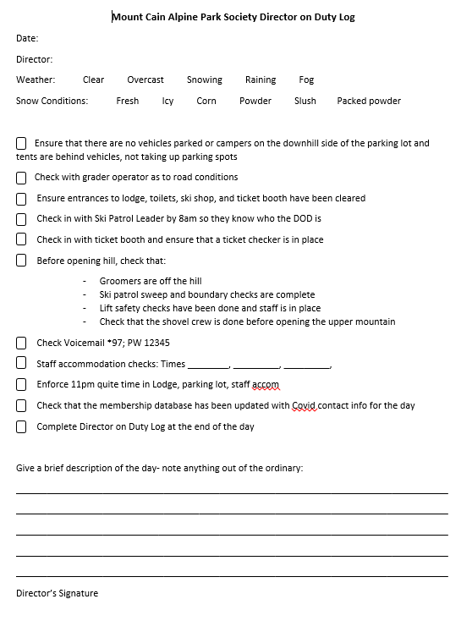
Appendix B - Email Motion November 2020

Motion to pursue all aspects of the ICET Small Capital Restart Grant which will cover up to $12,505 (50% of total cost) of the following materials and supplies:

EXPENSE ITEM BUDGET AMOUNT
COVID related signage $2,650
Plexiglass to create Barriers $3,650
Installation of Temporary Walls and Closet $3,980
Additional Chairs for Common Area $1,400
Hot Water tank for Staff Accommodation $1,000
Outdoor Beer Garden $1,130
Storage containers (2 20' sea cans) $11,200
Total Expenditures $25,010

Motion: Darryn McConkey; S: Alex McBeath
Motion Passed – 10:0; 5 abstentions

