Demonstration for accessing and using CAT
This is a short demonstration regarding how to access and use the team coding measure that we created for our research project. More details on the coding scheme that we use for the demonstration purpose and about the CAT software can be found in Klonek, Meinecke, Hay, & Parker (in press):

Step 1: Access to the Measure
Copy and paste the following link in a google chrome web browser:
https://cat.ctwd.com.au/?cooperation=_iJOPhV_
The first part of this link [blinded for review] is the web domain for the CAT app. The second part of this link [?cooperation=_iJOPhV_] gives access to the digital version of our coding measure.
Users will need to create a login name and password before they can access the coding measure. Alternatively, for this demonstration, users can access the coding scheme with this existing account:
Login: Michael.Smith@teamresearcher.com
Password: TEST999

Step 2: Overview of the main menu
Once the user has logged in, they should be redirected to the main page which displays the available Measures. In this case, users have access to the “Expert Panel: Team Communication Analysis”. The authorization for the current cooperation (i.e., cooperation code: “_iJOPhV_”) allows users to access collected data () and to access the feedback functions (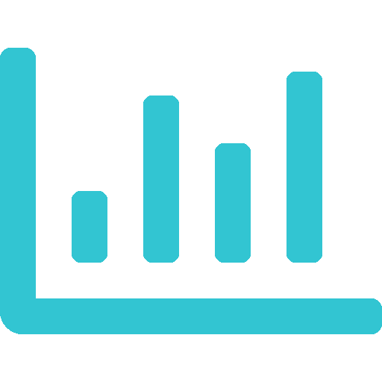). This cooperation has restricted some permissions, so that the user cannot edit the coding measure (), share it with others (), copy the measure (), or audio-record during live observations (). 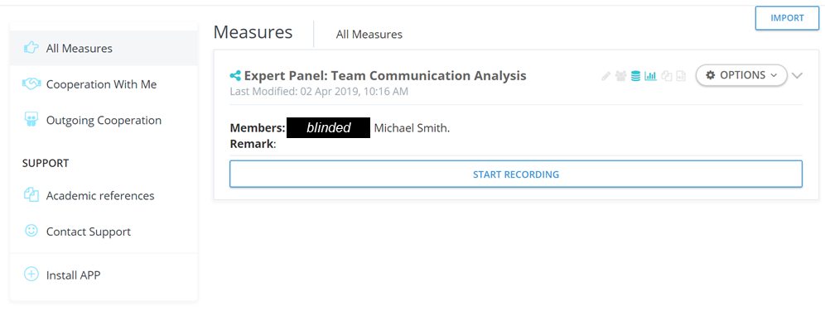

These permission rights are also explained when users click on the items that are displayed on the left of the “OPTIONS” function.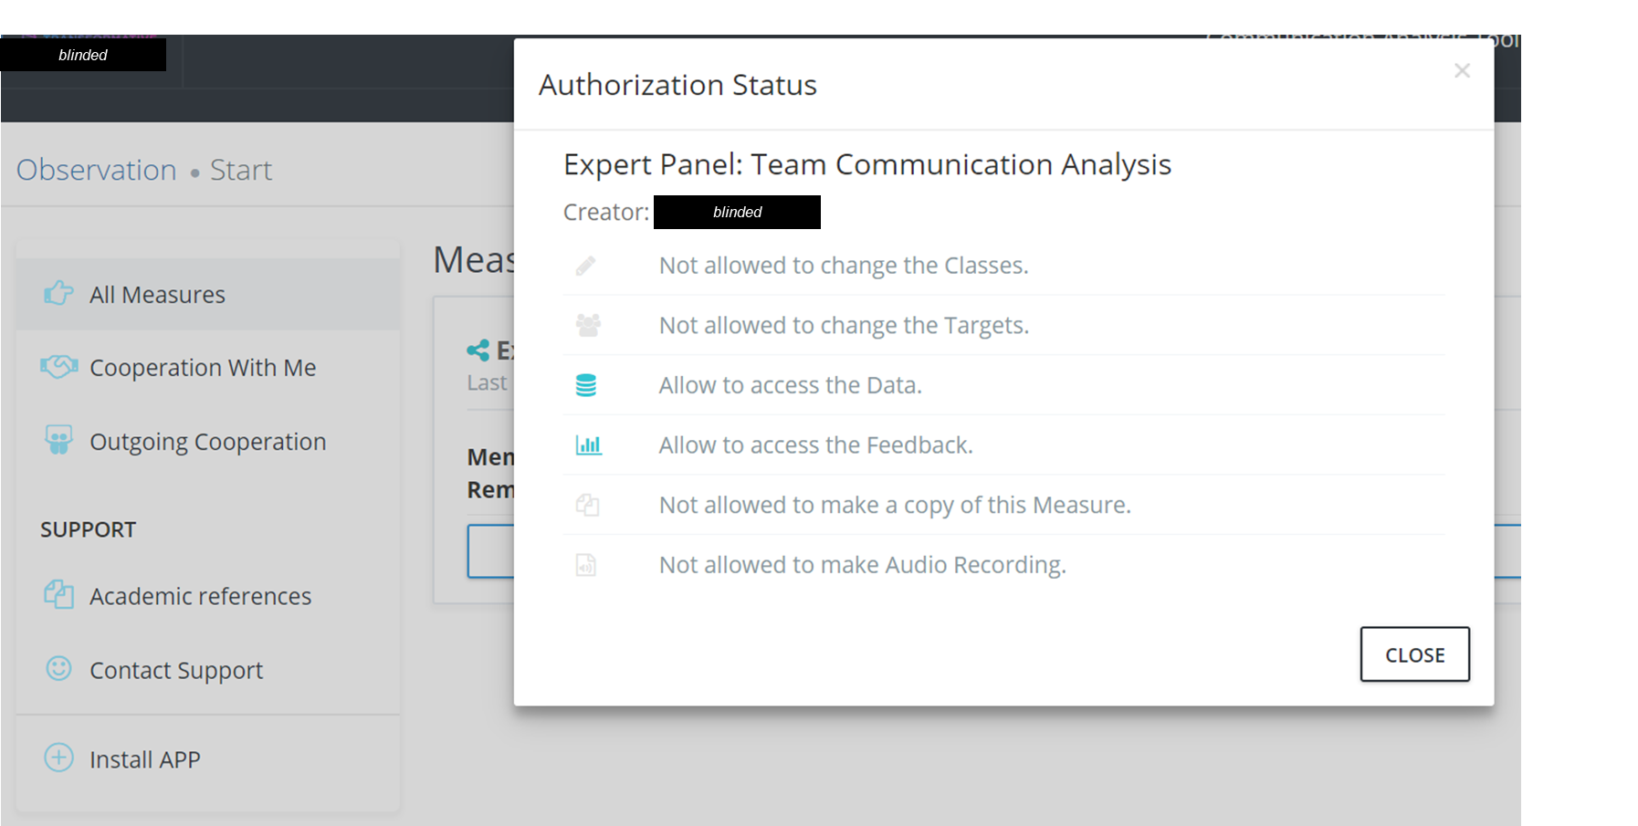
Step 3: Inspection of the coding measure
Users can inspect the team coding measure when they click on OPTIONS and EDIT. This will direct them to the coding scheme and display main codes (see Table 2 and Figure 1 from the main manuscript). In the current case, the user has no permission to edit the coding scheme (“No authorization”), hence they cannot edit, delete or add new codes.

Step 4: Using the coding measure to observe team dynamics
Users can start to collect live observations by using the “START RECORDING” button. This will display an “Information Sheet” which provides information about the research project, contact information and a disclaimer that researchers/users will need to obtain ethical approval for their observational research project. User cannot proceed if they do not agree with this information sheet.
Before starting with the observation and coding, users can specify some contextual information that will help them to structure their data within an observational project. For example, the user can specify a session name (e.g., team meeting 3 or TeamID: AB34), the user can indicate whether one or multiple observers will observe and code the current team episode, the user can enable/disable specific settings, indicate his/her name or observer ID (in case the login details do not match with his/her name), and provide some context about the observation (“What exactly are you observing?”).
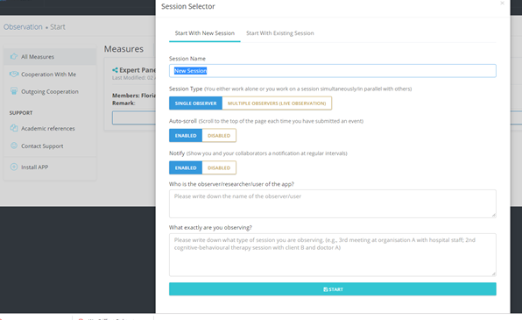
This information is not mandatory to proceed (but they will help the user to identify different observational session). When users click START, they proceed to the coding measure and recording page.

The recording page displays the coding measure from our research example (see Table 2 in main manuscript for details). The top of the page allows the user to specify an interval sampling strategy (“Interval Notify”), adapt or change the information that was provided before starting the session (“Session Setting”), link a recorded media file if users want to code video or audio-recorded team processes (“Play Media File”), or start to code a live observation (“Start Session”).
The central page shows the codes from the coding measure (e.g., “Knowledge exploration, “Knowledge exploitation” etc.). These codes can be selected by clicking on them (which is indicated by a dashed framing box) and event-logged (by double-clicking on the white background after code selection).
Logging any of these codes is only possible if the user has indicated that he/she wants to start the team observation (clicking on “START SESSION”).

When users want to incorporate an interval sampling plan (see section on “a primer on quantitative team interaction analysis”), they can change this in the “Interval Notify” settings. In this setting, users can indicate a time interval (e.g., 15 sec) and a customized signal (e.g., a visual shake of the page) that helps the observers to log events in regular intervals.

When users have selected and logged a code, they receive a short visual feedback on the top of the page (“Event saved!”). Logged events can also be inspected on the right plane when clicking on the blue icon (in the current example, six events have been logged). The bottom of the page shows a temporal time line that shows the duration of an event and the progression in time.

