Leading the Technology Revolution

AIMACTEK Summary
1/31/2019
Proposal No.
Version No. 1.0
Authorized by Fayiaz Chaudhri

Response to Request for Proposal
© 2018 AIMACTEK INC. Strictly private and confidential. No part of this document should be reproduced or distributed without the prior permission of AIMACTEK INC

Contact Information
For further information and discussions, please contact
Name | Fayiaz Chaudhri
Designation | CEO
Phone | +1-415-283-9568
Email | Fayiaz.chaudhri@aimactek.com

Confidential Information
This Document is confidential and for the use of evaluation purposes only. This document contains information and data that AIMACTEK considers confidential and proprietary (“Confidential Information”).
Confidential Information includes, but is not limited to, the following:
- Corporate, employee and infrastructure information
- project management and quality processes
- Customer and project experiences provided to illustrate capability
Any disclosure of Confidential Information to, or use of it by a third party, will be damaging to AIMACTEK. Ownership of all Confidential Information, no matter in what media it resides, remains with AIMACTEK.
Confidential Information in this document shall not be disclosed outside the buyer’s proposal evaluators and shall not be duplicated, used, or disclosed – in whole or in part – for any purpose other than to evaluate this proposal without specific written permission of an authorized representative of AIMACTEK.

Table of Contents

Executive Summary 4
Qualifications and Experience 5

Executive Summary

AIMACTEK understands your vision of leveraging industry best practices and delivery team which provides its stakeholders with the right resources, expertise and capabilities to ensure risk free delivery and does your reputation justice. AIMACTEK is aligned with your vision and has provided a summary of capabilities which are comprised of industry leading resources, yet providing true value for money. As an example, our Data Scientist are award winning and our GCP migration personnel are highly experienced. You shall have executive attention with the AIMACTEK onshore head of delivery liaising with you and providing personal attention.
AIMACTEK with its delivery model is uniquely positioned to deliver any program smoothly from start to finish based on the existing knowledge and experience of its personnel. AIMACTEK sees this as a start of a partnership where we would like to help you in all your IT needs and thus are willing to invest in this program and facilitate reduction in charges.
We look forward to working with you. We are committed to a successful outcome and are confident in our ability to meet and exceed your objectives and expectations.

Qualifications and Experience
AIMACTEK has built a delivery organization of experienced and highly skilled personnel. The delivery team includes developers, architects, design specialist, cloud migration experts, consultants, data engineers and data scientist. With such a breath of skills AIMACTEK is able to support any all your IT needs from application and site development, providing and implementing a cloud migration roadmap to machine learning projects.
With access to over 183 personnel including more than 20 GCP certified and GCP experienced experts, 12 data scientist, nearly 50 data engineers and inhouse teams of developers, coders and UI personnel. We are confident that we can deliver all your requirements.
Our onshore head of delivery is Hitesh Shah. Hitesh has over 2 decades of global enterprise SaaS (cloud) leadership experience in engineering and project management with recent exposure to owning product management and customer success. Hitesh has delivered large scale programs and solutions for Fortune 500 enterprises and scaled several technology startups funded by top tier VCs like Salesforce Ventures, Norwest Venture Partners (successful $100m exit), Accel-KKR, Costanoa Ventures.
Hitesh capabilities include expertise in agile methodologies (Scrum), large scale distributed systems, cloud (Google and AWS), big data (NoSQL) and machine learning.
Our offshore team has provided services to major Fortune 500 organizations and differ from your traditional offshore delivery center in that they undertake cutting edge work in a startup environment and thus are able to attract highly skilled motivated resources attracted by the working environment and quality of work. Some key members of our Offshore team include:

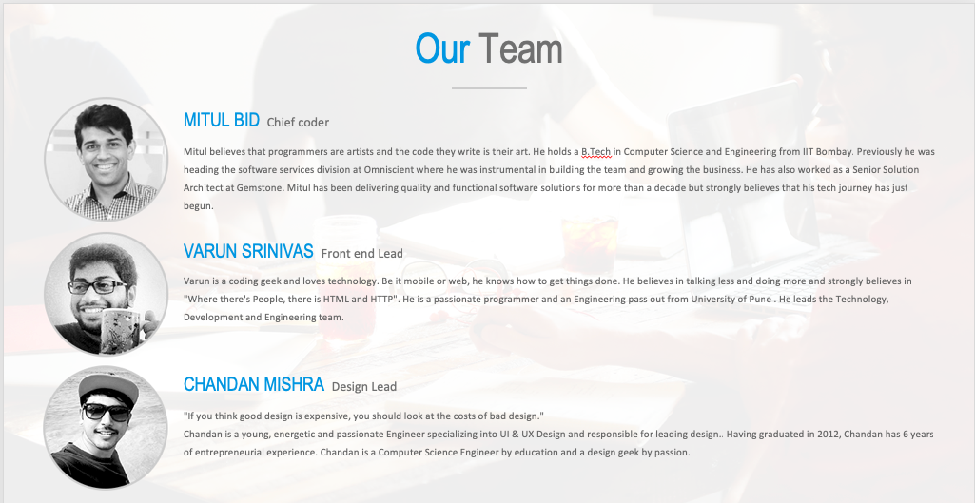

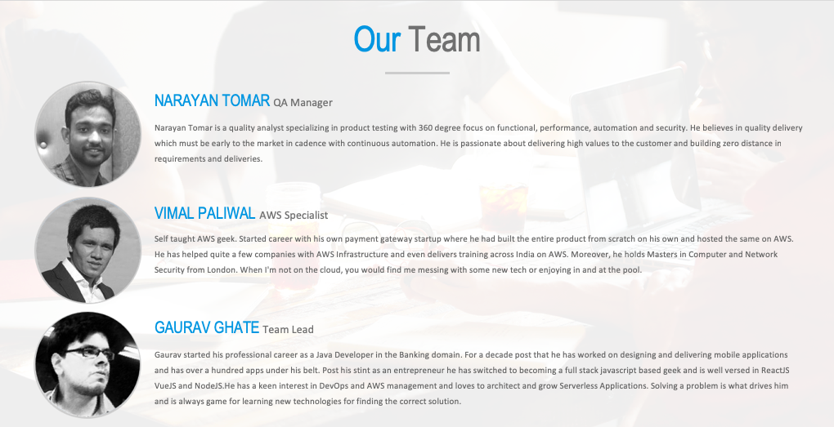

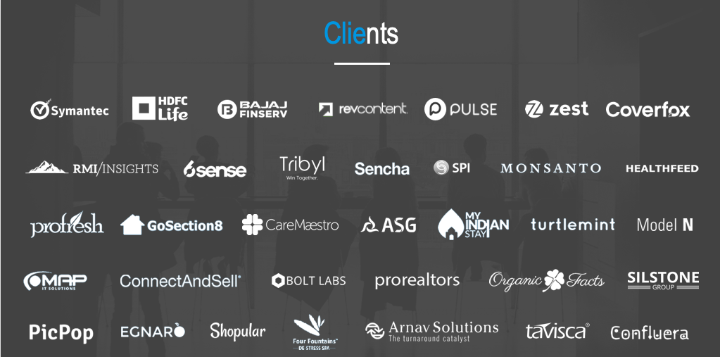

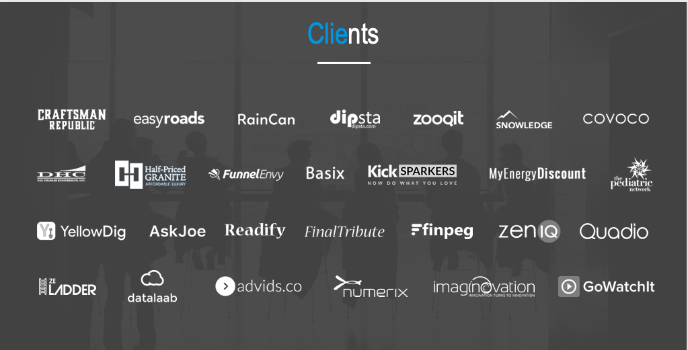

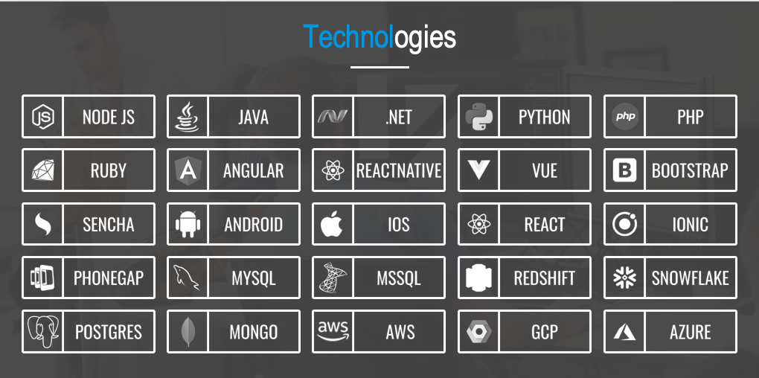

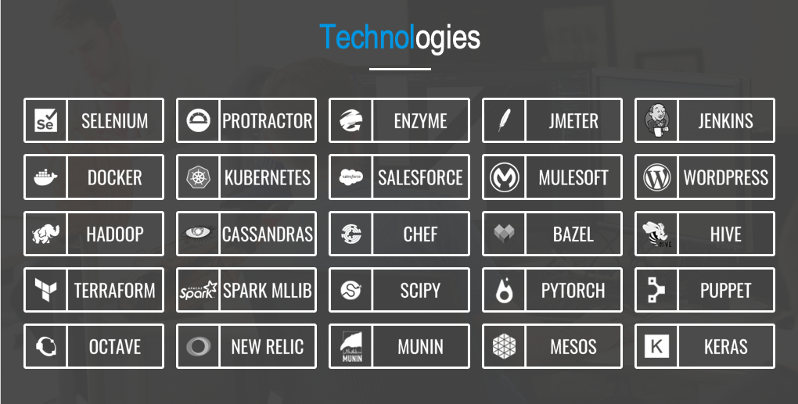

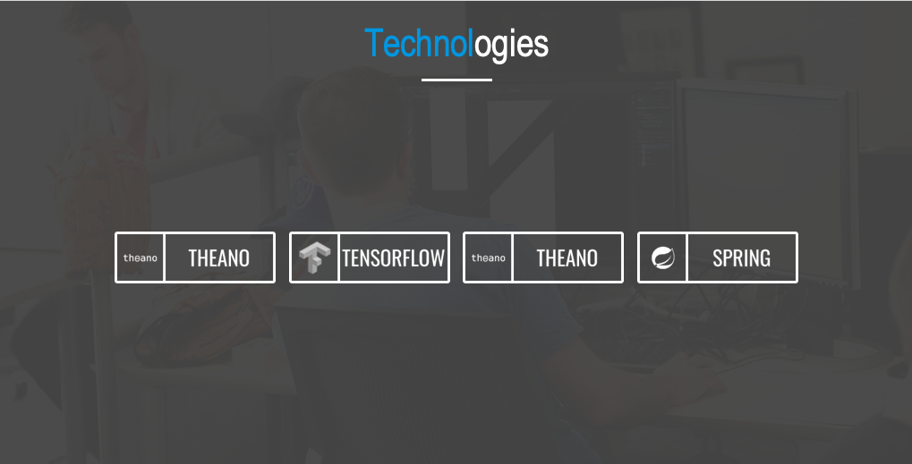

Work Undertaken

We have built more than 30 enterprise SaaS products/platforms deployed on multiple environments - on prem, AWS, Azure and GCP. These solutions span multiple verticals like Finance, Security, IoT, E-Commerce, Sales and Marketing, Health.

Four Recent GCP projects

Company/Industry | Media company running ~500 servers/PD
Workload/Use case | Application logs & Network logs- aggregation and analysis. At times applications used to generate GB(s) of logs on per minute basis.
Migrating from | AWS Kinesis | Lambda | AWS ElasticSearch | Kibana
GCP tech stack | VM - Fluentd | Logstash | Ansible | GCS | Pub/Sub | Dataflow | BigQuery | DataStudio.
Advantages | Significant savings and scalable system. GCP components allowed petabyte scaling with lower TCO.
Specific challenges faced and solutions | Sluggish ES response was the major challenge at peak hours; plus ES service does not give direct access to resources so investigation became a major bottleneck without AWS support.

Company/Industry | HR Saas Solution Company running ~150-300 servers on Windows stack.
Workload/Use case | Windows event log analysis to get insights on uncaught exceptions and audit logs
Migrating from | Azure log analysis | VM - Fluentd
GCP tech stack | VM - Logstash | GCS | Pub/Sub | Dataflow | BigTable | DataStudio.
Advantages | Significant savings and scalable system
Specific challenges faced and solutions | No direct support of tools like Kibana was the major challenge.

Company/Industry | Cab aggregator running ~ 300 - 500 servers & monthly cost > $30K
Workload/Use case | 360 Traffic Analysis - Route Traffic analysis, Spike Analysis, API Performance monitoring & Pattern Analysis
Migrating from | Not Applicable (new solution)
GCP tech stack | Kubernetes - Logstash (Data Search, Data Routing) | Pub/Sub | Dataflow | BigQuery | GCS Cloud SQL | Kibana
Advantages | GCP components allowed petabyte scaling with lower TCO.  Specific challenges faced and solutions: The Scalable system which can easily manage traffic spikes
Specific challenges faced and solutions | Kubernetes deployment complexities were overcome with scripting automation

Company/Industry | Video streaming platform running ~ 50 - 150 servers & monthly cost > $5K
Workload/Use case | Log Analysis
Migrating from | Not Applicable (new solution)
GCP tech stack | Click to deploy (https://console.cloud.google.com/marketplace/details/click-to-deploy-images/elasticsearch?q=elasticsearch)
Advantages | Ready to use, no administration overheads
Specific challenges faced and solutions | Not Applicable

Examples of Some Other Custom Applications Built.

CLIENT Number 1:
HDFCLife

HDFCLife is the one of largest private long-term life insurance provider in India offering individual and group insurance.
LAUNCH DATE:
October, 2018
PROJECT DESCRIPTION:
Responsible for designing the user experience and user interface for HDFC’s E3 app.
The design phase involved:

- Stakeholder interview and user research
- Designing the information architecture and user flows
- Drafting task flows and wireframes
- Low-Fidelity Prototype using InvisionApp
- Selection of the color which are used in the product
- Setting up the font family and typography scheme
- Design of all the icons and graphics assets which are used in the product
- Visual designs for over 50 screens and multiple users flows
- Creating a clickable walkthrough/prototype for all the products
- Setting up the visual design for the component library
- Preparing style guide and specification documents for the development teams to refer
- Creating and maintaining the entire design system, to be used by development teams spread across the globe
- The continuous cycle of testing, iterating and improving the visual designs
- Usability testing the product to identify the points of improvement

The development phase involved:

- Brainstorming - providing best solutions to devise app features as per the provided requirements
- Feasibility analysis
- Deciding platform based on the app needs
  - Node js (backend)
  - Angular 6 (frontend)
  - Postgres using Sequelize ORM (database)
- Collaborating with design team to finalize designs
- Providing estimates for requirements
- Sprint planning
- Structuring schema for the app and admin panel
- Implementation of app and admin panel features
- Creating and updating development and requirement related docs
- Regular deployment of app on dev and testing servers

SCREENSHOTS:
HDFC Life Mobile App

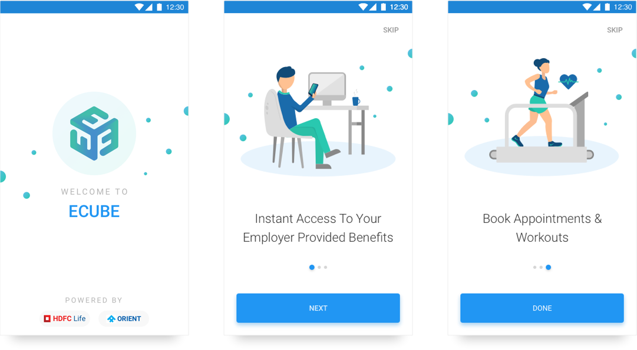

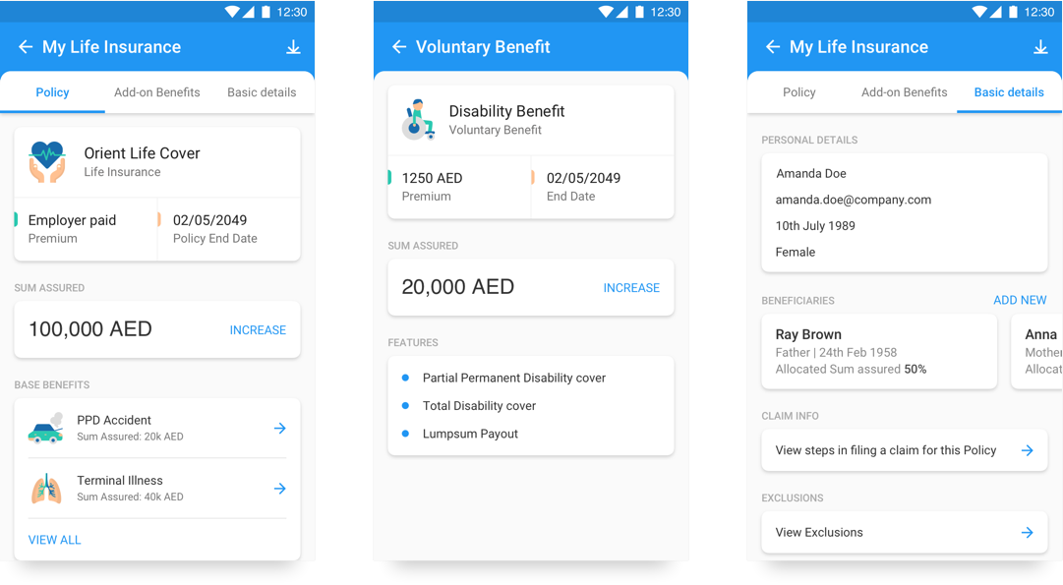

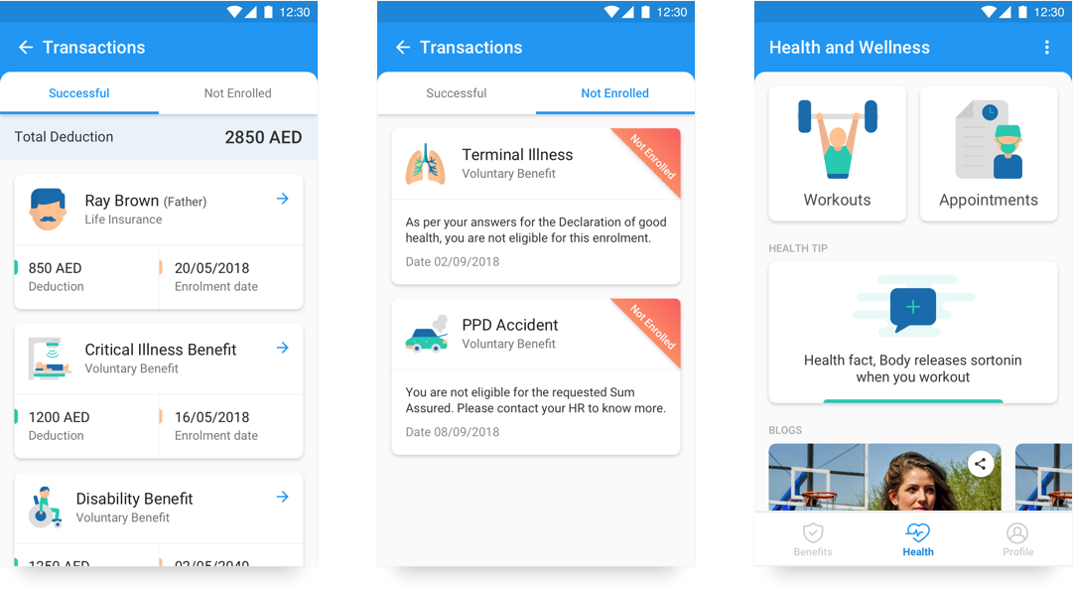

CLIENT Number 2:

ASG Technologies

ASG Technologies Group, Inc., is a provider of Enterprise Information Management and IT System Management solutions technology. Customers have included Coca-Cola, General Electric, Cisco Systems, Nissan, Verizon Wireless, United Airlines, American Fidelity Assurance, Liberty Mutual Insurance, Citigroup, Citizens Bank, Bank of America, Morgan Stanley, United Healthcare and Procter & Gamble.
Launch Date: Ongoing
Project Description:
Responsible for designing the user interfaces of 4 of ASG products.
The design phase involved:

- Selection of the color which are used in the product
- Setting up the font family and typography scheme
- Design of all the icons and graphics assets which are used in the product
- Visual designs for over 1500 screens and many users flows
- Creating a clickable walkthrough/prototype for all the products
- Setting up the visual design for the component library
- Preparing style guide and specification documents for the development teams to refer
- Creating and maintaining the entire design system, to be used by development teams spread across the globe
- The continuous cycle of testing, iterating and improving the visual designs
Screenshots:

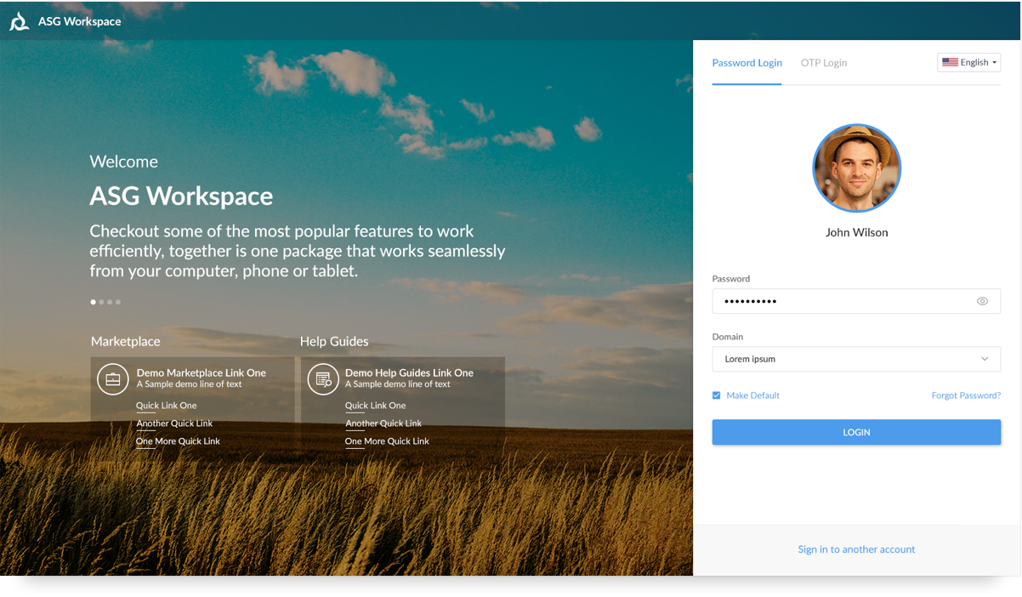

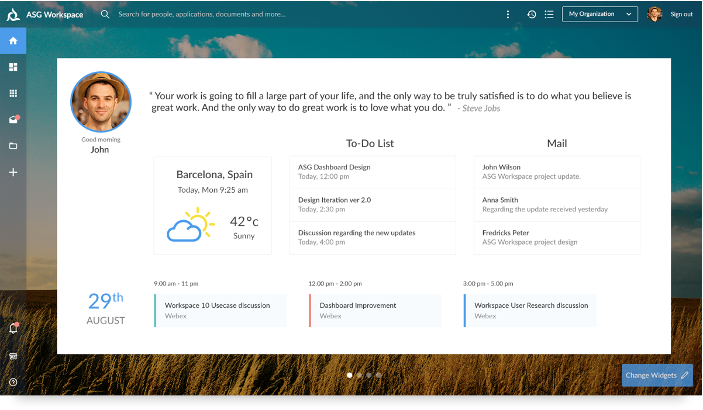
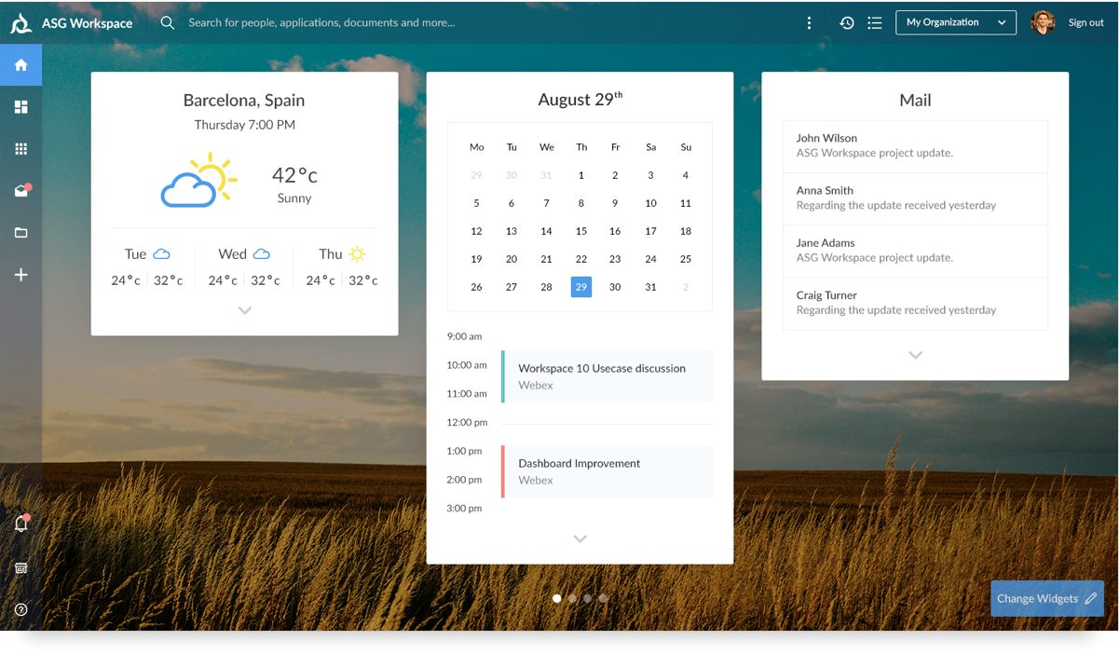
CLIENT Number 3:

Client: RiseSmart

Launch Date: 14-Mar-2017

Project Description

RiseSmart is a leading provider of contemporary career transition services that strengthen employer brands, improve retention and re-engage talent. RiseSmart's contemporary approach to outplacement combines personalized services from trained professionals with unmatched technology delivered through a convenient, cloud-based platform.

High-performing organizations in more than 40 industries rely on RiseSmart's outplacement solution to help former employees find new jobs faster. Landing rates exceeding 80 percent and time-to-placement averages more than 60 percent faster than national averages have helped make RiseSmart the nation's fastest growing outplacement firm. RiseSmart's innovative approach to human capital management has earned the company a wide range of awards and recognition from organizations including Bersin by Deloitte, the Best in Biz, Gartner Inc., the Golden Bridge Awards, GreatRated!, LAROCQUE, the Momentum Index, Red Herring, the San Francisco Business Times, SiliconIndia, the Silicon Valley/San Jose Business Journal, the Stevie Awards and TIE. Additionally, RiseSmart's outplacement solution has earned the exclusive endorsement of the American Hospital Association.

Screenshots and/or URLs if available: N/A

Team Size: 10 members

Technology Stack:
  - Java, JSP, Spring (MVC, Security, AOP), Spring Boot, Hibernate,
  - AWS - EC2, RDS (My SQL), SES, SQS, SNS, Lambda
  - UI: HTML, CSS, Boostrap, jQuery, Angular
  - Quartz Scheduler

Besides the BAU features like List load, Billing etc, team has extensively worked on different third party integrations like Qualtrics (for Surveys), Cronofy (for call and meeting scheduling) etc.

